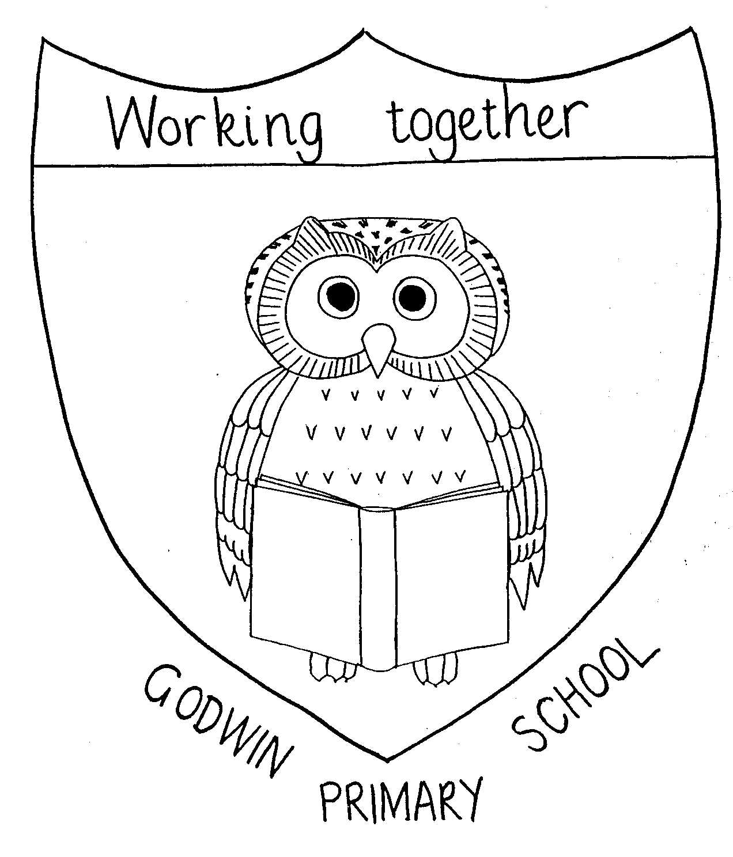

GODWIN PRIMARY SCHOOL – Art Overview

 | Reception | Year 1 | Year 2 | Year 3 | Year 4 | Year 5 | Year 6
Autumn 1 | Archimboldo  Portraits and cutting skills  Me and my family topic  Ranbir Kaur  Rangoli artist – different media to create Rangoli patterns – Diwali | Outdoor Art  Nature sculpture  Sculpture  Andy Goldsworthy  Plants - Science | Picasso  Portraits  Drawing | Edgar Degas (Impressionism)  Ballerinas  Drawing  Charcoal  The Royal Ballet - PE | Great Architects  Gaudi, Hadi, Foster, Adjaye  drawing 3D buildings  Religions represented in neighbourhood - RE | Roman sculptures  Pottery  Clay  Romans
Autumn 2 | Piet Mondrien  Painting - square art – Maths  L.S Lowry  Drawing – people in different environments  Once there was giants’ book |  | Van Gogh (post-Impressionism)  Starry Night  Nativity silhouettes and painting (colour mixing)  Nativity – CC unit
Spring 1 | J.M.W Turner  Storm painting  After the storm book | The Great Fire of London  Paintings  Primary and Secondary colours  Great Fire of London - History |  |  | Claude Monet/Alison Lappa  Rivers and Mountains  painting  Environmental regions, water cycle, geography, |  | Propoganda posters  WW2 art
Spring 2 | Karl Faberge  Sculpture – egg art  Farm topic and Easter  Georgia O’Keefe  Drawing flower pictures  Spring and growing topic | Drawing  Observational, still life drawing – pencils  Drawing the national flowers of countries of the UK  UK - Geography  Plants - Science |  | Margaret Godfrey/Andy Warhol  Volcanic art  Watercolours painting  Active Planet – geography and science |  |  | Benin African Art  Clay  History topic – Ancient Benin
Summer 1 | Andy Goldsworthy  Sculpture – using natural objects  Woodland topic  Yoa Bobby  Sculpture - using things he finds on the beach – Our local environment & recycling topic |  | African Art  Textiles  Adire Eleko & Senufo Cloth  Contrasting country – Nigeria - Geography |  |  | Rainbows  Painting
Summer 2  Special week will contain an element of art | Louise Beourgeois  Modroc spiders  Minibeast topic  Henri Rousseau  Tiger in a tropical storm  Wild animals topic | Art based around weather |  | Scultpure  3D make and decorate pottery  Scavengers and settlers - History | Sculpture  Ancient Greek masks – papier mache | Georgia O’Keefe (abstract art)  Flowers  Drawing - pastels  Plants - Science | Posters and prop design for Year 6 show

