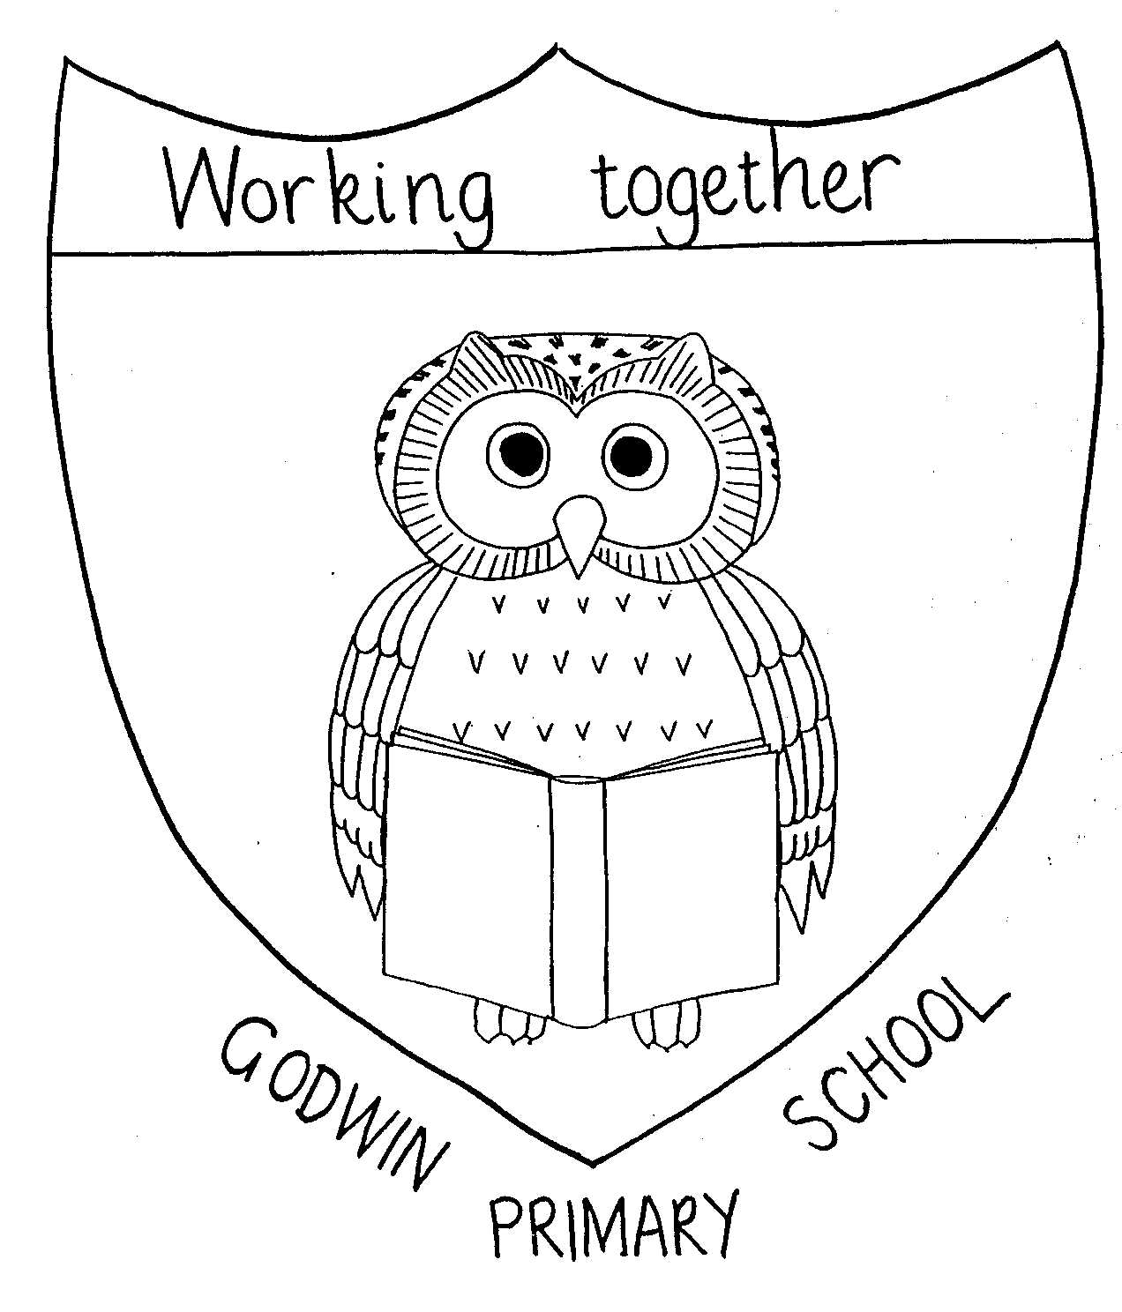
Curriculum Map - Year 4 2025 - 2026

GODWIN PRIMARY SCHOOL

 | Autumn Term 1 | Autumn Term 2 |  | Spring Term 1 | Spring Term 2 | Summer Term 1 |  | Summer Term 2
English | Lightning Girl – Alesha Dixon | Varjak Paw – SF Said |  |  | Who Let the Gods Out – Maz Evans |  | Harry Potter – J K Rowling
English | Diary, Persuasive leaflet, | narrative - chapter |  | Persuasive letter, newspaper recount | Recount, poem character description | narrative potions poem, character description, non-chron report |  | Narrative – rewrite scene; Wizard biography, letter
Whole class reading | Disney songs, Children’s classics 1, Poetry 1, States of matter, Guy Bass, Money | Picture books 1, Armistice Day, Electricity, Novels 1, Recycling week songs |  | Rivers, Children’s classic 2, Notable people 1, Jennifer Killick, Notable people 2, Chinese New Year | Poetry 2, Picture Books 2, International Woman’s Day, Rabbits, Novels 2, Songs from musicals | Romans, Greece, Teeth, Vikings, Keeping healthy, Witches and wizards |  | Habitats, Migration, Mental Health, Sports People
Drama |  |  |  |  |  |  |  | Ancient Greek theatre and feelings
Maths | Number: Place Value  Number: Addition and Subtraction | Measurement: Area  Number: Multiplication and Division |  | Number: Multiplication and Division  Measurement: Length and Perimeter | Number: Fractions  Number: Decimals | Number: Decimals  Measurement: Money  Measurement: Time |  | Geometry: Shape  Statistics  Geometry: Position and Direction
Science | States of matter | Electricity |  | Sound |  | Animals including humans |  | Living things and habitats inc.plants
Science | Working scientifically
Art | Drawing 3D buildings  Great Architects  Gaudi, Hadi, Foster, |  |  | Rivers and Mountains  Colour mixing – the colour blue;  Claude Monet/Alison Lappa |  |  |  | 3D design  Ancient Greek theatre masks  Papier Mache
Computing | Computing systems and networks – The internet (INTERNET BROWSER) | Creating media – Audio editing (Adobe Express/BAND LAB |  | Programming A – Repetition in shapes (2CODE / PURPLE MASH SUITE) | Data and information – Data logging (Microbit) | Creating Media – Photo editing (Adobe Express) |  | Programming B – Repetition in games (2CODE / PURPLE MASH SUITE)
DT |  | Electrical Systems  Design and make a Christmas decoration |  |  | Structures and Mechanisms  Design and make a shaduf | Food  Lovely Lunch
Geography | Environmental Regions of the World  Water cycle | Distribution of Natural Resources  Energy |  | Rivers and mountains
History |  |  |  |  | Ancient Egypt | Ancient Greece |  | The legacy of Greek Culture
French  Rising Stars Stage 2 | On y Va!  (All aboard) | L’agent de poche  (pocket money) | Raconte-moi une histoire  (Tell me a story!) |  | Vive le sport!  (Our sporting lives) | Le Carnaval des Animaux  (The Carnival of the Animals) |  | Quel temps fait-il?  (What’s the weather like?)
Music  English Model Music Scheme | Musical Structures | Nativity | Exploring Feelings When You Play |  | Compose with Your Friends | Whole class general musicianship skills |  |  | The Show Must Go On
Indoor PE  Complete PE | Gymnastics – Bridges | Dance – Cats |  | Gymnastics – levels and direction | Swimming | Dance - Space |  | Dance – World War II
Outdoor PE  Complete PE | Net and Wall games – tennis | Invasion games - football |  | Swimming | Striking & fielding- Cricket | OAA - Orienteering |  | Invasion games - Rugby
PSHE | Eco Warriors | Rules And Laws  (link with British Parliament Week) |  | Family and friends | Effects of Alcohol/ Witnessing Bullying | Healthy Eating |  | SRE – What is puberty?/ Safety Week
Seal | New beginnings | Getting on and falling out |  | Relationships | Good to be me | Going for goals |  | Change
RE  New scheme | What is important to people in my local community?
RE  New scheme | How and why do Hindus worship at home and in the Mandir? | Why is the Bible special for Christians? |  | What religions and worldviews are represented in out neighbourhood? | Why is Easter important to Christian people? | What makes me the person I am? |  | What happens when someone gets married?
Special Events subject to availability | Hindu temple visit - FREE | Nativity performance – Yr 4  Pantomime trip - COST |  | Houses of Parliament - FREE |  | British Museum - FREE

