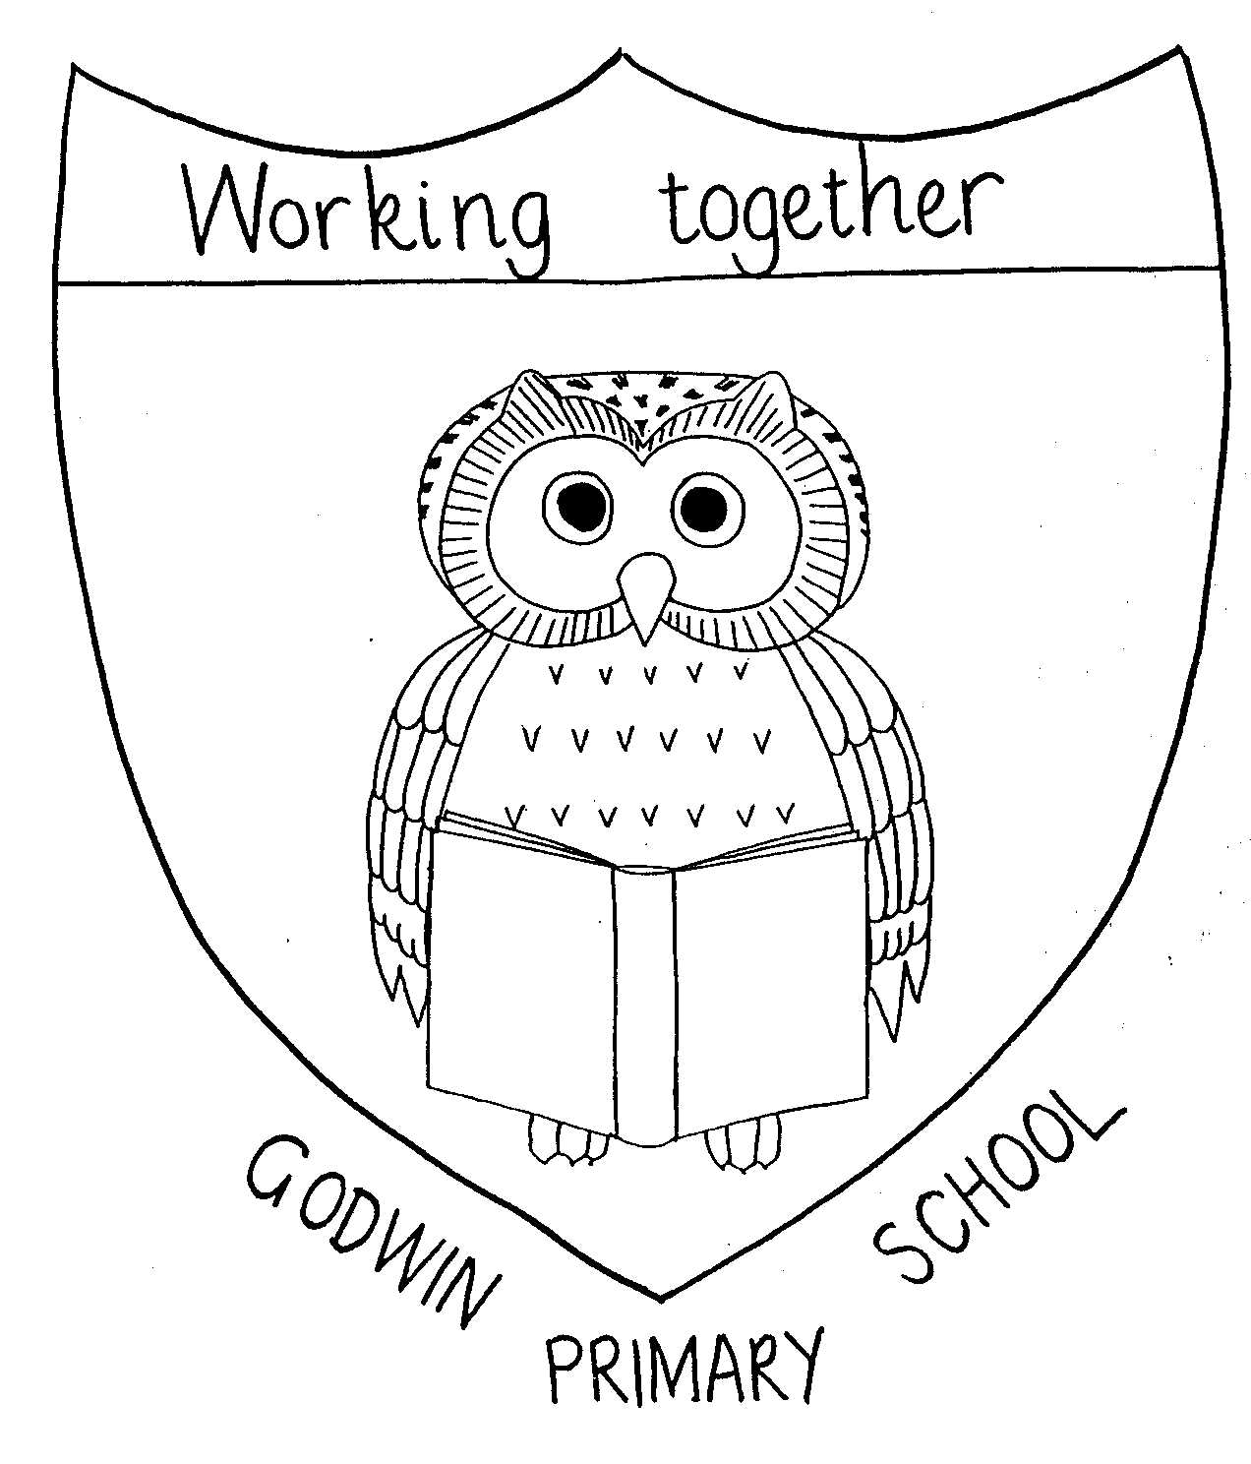

GODWIN PRIMARY SCHOOL

Curriculum Map - Year 5
2025 - 2026
 | Autumn Term 1 | Autumn Term 2 | Spring Term 1 | Spring Term 2 | Summer Term 1 | Summer Term 2
English | Malamander – Thomas Taylor | Wonder – R J Palacio |  | The Boy at the Back of the Class – Onjali Rauf/HWCL |  | The House with Chicken Legs – Sophie Anderson
English | Entertain – narrative, persuasive leaflet, inform – non-chronological report | Balanced argument, entertain – diary entry, discussion – review | Inform – biography, entertain – description | Entertain – narrative recount, poetry, | Inform – journalist writing | Persuasive speech, explanations, narrative
Whole Class reading | Disney Songs, Picture Books Vol 1, Frank Cottrell Boyce, Changing Materials, Circuses, Novels Vol 1, Notable People Vol 2 | Children’s Classics Vol 1, Brazil, Energy/Forces, Nigeria, Rainforests, Antarctic Explorers, Christmas | Sia, Space, Notable People Vol 1, Great openings, Poetry Vol 1, Novels Volume 1 | Novels Volume 2, Middle Eastern countries, Equality, Children’s classics, Kate DeCamillo, Songs from musicals | Life Cycles, Islands/leprosy, Poetry Vol 2, Medieval Monarchs, Titanic | Children’s Classics Vol 2, Beetles, Songs, Picture Books Vol 2, Michael Morpurgo
Drama |  |  |  | Refugees
Maths | Number: Place Value  Number: Addition and Subtraction | Number: Multiplication and Division  Number: Fractions | Number: Multiplication and Division  Number: Fractions | Number: Decimals and Percentages  Measurement: Perimeter/Area Statistics | Geometry: Properties of Shape Geometry: Position and Direction  Number: Decimals | Number: Negative numbers  Measurement: Converting Units  Measurement: Volume
Science | Properties and changes of materials | Forces and Magnets | Earth and Space | Light | Animals including humans | Living things and habitats
Science | Working scientifically
Art | Roman Sculptures  Pottery and Clay |  |  |  | Painting  Rainbows (child-led) | Drawing  Georgia O’Keefe (abstract art)
Computing | Computing systems and networks – Sharing information  (INTERNET BROWSER) | Creating media – Vector drawing  (MICROSOFT POWERPOINT) | Data and Information - Flat-file Databases  (J2e) | Programming A – Selection in physical computing – (Crumble) | Creating media – Video editing  (Adobe Express) | Programming B – Selection in quizzes  (2CODE / PURPLE MASH SUITE)
Design technology |  | Textiles  Phone cases | Electrical systems ad mechanisms  Moon Buggies | Food  Serve a Salad
Geography |  | The World |  |  | Comparing areas of the World
History | The Roman Empire and its impact on Britain |  | Britain’s settlements by Anglo Saxons and Scots | The Viking and Anglo-Saxon struggle for the Kingdom of England to the time of Edward the Confessor
French | Bonne appetit, bonne sante  (Healthy eating) | Je suis le musician  (I am the music man) | En route pour l’ecole  (On the way to school) | Scene de plage  (Beach scene) | Le Retour to Printemps  (The Return of Spring) | Les planets  (The planets)
Music | Whole class instrumental learning - fifes
Indoor PE | Swimming | Dance - The Greeks | Gymnastics – Counter tension and balance | Dance – Graffiti | Gymnastics – Flight | Dance – The Circus
Outdoor PE | Invasion Games  Rugby | Swimming | Net and Wall - Tennis | Invasion Games  Hockey | OAA  Communication and Tactics | Striking and Fielding  Cricket
RE | What impact do beliefs have on actions?
RE | What inner forces affect how we think and behave? | How is Christmas celebrated around the world? | Why is Muhammed and the Qu’ran important to Mulsims? | How do Christians try and follow Jesus’ example? | Should all creatures be treated equally? | What do religions and worldviews believe about God?
PSHE | Looking After Ourselves & Our Community | Being Smart Online  (including cyber-bullying) | Legal and  Illegal Drugs | Healthy Minds,  Healthy Bodies | First Aid 1: Breathing, Bones, Burns & Bleeding | Puberty/  Safety Week
SEAL | New Beginnings | Getting On & Falling Out | Good To Be Me | Going For Goals | Relationships | Changes
Special Events | London Mithraeum – FREE  School Nurse |  | Mosque visit - FREE | Trip to Greenwich Planetarium - COST

