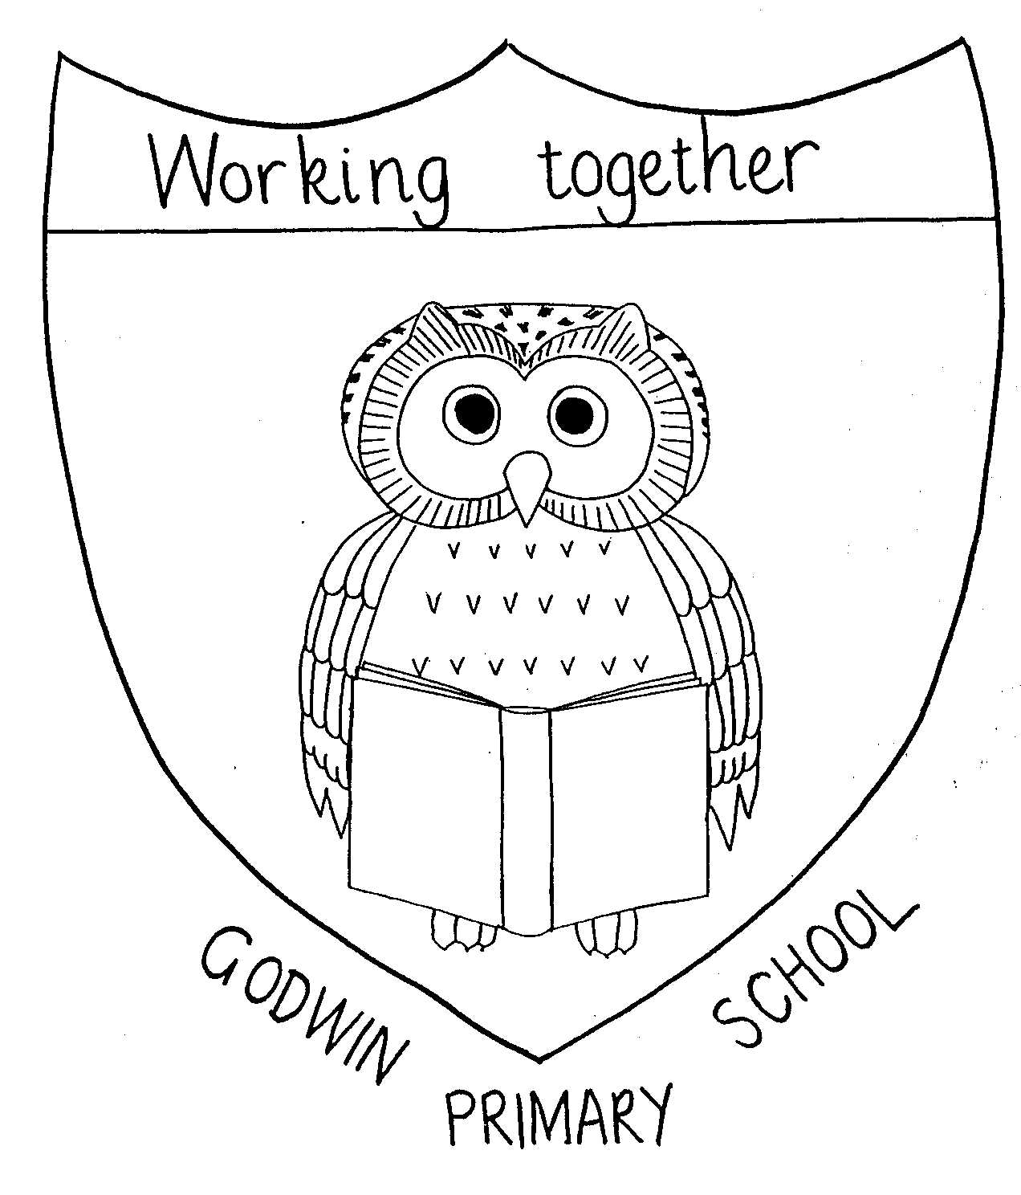

GODWIN PRIMARY SCHOOL

Curriculum Map - Year 1

 | Autumn Term 1 | Autumn Term 2 | Spring Term 1 | Spring Term 2 | Summer Term 1 | Summer Term 2
English | Read, Write, Inc  In phases | Read, Write, Inc  In phases | Read, Write, Inc  In phases | Read, Write, Inc  In phases | Read, Write, Inc  In phases | Catch up
Class books with linked writing | Elmer  Amazing Grace  Pumpkin Soup | Goldilocks and the Three Bears  The Jolly Christmas Postman | The Three Little Pigs  Mr Wolf’s Pancakes | Red Riding Hood  The Journey | Jack and the Beanstalk  Man on the Moon | The Day the crayons Quit  Emily Brown books
Drama | All About Me presentations (tbc)
Maths | Number: Place Value (within 10); Number: Addition and Subtraction (within 10) | Number: Addition and Subtraction (within 10)  Geometry: Shape | Number: Place Value (Within 20)  Number: Addition and Subtraction (within 20) | Number: Place Value (Within 50)  Measurement: Length and Height  Measurement: Mass and Volume | Number: Multiplication and Division  Number: Fractions  Geometry: Position and Direction | Number: Place Value (within 100)  Measurement: Money  Measurement: Time
Science | Animals including humans (include healthy eating, linking to food tech). |  | Everyday Materials | Plants |  | Seasonal Changes  (have to be aware of throughout year)
Science | Working scientifically
Art | Sculpture  Andy Goldsworthy art from nature |  | Painting  Great Fire of London paintings (hot colours) | Drawing  Observational – National flowers
Computing | Computing Systems and Networks – Technology Around Us  (UNPLUGGED) | Creating Media – Digital Painting  (2PAINT / PURPLE MASH SUITE) | Creating Media – Digital Writing  (2PUBLISH / PURPLE MASH SUITE) | Programming A – Moving a robot  (BEEBOTS) | Data and Information – Grouping Data  (MAINLY UNPLUGGED / SORTING ACTIVITY) | Programming B – Introduction to Animation  (2CODE / PURPLE MASH SUITE)
DT |  | Food Technology  Bring on breakfast |  |  | Mechanisms  Design and make a weather vane/weather station | Textiles  Fabric Faces
Geography |  | Local area, London and England |  | The UK - Scotland, Ireland, Wales | Weather in the UK
History |  | My History  significant historical events and places in their own locality | The Great Fire of London |  |  | First aeroplane flight
Music | My Musical Heartbeat | Dance, Sing and Play! + Christmas Carols | Exploring Sounds | Learning to Listen | Having Fun with Improvisation | Let’s Perform Together
Indoor PE | Gymnastics - Body parts | Dance – Growing | Gymnastics – Wide, narrow, curled | Dance – Heows | Dance – The Zoo | Games for understanding
Outdoor PE | Jumping | Running | Rackets, Bats and Balls | Hands | Feet | Team Building
PSHE | Understanding emotions and self-regulation | My Special People, My Special Places | Healthy Eating and looking after teeth | Keeping safe and medicines | What Is Bullying? | SRE – Growing & Caring for Ourselves/ Safety Week
SEAL | New Beginnings | Going For Goals | Getting On & Falling Out | Good To Be Me | Relationships | Changes
RE | What does it mean to belong?
RE | What does it mean to belong to Christianity? | How do Christians celebrate Christmas? | What does it mean to belong to Sikhism? | What does it mean to belong to Islam?  (Eid al-Fitr 30th March) | How do Hindu people belong? | What can be special about living with family and friends?
Special Events | Cinema trip  Local walk to collect natural materials  Church visit | Dagenham Heathway WW2 memorial trip  Valence House trip  Local walk to the postbox | Great Fire of London – drama group  Firefighter visit Eastbrook End Country Park  Safer Internet Day | World Book Day  Eid assembly for parents | Eastbrook End Country Park
NB: during the autumn 1 the focus will be on transition and based on topics - subjects might get combined and outcomes will not necessarily be recorded.

