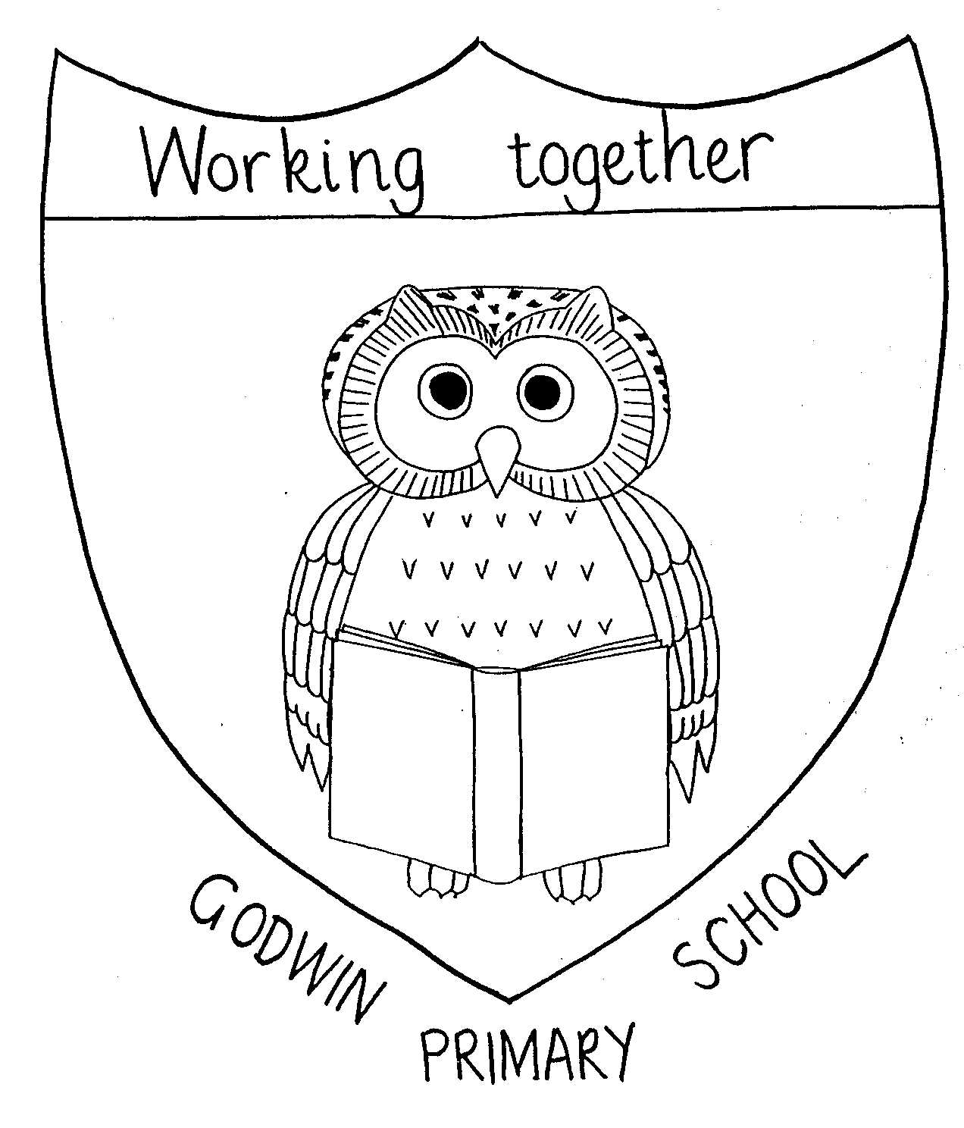

GODWIN PRIMARY SCHOOL

Curriculum Map - Year 2
2024 - 2025

 | Autumn Term 1 | Autumn Term 2 |  | Spring Term 1 | Spring Term 2 | Summer Term 1 | Summer Term 2
Class book | Once Upon a Wildwood | Molly McDrew an adventure around the World  The Owl who was afraid of the dark |  | Fantastic Mr Fox | Fantastic Mr Fox | Flat Stanley | The Adventures of the Breakfast Club
English writing | Character description; beginning of a traditional tale |  |  | Non-chronological report, diary | Instructions, | Tower of London trip recount Letter to inform, middle of an adventure story | Fantasy story, non-chronological report
Drama |  | Nativity
Maths | Number: Place Value  Number: Addition and Subtraction | Number: Addition and Subtraction  Geometry: Properties of shape |  | Measurement: Money  Number: Multiplication and Division | Measurement: Length and Height  Measurement: Mass, Capacity and Temperature | Number: Fractions Measurement: Time | Statistics  Geometry: Position and Direction
Science | Living things  and habitats |  |  | Animals, including humans |  | Everyday materials | Plants
Science | Working scientifically
Art | Drawing  Picasso - Portraits | Painting  Van Gogh - Starry Night |  |  |  | African Art  Textiles
Computing | Computing Systems and Networks – Information Technology Around Us  (UNPLUGGED) |  | Creating media – Making Music  (CHROME MUSIC LAB) | Programming A – Robot algorithms  (2CODE / PURPLE MASH SUITE) | Data and Information – Pictograms  (2COUNT and 2GRAPH / PURPLE MASH SUITE) | Creating media – Digital photography  (TABLET DEVICES / CAMERA APPS) | Programming B – An introduction to quizzes  (2CODE / PURPLE MASH SUITE)
Design and Technology |  |  |  | Mechanisms  Traditional Tales/linked to Fantastic Mr Fox | Mechanisms  Hoisting a trap for Mr Fox |  | Food  Prepare to Party!
Geography | The World |  |  | Weather  around the World |  | Contrasting non-European country – Nigeria
History |  | Explorers |  |  | Queens and Kings |  | Significant people in Dagenham
Music | Pulse, Rhythm and Pitch | Playing in an Orchestra |  | Inventing a Musical Story | Recognising Different Sounds | Exploring Improvisation | Our Big Concert
Indoor PE
Outdoor PE
RE | Can stories change people?
RE | Why are different books special for different people? Christianity and Islam | Why do people celebrate?  Kwanzaa* |  | How does special food and fasting help people in their faith? (Lent and Ramadan) | How do we know that Easter is coming? What special story is told at Easter*? | Why did Jesus tell stories? | Where did the world come from and how should we look after it?
PSHE | Looking After Our School and Our Community | Keeping Healthy |  | Drugs Education  Hazardous substances | Saving Money | Understanding Bullying | SRE – Differences: Boys & Girls/ Safety Week SEAL
SEAL | New Beginnings | Going For Goals |  | Good To Be Me | Getting On & Falling Out | Relationships | Changes
RE | Can stories change people?
RE | Why did Jesus tell stories? | Why are different books special for different people? |  | What can stories teach us about peace? | Why is Easter important to Christians? | How does special food and fasting help people in their faith? | Where did the world come from and how should we look after it?
Special Events | Iingrebourne Valley Nature Discovery Centre | Nativity in the church to parents |  | Gurdwara visit |  | Tower of London | Local visit – Goresbrook Park – historical monuments

