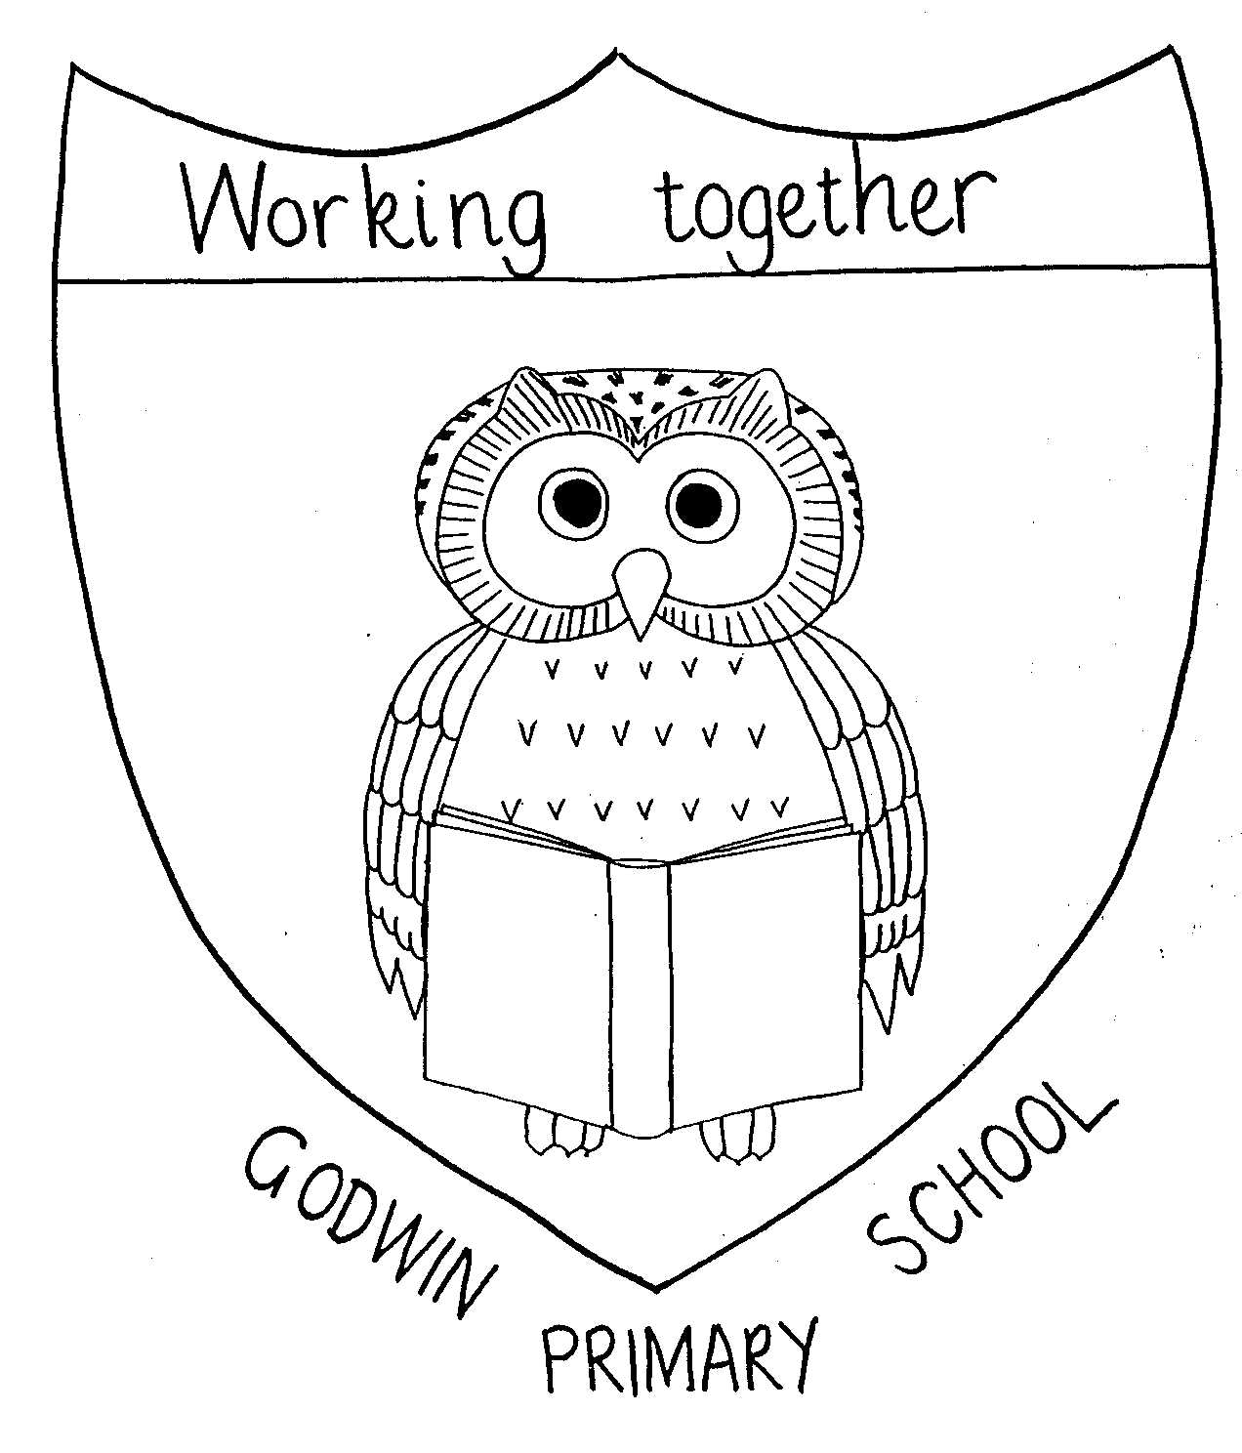

GODWIN PRIMARY SCHOOL

Curriculum Map Year 3 - Year 2024 – 2025

 | Autumn Term 1 | Autumn Term 2 | Spring Term 1 | Spring Term 2 | Summer Term 1 | Summer Term 2
English | Nothing to See Here Hotel | The Hundred Mile an Hour Dog | Iron Man | How to Train Your Dragan |  | The Wild Way Home
English | Persuasion – menu, inform – Hotel review | Inform – Newspaper article, Entertain – letter of explanation | Entertain – Character description  Entertain – middle of a science fiction | Inform – Non-chronological report, poetry – shape, kenning, alliterative | Persuade – advert, Inform – biography based on David Attenborough (link science) | Entertain – narrative, persuade – letter
Whole Class Reading | Songs from musicals, Roald Dahle, Towns, Cities and Villages, Forces, Weather, Anne Fine, Monsters | Internet Safety, Different cultures, Children’s clasics Vol 1, Light and shadows, Lighthouse, Poetry Vol 1, Disney songs | Notable People Vol 1, Plants, Colours, Novels Vol 1, Dick King Smith, Shang Dynasty | Children’s Classics Vol 2, Picture Books Vol 1, Robots, Rocks and Fossils, Phillip Reeves and Sarah McIntyre, Songs | Spiders, Prehistoric Britain, Keeping Healthy, Hearing Impairment, Poetry Vol 2, Picture Books Vol 2 | Novels Vol 2, Notable People Vol 2, Greece
Drama |  | Character description
Maths | Number: Place Value  Number: Addition and Subtraction | Number: Addition and Subtraction  Number: Multiplication and Division | Number: Multiplication and Division  Measurement: Length and Perimeter | Number: Fractions  Measurement: Mass and Capacity | Number: Fractions  Measurement: Money  Measurement: Time | Geometry: Properties of Shape  Statistics
Science | Forces and magnets | Light | Plants | Rocks | Animals including humans
Science | Working scientifically
Art | Drawing  Ballet dancers  Edgar Degas |  |  | Painting  Andy Warhol/Margaret Godfrey  Watercolours |  | Sculpture  Make and decorate pottery
Computing | Computing Systems and Networks (UNPLUGGED / WORKSHEETS) | Creating media – Desktop publishing (2PUBLISH+ / PURPLE MASH SUITE) | Programming A – Sequence in music (2CODE / PURPLE MASH SUITE) | Data and Information – Branching Databases (2QUESTION / PURPLE MASH SUITE) | Creating Media – Animation (2ANIMATE / PURPLE MASH SUITE) | Programming B – Events and actions (2CODE / PURPLE MASH SUITE)
Design and Technology |  | Mechanisms and Structures  Ballet Dancers | Food  Be a Baker |  | Textiles  Design and make clothing
Geography | UK Cities and counties |  | Distribution of natural resources | Volcanoes and earthquakes
History |  | The history of Barking and Dagenham |  |  | Scavengers and Settlers  From the Stone Age to the Bronze Age | Scavengers and Settlers  From the Bronze Age to the Iron Age
French  Rising Stars Stage 2 | “Moi”  All about me | Jeux et Chansons  (Games and Songs) | On fait la fete  (Celebrations) | Portraits  (Portraits) | Les quatre amis  (The four friends) | Ca pousse!  (Growing things)
Music  English Model Music Scheme | Writing Music Down | Playing in a Band | Compose Using Your Imagination | More Musical Styles | Enjoying Improvisation | Opening Night
Indoor PE – tbc | Dance – Royal Ballet | Dance – Weather | Gymnastics – Symmetry and Asymmetry | Dance – Wild Animals | Gymnastics – Canon and Unison | Swimming
Outdoor PE - tbc | Invasion Games – Football | Invasion Games – Tag Rugby | Net and Wall Games - Tennis | OAA – Problem Solving | Swimming | Striking and Fielding - Cricket
RE  New scheme | How are symbols and sayings important in religion?
RE  New scheme | How did Jesus and Buddha make people stop and think? | What is the significance of light? | How do Jews celebrate their beliefs at home and I the synagogue? | How and why do Hindus celebrate Holi? (14th March) | What can we learn about special symbols and signs used in religions? | What do Sikh sayings tell us about Sikh beliefs?
PSHE | Dealing with Bullies/  Firework Safety | Moral  Dilemmas | Hygiene & Health | Smoking/  Sun Safety | Staying Safe In My Community | Valuing Difference & Keeping Safe/Safety Week
SEAL | New Beginnings | Getting On & Falling Out | Going For Goals | Good To Be Me | Relationships | Changes
Special Events | Dagenham Park ballet trip  Ballet performance | Cinema trip  Nativity Experience  Valence House | Drama group in linked to volcanoes  Synagogue visit | Exit –parents in to see volcano eruption | Natural History Museum

