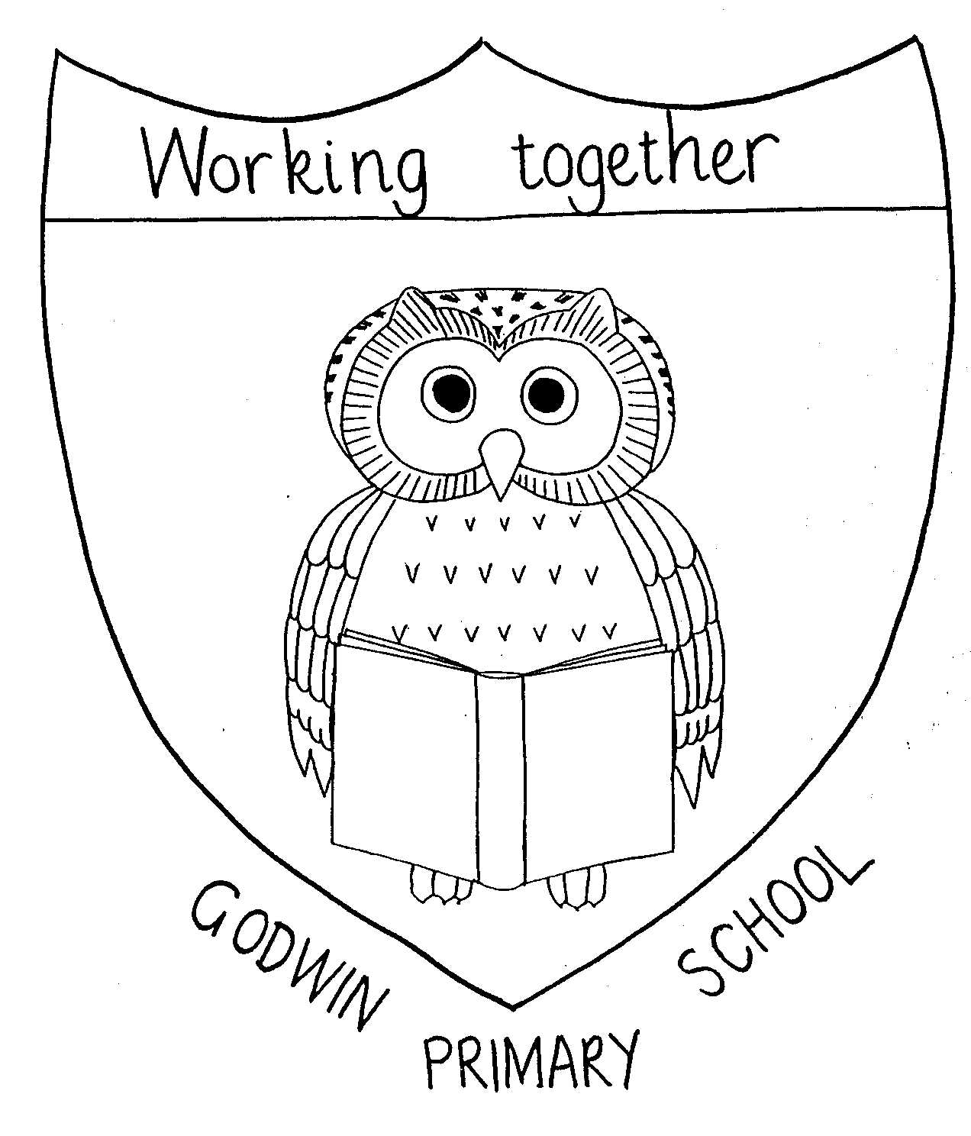
Design and Technology Overview 2021 - 2022

GODWIN PRIMARY SCHOOL

 | EYFS | Year 1 | Year 2 | Year 3 | Year 4 | Year 5 | Year 6
Autumn 1 |  | Textiles  Fabric Faces
Autumn 2 |  | Food  bring on Breakfast |  | Mechanisms and Structures  Ballet Dancers | Electrical systems  Design and make an electric light/torch | Textiles  Phone cases | Structures  Design and make an  accurate, scaled version of a WW2 shelter
 |  | All year groups design and make a Christmas decoration
Spring 1 |  |  | Mechanisms and Structures  Traditional Tales | Food  Be a Baker! | Structures and mechanisms  Design and make a shaduf | Electrical systems and mechanisms  Design and make an electric moon buggy
Spring 2 |  |  | Mechanisms and Structures  Hoisting a flag |  |  | Food  Serve a Salad
Summer 1 |  |  |  | Textiles  Design and make a set of clothing for scavengers and settlers | Food  Lovely Lunch
Summer 2 |  | Mechanisms and structures  Design and make a weather vane/station | Food  Prepare to Party |  |  |  | Food  Grab and go

