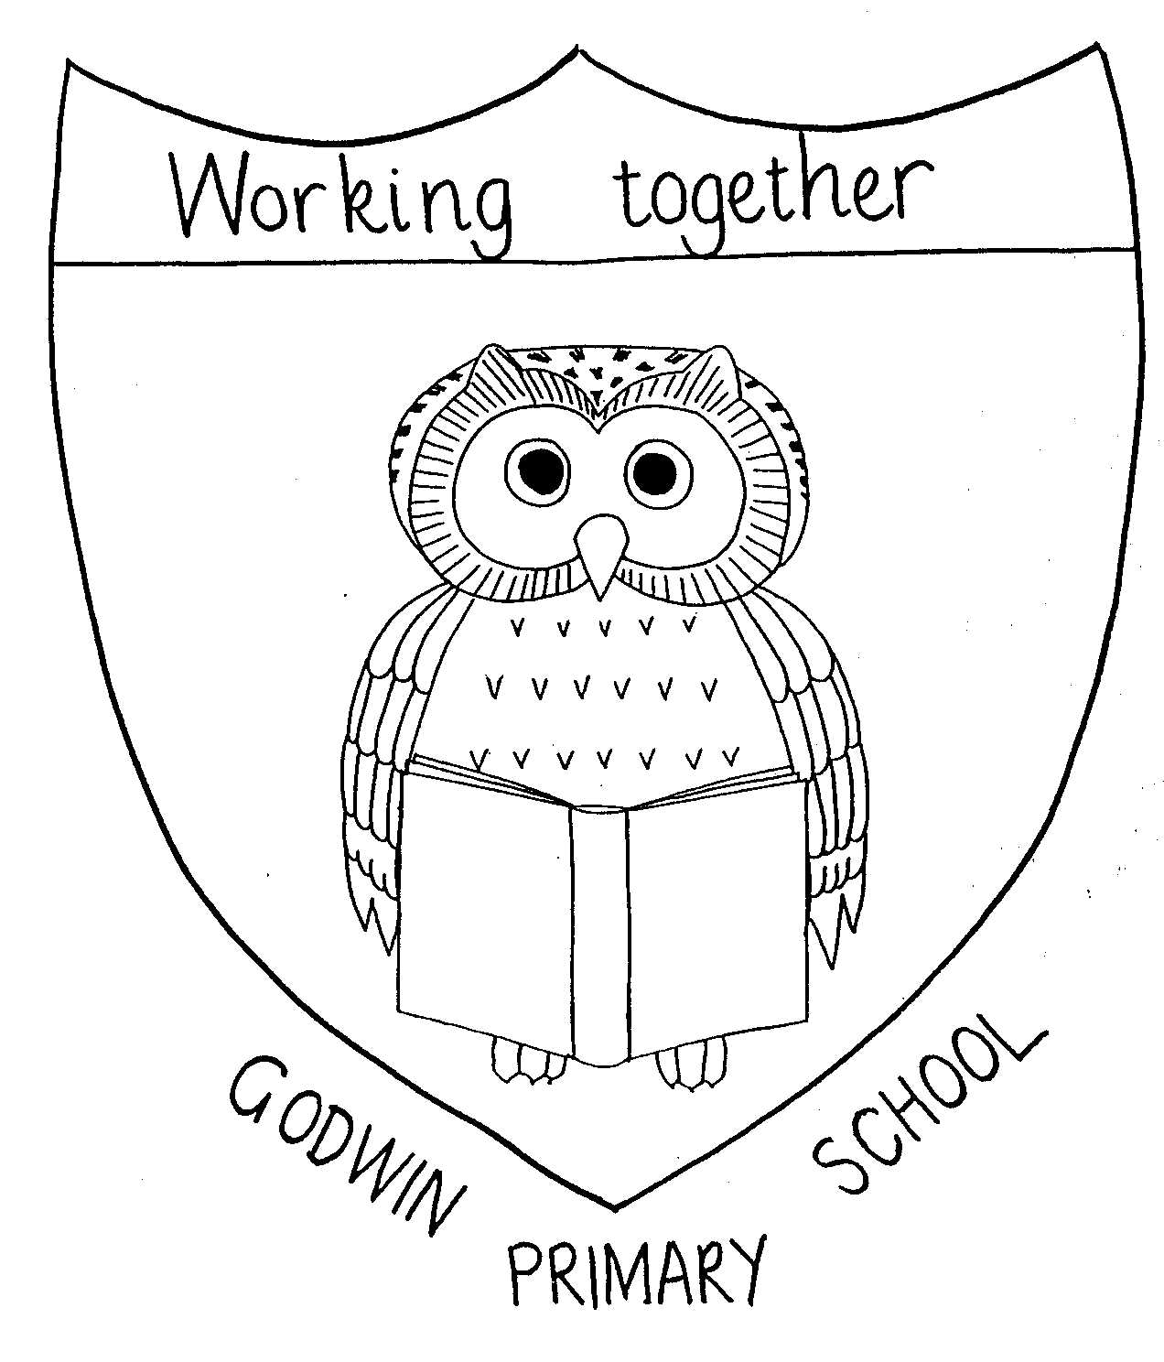
Geography Overview 2021 - 2022

GODWIN PRIMARY SCHOOL

 | Year 1 | Year 2 | Year 3 | Year 4 | Year 5 | Year 6
Autumn 1 |  | The World  name and locate the world’s seven continents and five oceans  Before historys topic Great Explorers of the past’ | UK cities and counties  name and locate counties and cities of the United Kingdom, geographical regions and their identifying human and physical characteristics, key topographical features (including hills, mountains, coasts and rivers), and land-use patterns; and understand how some of these aspects have changed over time  Before history topic ‘’Scavengers and Settlers’, | Environmental regions of the world  locate the world’s countries, using maps to focus on Europe (including the location of Russia) and North and South America, concentrating on their environmental regions, key physical and human characteristics, countries, and major cities  Before history topic ‘Ancient Egypt’, ‘Ancient Greece’  Water cycle  describe and understand key aspects of the water cycle through science unit on ‘States of Matter’
Autumn 2 | Local area, London and England  name, locate and identify characteristics of the four countries and capital cities of the United Kingdom and its surrounding seas  Before history topic ‘The Great Fire of London’ |  |  | Distribution of Natural Resources – energy  through Science ‘Electiricty’ unit | The World  identify the position and significance of latitude, longitude, Equator, Northern Hemisphere, Southern Hemisphere, the Tropics of Cancer and Capricorn, Arctic and Antarctic Circle, the Prime/Greenwich Meridian and time zones (including day and night)  Before science topic ‘Space’
Spring 1 |  |  | Distribution of natural resources – food linked to Food Technology | Rivers and mountains
Spring 2 | The UK - Scotland, Ireland, Wales  name, locate and identify characteristics of the four countries and capital cities of the United Kingdom and its surrounding seas | Weather around the World  the location of hot and cold areas of the world in relation to the Equator and the North and South Poles Alongside science unit on ‘animals and their habitats | Volcanoes and earthquakes  describe and understand key aspects of volcanoes and earthquakes  Alongside science unit on ‘The Active Planet’ | Ancient Egypt  describe and understand key aspects of types of settlement and land use  Alongside history unit on ‘Ancient Egypt’ |  | Geography of West Africa  locate the world’s countries, concentrating on their environmental regions, key physical and human characteristics, countries, and major cities  Alongside history unit on ‘Ancienr Benin’
Summer 1 |  | Contrasting non-European country – Nigeria  understand geographical similarities and differences through studying the human and physical geography of a small area of the United Kingdom, and of a small area in a contrasting non-European country |  | Ancient Greece  describe and understand key aspects of types of settlement and land use  Alongside history unit on ‘Ancient Greece | Comparing areas of the world  Trewern in the UK, Paris in France and Quebec city in North America  understand geographical similarities and differences through the study of human and physical geography of a region of the United Kingdom, a region in a European country, and a region within North or South America  Before Year 6 visit Trewern  Alongside French learning
Summer 2 | Weather in the UK  identify seasonal and daily weather patterns in the United Kingdom  Alongside science unit on ‘Seasons and the Weather’ |  |  |  |  | Dagenham vs Trewern  An in-depth field study  Alongside Year 6 residential  Dependent on dates of Trewern

