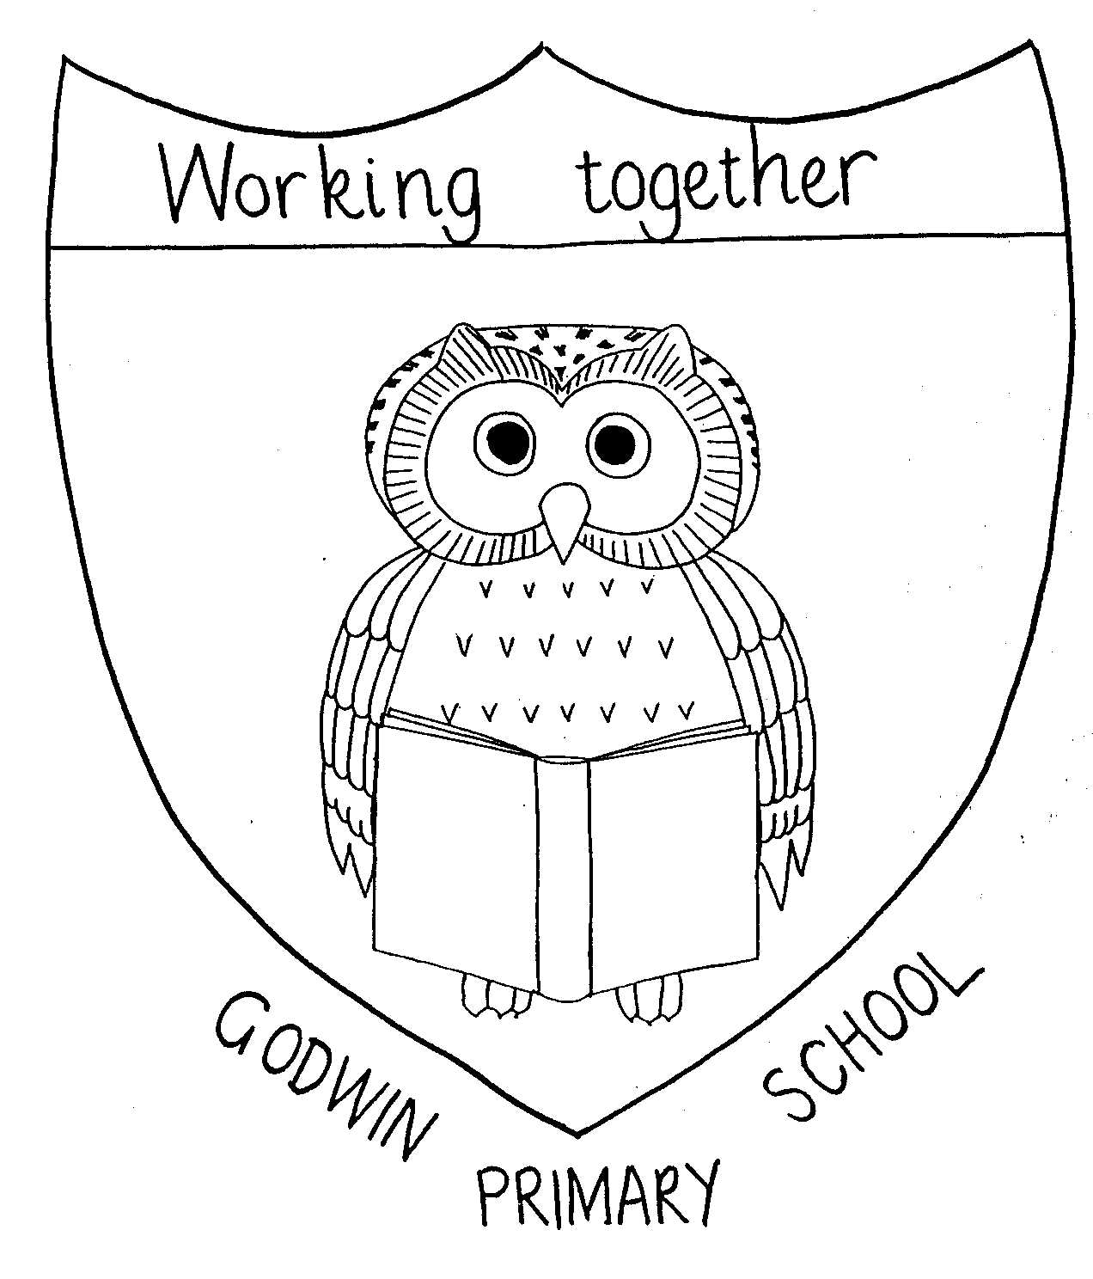
History Overview

GODWIN PRIMARY SCHOOL

2024-2025

 | EYFS | Year 1 | Year 2 | Year 3 | Year 4 | Year 5 | Year 6
Autumn 1 |  |  |  |  |  | The Roman Empire and its impact on Britain
 | All year groups are involved in Remembrance Day Events
Autumn 2 | Gunpowder Plot (November 5th) | My Borough  significant historical events and places in their own locality –Remembrance Day and Dagenham Heathway | Explorers  the lives of significant individuals in the past who have contributed to national and international events; | The history of Barking and Dagenham 1800 - now  A local history study – history of Barking and Dagenham and discussing people who lived here in the past |  |  | World War 2  A study of an aspect or theme in British History that extends pupils’ chronological knowledge beyond 1066
Spring 1 |  | The Great Fire of London  Significant historical events – significant nationally and in their own locality | Queens and Kings  the lives of significant individuals in the past who have contributed to national and international events; |  |  | Britain’s settlement by Anglo-Saxons and Scots | World War 2  A study of an aspect or theme in British History that extends pupils’ chronological knowledge beyond 1066
Spring 2 |  |  |  |  | Ancient Egypt  The achievements of the earliest Civilizations | the Viking and Anglo-Saxon struggle for the Kingdom of England to the time of Edward  the Confessor | Benin AD 900 – 1300  A non-European Study
Summer 1 |  | The first aeroplane flights  Events beyond living memory – significant globally |  | Scavengers and Settlers  Changes in Britain from the Stone Age to the Iron Age | Ancient Greece  a study of Greek life and achievements and their influence on the  western world
Summer 2 |  |  | Significant people from Barking and Dagenham  the lives of significant individuals;  significant people in their own locality; | Scavengers and Settlers  Changes in Britain from the Stone Age to the Iron Age | The legacy of Greek culture  A study of an aspect or theme in British History that extends pupils’ chronological knowledge beyond 1066
History related  Trips |  | Local WWII memorial – Dagenham Heathway  Valence House trip  Local walk to the postbox | Local visit – Goresbrook Park, Jo Richardson- historical monuments  Tower of London | Valence House  Natural History Museum | British Museum | London Museum | Duxford Air museum

