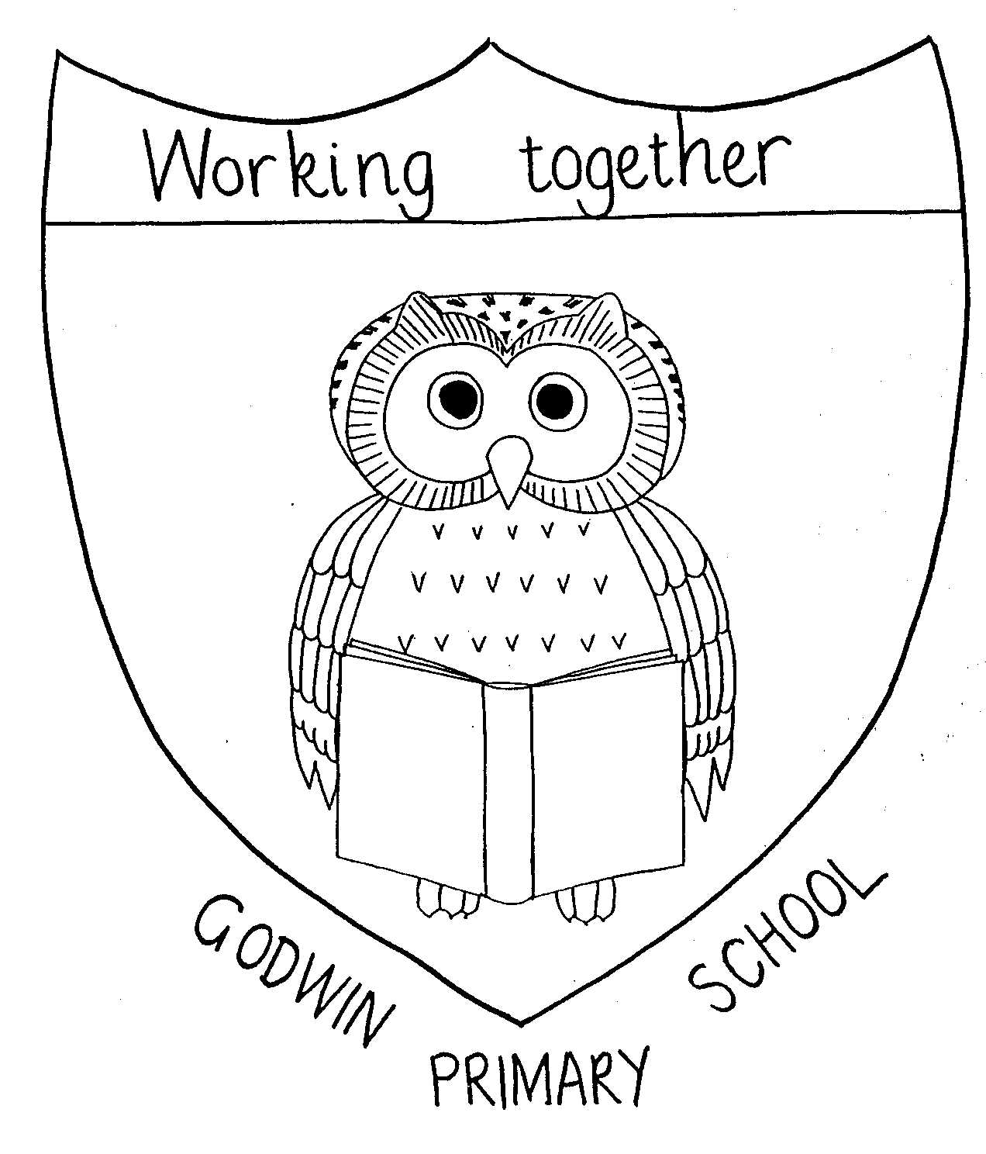

GODWIN PRIMARY SCHOOL

French Curriculum Map
 | Autumn Term 1 | Autumn Term 2 | Spring Term 1 | Spring Term 2 | Summer Term 1 | Summer Term 2
3 | Moi  (All about Me) | Jeux et Chansons  (Games and Songs) | On fait la fete  (Celebrations) | Portraits  (Portraits) | Les quatre amis  (The Four Friends) | Ca pousse!  (Growing Things)
Vocab | Bonjour, Salut, Au revoir, Ca va? Ca va bien/mal, Et toi? Pere, mere, frere, soeur, un, deux, trois, quatre, cinq, six, sept, huit, neuf, dix  Je m’appelle, J’ai sept ans | onze, douze, treize, quartorze, quinze, seize, dix-sept, dix-huit, dix-neuf, vingt  Combien de….? Je prefere…J’ai…le football, le saut a la corde, Chat Perhe, Cache-cache, le scoubidou, le chat, le chien, la souris | (très) bien, Je joue bien au football, Je nage bien, Je nage, Je danse, Je chante, Je lis, Bravo! Super! Chouette! Fantastique! Je suis/Tu es un génie/génial(e)! Joyeux anniversaire! Les mois: (en) janvier, février, mars, avril, mai, juin, juillet, août, septembre, octobre, novembre, décembre Je peux .../Je peux ... ? s’il te plaît please Je saute, Je lance le ballon, J’attrape le ballon. | Les couleurs, rouge, rose, jaune, bleu(e), vert(e), noir(e, blanc(he), violet(te), marron orange, J’ai ... un nez, une bouche, des yeux, un bras, une jambe, Il/Elle a ...... le nez bleu. ... la bouche bleue.... les yeux/cheveux bleus. Il/Elle est grand(e)/petit(e). | le cheval, le mouton, le lapin, la souris, Il galope, Elle court, Il/Elle est ... gris(e), Non, le lapin ne galope  pas, etc. gallop, etc. vite,  lentement,  Il sautille, Elle trottine, la pomme | Tu aimes ... ? Do you like ...? J’aime ... I like ... Je n’aime pas ... I don’t like ... beaucoup a lot/much Je voudrais ... I would like ... Dans mon panier In my basket il y a there is/there are un haricot a bean un concombre a cucumber une tomate a tomato une laitue a lettuce du cresson some watercress une graine a seed une graine de haricot a bean seed un marché
Key vocabulary learning | Understand and use greetings;  Understand and answer simple questions – name and age;  Name family members;  Count from 1 – 10; | Count from 1 – 20;  Understand and answer the questions Combien de…?(How many);  Understand and talk about preferences;  Use ‘Il y a’ (there are) and j’ai (I have); | Understand and answer the questions Qui danse? (Who dances?) And C’est quand ton anniversaire? (When is your birthday?);  Name the months of the year;  Talk and write about hobbies;  Identify a pronoun and verb in French; | Understand, name and write colours;  Names of body parts;  Describe the facial features; | Understand the names of animals;  Answer ‘C’est de quelle couleur?’ – What colour is it?  Write sentences about how animals move; | Names of vegetables;  Talk about food likes and dislikes;  Use expressions of approval and disapproval;  Write sentences about likes and dislikes;  Use beaucoup for emphasis;
Key skills learnt |  |  | Join sentences using ‘et’ (and);  Identify a pronoun and verb in French; | Know nouns are masculine or feminine and how this relates to ‘the’;  Identify a noun and adjective; | Listen and join in with a story;  Sort words according to gender;  recognise movement-related verbs;
4 | On y va  (All aboard!) | L’argent de poche  (Pocket Money) | Raconte-moi une histoire!  (Tell me a story!) | Vive le sport!  (Our Sporting Lives) | Le Carnaval des Animaux  (The Carnival of the Animals) | Quel temps fait il?  (What’s the weather like?)

5 | Looking After Ourselves & Our Community | Being Smart Online  (including cyber-bullying) | Legal and  Illegal Drugs | Healthy Minds,  Healthy Bodies | First Aid 1: Breathing, Bones, Burns & Bleeding | Puberty/  Safety Week

6 | Money, Money, Money |  | Jobs | Preventing the Early Use of Drugs/  Sticks and Stones | First Aid 2: Choking, Heads & Responses/  Jnr Citizen | Puberty, Relationships & Reproduction/  Safety Week

