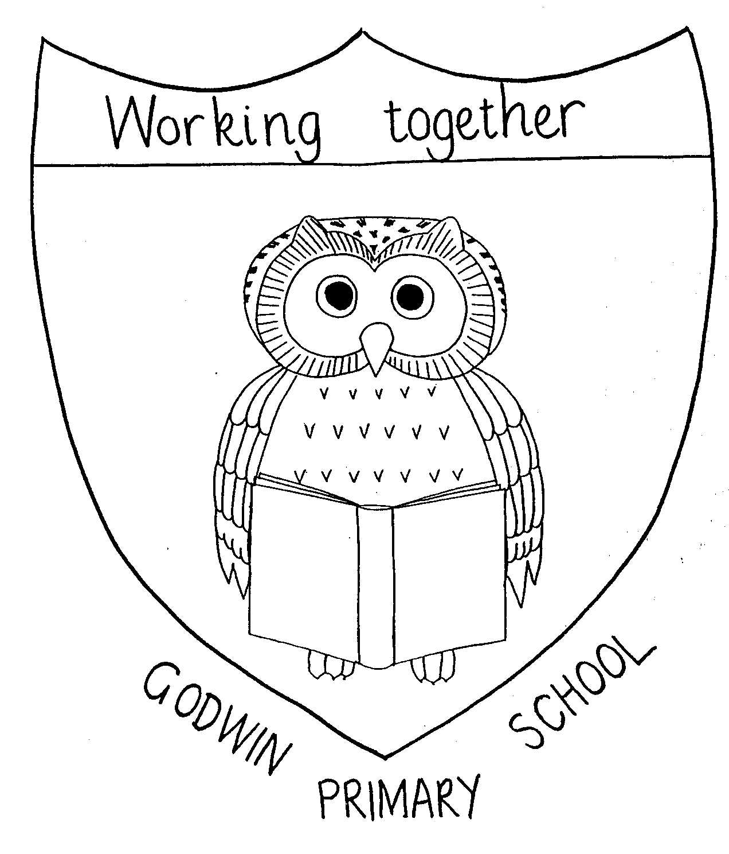
Music Overview

GODWIN PRIMARY SCHOOL

 | Nursery | Reception  Oak Academy | Year 1 | Year 2 | Year 3 | Year 4 | Year 5 | Year 6
Autumn 1 | Twinkle, twinkle little Star  Wind the Bobbin Up  Baa Baa Black Sheep  Dingle Dangle Scarecrow | How Much is that Doggy in the Window?  Harvest Leaves are Falling  Family Fingers | My Musical Heartbeat | Pulse, Rhythm and Pitch | Writing Music Down | Musical Structures | Whole class instrumental lessons - Fifes | Young Voices Musical Performance Preparation
Autumn 1 |  | Harvest Performance |  |  |  |  | Whole class instrumental lessons - Fifes | Harvest Performance
Autumn 2 | Incy Wincy Spider  Humpty Dumpty  Hey Diddle, Diddle  I Hear Thunder | Diwali Lamp  Peter Hammers  5 Little Aliens | Dance, Sing and Play | Playing in an Orchestra | Playing in a Band | Exploring Feelings when you Play | Whole class instrumental lessons - Fifes | Young Voices Musical Performance Preparation
Autumn 2 | Christmas Performance | Christmas Performance | Dance, Sing and Play | Christmas Performance | Playing in a Band | Christmas Performance | Whole class instrumental lessons - Fifes | Young Voices Musical Performance Preparation
Spring 1 | Here we go Round the Mulberry Busy  Row, Row the Boat  Down in the Jungle  Animal Fair  Hickory Dickory Dock | Miss Polly had a Dolly  5 little Fireman | Exploring Sounds | Whole class djembe drumming lessons | Compose Using Your Imagination | Compose with your Friends | Whole class instrumental lessons - Fifes | Young Voices Performance
Spring 2 | Round and Round the Garden  Mary, Mary Quite Contrary  Peas in a Pod  Peter Rabbit | Old MacDonald  Chick, Chick, Chicken  Goosey, Goosey Gander  Horsey, Horsey | Learning to Listen | Recognising Different Sounds | More Musical Styles | Feelings Through Music | Whole class instrumental lessons - Fifes
Spring 2 |  |  | Eid Performance
Summer 1 | Teddy Bear, Teddy Bear Turn Around  The Grand Old Duke of York  Number songs | Wiggly Woo  Ants Come Marching In | Having Fun with Improvisation | Exploring Improvisation | Enjoying Improvisation | Whole class General Musicianship lessons | Whole class instrumental lessons - Fifes
Summer 2 | Down at the Station  Miss Polly had a Dolly  London’s Burning  The Wheels on the Bus | Daddy’s Taking us to the Zoo Tomorrow  Number Songs | Let’s Perform Together | Our Big Concert | Opening Night | The Show Must Go On! | Whole class instrumental lessons - Fifes | Year 6 musical
Summer 2 | Whole school Celebration |  |  |  |  |  |  | Year 6 musical

