|  |
| --- |
| **Godwin Primary School**    **Handwriting Policy and Guidelines**  **March 2023** |

**GODWIN PRIMARY SCHOOL**

**Handwriting Policy and Guidelines**

|  |  |  |
| --- | --- | --- |
| **Date** | **Review date** | **Responsible Person** |
| **March 2023** | **March 2026** | **Faye Spooner** |

**Rationale**

At Godwin Primary School we believe in the importance of clear and neat presentation in order to communicate effectively. We believe that children need to practise handwriting regularly in order for handwriting skills to become embedded in long-term memory, for handwriting to become fluent and allow them to focus more on the content of the writing.

*‘Procedural memory is the ability to recall how to do something. Procedural memory is important in the classroom because once students are familiar with specific activities or skills, the process becomes automatic, therefore working memory is freed up and can instead be used to focus on the content or questions instead of how to complete a task.’*  Retrieval Practice: Primary, Kate Jones

We need the procedural memory of handwriting to be firmly embedded within long-term memory.

Alex Quigley in ‘Closing the Writing Gap’ says*:*

*‘The researchers who developed the Simple View of Writing show very clearly that handwriting remains a vital skill that is foundational to all writing development. Indeed, handwriting automacity – being able to write fluently and legibly, with little conscious thought – can prove a unique predictor for the length and quality of sentence composition for young children.’*

Pupils should be able to write legibly in both joined and printed styles with increasing fluency and speed by:

* Having a correct pencil grip (see Appendix 5)
* Knowing all letters start from the top, except d and e which start from the middle
* Forming all letters correctly
* Knowing the size of letters, relative to one another, and the orientation of letters.

**Teaching time**

Until children’s handwriting is joined legibly and they are writing fluently, handwriting practice should happen daily. This could be done in Early Bird time as part of a rota of ‘independent practice’ activities. Included in the daily practice, there should ideally be a minimum of 3 x 15 minute taught sessions weekly (to include teacher modelling). In Upper Key Stage 2, if children are already joining their writing legibly and writing fluently, the taught sessions might be an intervention for those children who need it.

**Model used**

Godwin Primary School uses the *PenPals* Handwriting scheme. However, in EYFS and Year 1, the formation of letters k and f is adapted to fit with the *Read Write Inc* phonics programme.

**Lower case letters - EYFS and Year 1:**

**Lower case letters – Years 2 to 6:**



**Capital letters (all year groups):**



**Number formation:**

**Joined writing:**

The six joins that are taught (not necessarily in this order) are:

* Diagonal joins to letters without ascenders.
* Diagonal joins to letters with ascenders.
* Diagonal joins to anti-clockwise letters.
* Horizontal joins to letters without ascenders.
* Horizontal joins to letters with ascenders.
* Horizontal joins to anti-clockwise letters.

For the order of teaching letters and joins, see Appendix 1.

The break letters (letters that are not joined from) are: **g j x y and z**

**Order of teaching**

The order of teaching is set out in Appendix 1 by the expected teaching for each year group. However, individual children within a year group may be at a different point to this (due to co-ordination issues, lack of previous experience etc.) and for these children you will need to adapt teaching for their starting points. Please speak to the Inclusion lead for more advice.

**A typical 15 minute handwriting lesson should include:**

(see Appendix 6 for planning format)

* A speedy 1-minute warm-up activity and reminder of the expectation for ‘good handwriting’.
* A quick review of the previous lesson’s handwriting focus which children practise and/or review of a pattern that supports the learning for the movement of the day.
* Teaching and modelling of the focus for this lesson (including the success criteria (based on Appendix 2) for the focus) – a letter, specific join or application of the letter/joins in words.
* Guided practice of what has just been modelled – during which the teacher should circulate – scaffolding children as necessary and giving live feedback.
* Self-assessment against the success criteria and practice of an improvement point.
* Each week should focus on one individual letter or join, with the first lesson of the week focusing on that letter or join and subsequent lessons focusing on the application of this in words – where possible linked to that year group’s spellings.

**Handwriting exercise books**

In Reception, children initially use plain A4 books, before moving on to small wide-lined ‘phonics’ books – in line with where they are in their phonics learning. RWI says that children should start to use wide-lined paper once they have learned to form the letters correctly (as soon as you begin to talk to children about ‘sun’, ‘water’ and ‘boat’ letters).

In Years 1 and 2, children continue to use phonics exercise books for practising spellings and sounds, where opportunities should be made to focus on letter formation, but will also use the back of their English books for specific handwriting practice. In Years 1 and 2, whilst children focus on letter formation, they do not need to write a learning challenge. Once children are able to write with some speed, and are beginning to join, they should write a learning challenge.

In KS2, children should practise their handwriting in the back of their English books, with learning challenges (as appropriate to the stage of development of the child).

**Handwriting seating and posture**

Class teachers should ensure that children have a chair and table at a comfortable height. Particularly tall or short children may need different tables or seats to write comfortably. If this is the case, please speak to the Headteacher or Deputy Headteacher. The room needs to be well-lit and children’s tables should be free of clutter.

When writing children need to have their:

* feet flat on the floor
* bottom at the back of the chair
* body one fist away from the table
* shoulders down and relaxed

For right-handed children, the paper should be placed to the right, slightly tilted to the left, and children should hold the paper with their left hand.

For left-handed children, the paper should be placed to the left, slightly tilted to the right, and children should hold the paper steady with their right hand.

Please note:

* Left-handers may need to use a different pen to avoid smudging on the page (See SENCO for resources)
* Left handed pupils should sit to the left of their partners
* Left-handers may need a cushion to raise them up higher than their writing (so they can see over their hand if this obstructs their work)

Widgit ‘Handwriting sheets’ should be displayed in classrooms (Appendix 4).

**Early Bird Work**

Handwriting in early bird work should focus on practising skills that have been taught in previous weeks. Children could be practising letter or join formation they have already learnt, words that they have previously practised or patterns* (these could be done on plain paper with coloured pens/pencils). Teachers should circulate and feedback as they are able, ensuring children are taking care.

* These seven basic patterns are an excellent way to reinforce many of the movements used in letter formation:

|  |  |
| --- | --- |
| Straight lines |  |
| Upward loops |  |
| Downward loops |  |
| Circles |  |
| Zig-zags |  |
| Eights |  |
| Spirals |  |

**Feedback on handwriting**

During handwriting lessons, the class teacher should circulate giving live feedback.

After a lesson, children’s work should be looked at and self-assessment should be checked. Any child’s handwriting that is not meeting a minimal standard within the lesson (or poor self-assessment) should be identified and that child should become a focus during the next lesson (they may need more practice before moving on with the rest of the class or some individual intervention).

During writing lessons, teachers should focus any feedback about children’s handwriting on the current, and previous, skills that have been developed – ensuring that there is a high expectation that children will be transferring these handwriting skills into their writing.

**Appendix 1**

**Order of teaching – Reception**

To be taught alongside phonics in the order that sounds are introduced in *Read Write* *Inc*

* m a s d t
* i n p g o
* c k u b
* f e l h r
* j v y w
* Graphical user interface, application

  Description automatically generatedz x

Mnemonics (from *Read Write Inc*) will be used to support letter formation.

Initially, children will learn to write the letters on plain paper. Once children can form letters they will then use wide-lined paper.

**Activities that support learning letter formation**

* tracing patterns
* tracing
* writing over (letters, numbers and words)
* copying under (letters, numbers and words)

**Order of teaching – Year 1**

In Year 1, children will need to have plenty of access to activities that support both their fine-motor and gross-motor development. Theses should be planned in, initially in continuous provision during transition, and then during lessons.

|  |  |
| --- | --- |
| **Suggested activities** | |
| Fine-motor activities are actions taken using the smaller muscles of the hands and wrists to perform everyday tasks. Requiring coordination between those muscles and the brain, they fall into everyday tasks from writing and typing into basic functions like scratching or holding cutlery. | Threading activities  Using tweezers  Cutting out using scissors  Play dough activities |
| Gross-motor activities are to do with the larger muscles. Activities can include any kind of physical movement, from sitting up and rolling, to opening doors. | Climbing using the Nursery outdoor classroom  Using the gym equipment in the playground  Giant mark-making – large paper and pens  Building and construction  Throwing balls  Hopscotch, dancing |

The focus of handwriting lessons in Year 1 should be about ensuring children have the correct letter formation, the correct sizing of letters relative to one another, and that they are writing on the line with clear, correctly-sized ascenders and descenders. Grouping letters into the following families will give extra hooks to reinforce the correct formation:

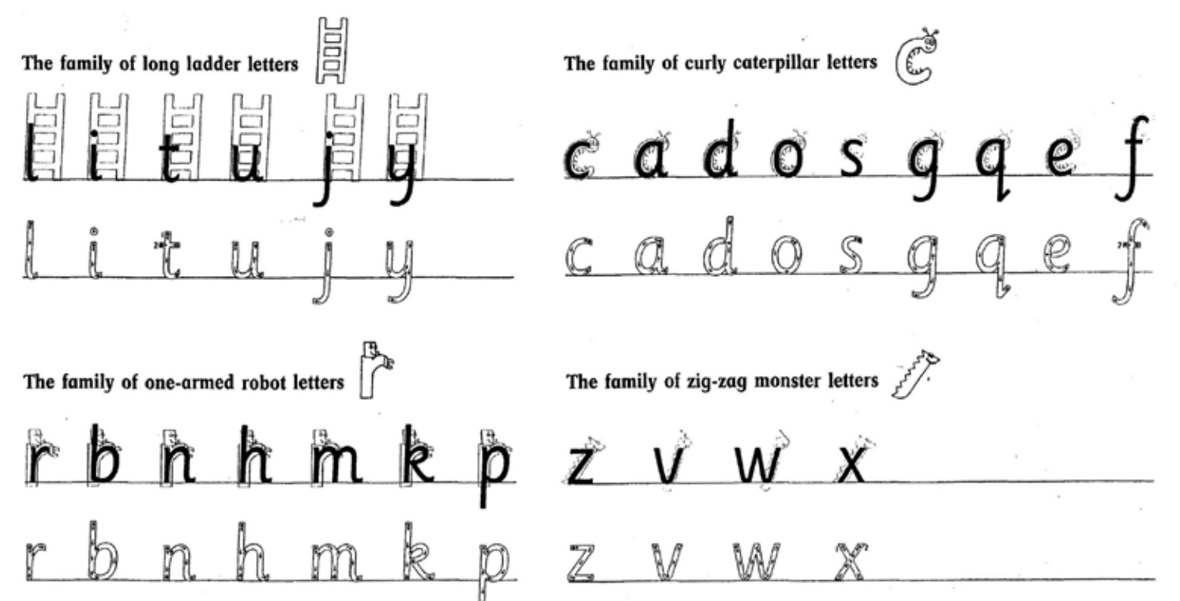

The correct formation should also be taught for capital letters and the digits 0-9 (the latter should be a focus in maths lessons).

Children should complete a baseline assessment to inform planning for the autumn term and to ensure that letter formation is the correct place to start. (Appendix 3)

|  |  |  |
| --- | --- | --- |
| **Autumn 1**  Teach formation of all capital letters  Revision of **curly caterpillar letters**  c o a d g q f e s  (most start at the top and move in an anti-clockwise direction; d starts in the middle)  Also numbers 0 6 8 9 | **Spring 1**  Revision of **one-armed robot** **letters**  r n m p h b k | **Summer 1**  Capital letters  Numbers 2 3 5 (which do not fit with any of the four letter families) |
| a, of, go, do, | by, my, no, our, pull, put, your | I |
| **Autumn 2**  Revision of **ladder letters**  l i u y t j  (all letters start at the top and move straight down)  Also numbers 1 4 | **Spring 2**  Revision **zig-zag monster** **letters** family  v w x z  Also number 7 | **Summer 2**  Capital letters |
| full, to, today, you | ar**e**, a**s**k, b**e**, com**e**, fri***e***nd, ha**s**, h**e**, hi**s**, hou**se**, i**s**, lo**ve**, m**e**, onc**e**, on**e**, pu**s**h, **s**aid, **s**ay**s**, **s**chool, **s**h**e**, **s**o, **s**om**e**, th**e**, th**e**r**e**, th**e**y, **w**a**s**, **we**, **we**r**e**, **w**h**e**r**e** |  |

**Order of teaching – Year 2**

In Year 2, children need to consolidate their letter formation.

To meet the expected standard by the end of Year 2, children need to:

* form capital letters and digits of the correct size, orientation and relationship to one another and to lower-case letters;
* use spacing between words that reflects the size of the letters.

To be greater depth they need to:

* use the diagonal and horizontal strokes needed to join some letters.

Our first priority is to ensure that all children meet the expected standard with their handwriting and that this does not create a barrier for their writing. By the end of Year 2, we want all children who are ready, to have been introduced to joining letters.

Children should complete a baseline assessment to inform planning for the autumn term (see Appendix 3).

|  |  |  |
| --- | --- | --- |
| **Autumn 1**  Revision of letter formation as appropriate to the class.  Revision of capital letters and lowercase letters and the difference between the two. | **Spring 1 – PP Y1, T2**  If appropriate, introduce diagonal join to letters with no ascender  in, im, cr, tr, dr, | **Summer 1 – PP Y1, T3**  Horizontal join to letters with no ascender  op, oy, on, om, |
|  | improve, find, kind, mind, behind, climb, any, many, again, children | only, money, move, prove, could, would, should, people, water |
| **Autumn 2**  Revision of letter formation as appropriate to the class:  at, all, th, ch, ck, cl, ak  Capital letters and lowercase letters and the difference between the two | **Spring 2 – PP Y1, T2**  Introduce diagonal join to ascender: | **Summer 2 – PP Y1, T3**  Horizontal join to letters with an ascender  ol, ot, wh, oh |
| Mr, Mrs, Christmas | child, children, class, bath, path, great, break, steak, father | old, cold, gold, hold, told  both, whole, who |

**Order of teaching – Years 3 and 4**

The focus of handwriting in Years 3 and 4 is on joining legibly and fluently.

By the end of Year 4 children need to:

* use the diagonal and horizontal strokes that are needed to join letters and understand which letters, when adjacent to one another, are best left unjoined
* increase the legibility, consistency and quality of their handwriting, for example, by ensuring that the down strokes of letters are parallel and equidistant, and that lines of writing are spaced sufficiently so that the ascenders and descenders of letters do not touch

Before embarking on teaching in the autumn term, children should complete a baseline assessment to identify starting points for teaching (see Appendix 3).

**Year 3**

|  |  |  |
| --- | --- | --- |
| **Autumn 1** | **Spring 1** | **Summer 1** |
| Revision of capital letters  Revision of diagonal joins taught in Year 2 – applying to Year 3/4 spelling list  at, all, th, ch, ck, cl, ak  in, im, cr, tr, dr, | Diagonal joins to an anti-clockwise letter  id, ig nd, ld, ng | Horizontal joins to an anticlockwise letter  oa, og, wa, wo, of, if, |
| **Autumn 2** | **Spring 2** | **Summer 2** |
| Diagonal joins to letters with no ascenders  lp, mp, ee, ai, ay, ime, ine | Revision of horizontal joins taught in Year 2 – applying to Year 3/4 spelling list  op, oy, on, om, ol, ot, wh, oh | Joining to r – diagonal and horizontal (eg:…)  Joining from r – to ascender, to letter without ascender  Joining to s – diagonal and horizontal (eg: …)  Joining from s – to ascender, to letter without ascender |

**Year 4**

|  |  |  |
| --- | --- | --- |
| **Autumn 1** | **Spring 1** | **Summer 1** |
| Revision of capital letters  Revision of diagonal joins previously taught, as identified in assessment. | Revision of horizontal joins previously taught, as identified in assessment. | Break letters and focus on formation of k  Joining ‘nn’, ‘mm’,  Joining ‘tt, ‘ll’, ‘bb’ focusing on parallel ascenders |
| **Autumn 2** | **Spring 2** | **Summer 2** |
| Revision of diagonal join from s  Joining ‘ss’  Joining ‘qu’  Diagonal joins from b and p | Revision of horizontal join from r  Joining ‘rr’  Horizontal join from ‘v’  Horizontal join from f  Joining ‘ff’ | Layout, speed and fluency practice |

**Order of teaching – Years 5 and 6**

By the end of Year 6 children need to:

maintain legibility in joined handwriting when writing at speed.

At the beginning of the each year an assessment should be done (see Appendix 3) and used to identify what needs consolidating or re-teaching from previous years.

The focus of lessons may include:

* Practising joining to and from any letters children are struggling with, paying particular attention to s, f, k which our children struggle with
* Ensuring letters are consistent in height and size
* Ensuring the ascender on the letter t is the correct height
* Practising using a diagonal or horizontal joining line
* Practising consistency in forming and joining letters
* Practising break letters
* Practising crossing double tt on completing the work
* Practising with punctuation
* Practising spacing within words
* Practising speedwriting
* Developing fluency
* Practising presentation
* Looking at different handwriting styles

**Appendix 2**

**Handwriting Success Criteria**

This should be adapted for the focus and for your year group, but all success criteria should be based around these principles.

**Appendix 3**

**Start of year assessments**

You may need to assess against previous year groups prior to your own year group (or later) depending on where children’s handwriting skills are.

**Years 1 and 2**

**Year 3**

**Year 4**

**Years 5 and 6**

**Appendix 4**

**Handwriting resources for display and use in classrooms**

Note: Each of the visuals in this section can be enlarged by clicking in the centre, then dragging out the handle in the corner

**EYFS and Year 1**

**Years 2 – 6**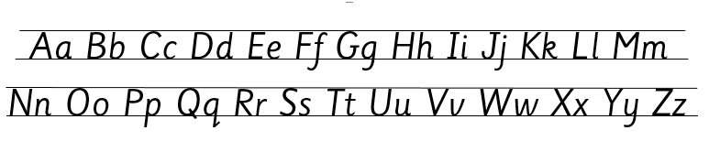

**All year groups**

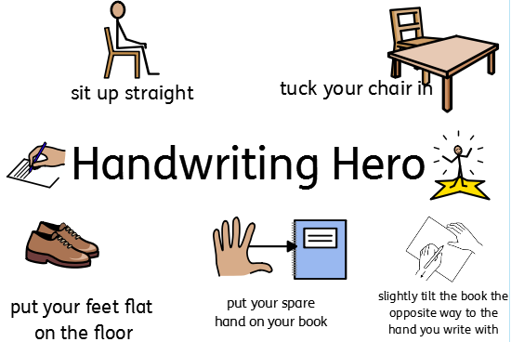

**Appendix 5**

**Pencil grip development and the development of drawing skills**

**Appendix 6**

**Lesson sequence for a week**

**HANDWRITING Year 1 teachers Date: 5-9-22**

|  |  |  |  |
| --- | --- | --- | --- |
| **Handwriting focus for week** |  |  |  |
| **Handwriting revision** |  |  |  |
|  | **Lesson 1** | **Lesson 2** | **Lesson 3** |
| **Warm up exercises (may include pattern forming)** |  |  |  |
| **Review** |  | | |
| **Teacher modelling and success criteria** |  |  |  |
| **Self-assessment** |  | | |
| **Patterns which support the formation** |  | | |
| **Children who need more support** |  | | |

**HANDWRITING Year 1 Teachers Date: 5-9-22**

|  |  |  |  |
| --- | --- | --- | --- |
| **Handwriting focus for week** | Letter ‘c’ | | |
| **Handwriting revision** | Week 1 – nothing to revise |  |  |
|  | **Lesson 1** | **Lesson 2** | **Lesson 3** |
| **Warm up exercises (may include pattern forming)** | Children could ‘make’ the letter ‘c’ first with pipe cleaners, playdough, cutting etc, | Children to rub hands, move wrists, make ‘big’ letter C’s in the air, draw them on the carpet | Flick hands, shake hands, do push-ups on the carpet, warm hands up |
| **Review** | Revise how to sit for good handwriting - feet flat on the floor, bottom at the back of the chair, body one fist away from the table, shoulders down and relaxed | | |
| **Teacher modelling and success criteria** | Letter ‘c’  Mnemonic – curl around the caterpillar  SC:   * start at the top, go round * body of c sits on the line, * letters are the same size as each other   Model the formation  Children to practise finger writing the letter on their hands (could finger write on another child’s back if they ask permission for touch)  Children to ‘air write’ – ensure they have a pencil in their hand  Talk through success criteria  Children to have a go | Model writing phonetically decodable words starting with c or high frequency words  HFW - can, cat, car  Model each one – talk to the children about the formation of ‘a’ being similar (starts the same way) as they are part of the same family.  Model one, then ask children to write a few of that word. Repeat  Add to SC:   * Space between each word is about the same size as a letter ‘c’ | Introduce the spelling word ‘come’ – explain it is a red word that they just need to learn to spell.  Talk through spelling and writing it focusing on letter formation of ‘c’ and ‘o’  Children write it a few times.  Tell children the story: I went to a party the other day and my child said to me:  ‘Can the cat come?’  Model writing sentence – focusing on c, talk about capital C being taller but the same shape so we need to be careful etc.  Add to SC:   * Capital ‘C’ nearly touches the top line * Lower case ‘c’ is half the size |
| **Self-assessment** | Make sure the focus of the self-assessment is the letter c | | |
| **Patterns which may support formation** |  | | |
| **Children needing more support** | Model in books the letter  Put arrows to show them which direction to write the letter in | | |

|  |
| --- |
| *Ratified by Governors at ______________________________ meeting*  *Signed by: ______________________________ (*Chair *of Governors) Date: _____________* |