The TOP TEN maths skills Year 1 children need to know!
1 | Read and write numbers 0 to 20 in numerals and words.  0 zero, 1 one, 2 two, 3 three, 4 four, 5 five, 6 six, 7 seven, 8 eight, 9 nine, 10 ten, 11 eleven, 12 twelve, 13 thirteen, 14 fourteen, 15 fifteen, 16 sixteen, 17 seventeen, 18 eighteen, 19 nineteen, 20 twenty. | Play matching pairs: Write all the numerals and words to 20. Cut them out, mix them up and get the children to match the numerals to the correct word.  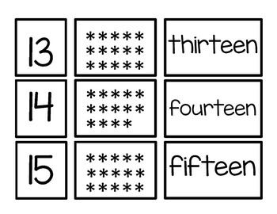  Write the correct numeral or word: Show one numeral at a time and the children have to write the correct word (then swap it around so that you show them the word and they have to write the correct numeral).  Number hunt: Hide the numbers around the house or bedroom and the children have to collect all the numbers (numerals and words) then match them correctly.
2 | Count, read and write numbers to 100.  Children do not need to know how to write the words for numbers beyond 20 but they need to make sure they have the numbers in the correct order eg. thirty four is 34 not 43 which children often write.  ‘Teen’ numbers are unusual because in fourteen for 4 is said first but is in the 1s column; | Practise writing the numbers correctly: Find different ways children can practice writing the numbers correctly eg. on a steamy mirror, building them with lego, tracing on the back of your hand or back, drawing them in the air, using chalk on a footpath, etc  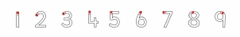  Design your own snakes and ladders game: If you have space outside and some chalk then help children make a giant snakes and ladders game or alternatively you could draw one on paper indoors. All you need are dice and counters (which you could also make). The focus is on writing the numbers correctly in the right spaces. You could make one up to 30, 40 or 50 if you prefer a smaller one.  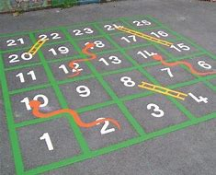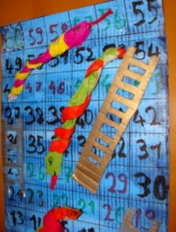  Walking number hunt: Go for a walk and see how many 2-digit numbers your children can find and read to you. Make sure they say 20-ty NOT 20-teen, 30-ty NOT 30-teen.
3 | Count forwards and backwards from any given number within 100.  Start counting from a different number each time. Practise counting forwards (counting on) and counting backwards (counting back). | Play a board game: Play the snakes and ladders game that you have made or any other board game that has dice.  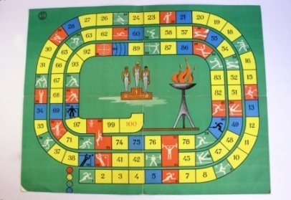  Walk forwards or backwards: If you have space outdoors or in a hallway indoors, start on an imaginary given number and pretend there is a number track. Jump forwards on the number track while counting on and jump backwards on the number track while counting back. Move forwards and backwards in different ways.  Finish the sequence: Start a sequence of numbers and get the children to write the rest of the numbers in the sequence.  31, 32, 33, 34 __, __, __ or __, __, __, __, 35, 36,37  Try missing out some numbers too!  31, __, 33, 34, __, 36, 37
4 | Identify the number that is 1 more or 1 less than a given number up to 100.  Ask the questions: What is 1 more than ...? What is 1 less than ...? How do you know? (eg. It is 1 less than ... because this number comes before...) | Draw up a table with random numbers to 100: Here is an example for you. Get them to write the number that is 1 less and 1 more for each number.  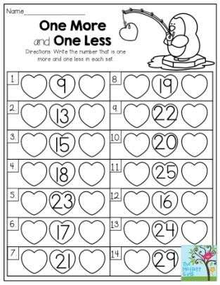  Guess my number: Give your child clues – “The number I am thinking of is 1 less than 49. What is it?” They can think of a mystery number for you to guess too.  Write the calculation: Get children to write the number calculations or design their own flashcards. See example.  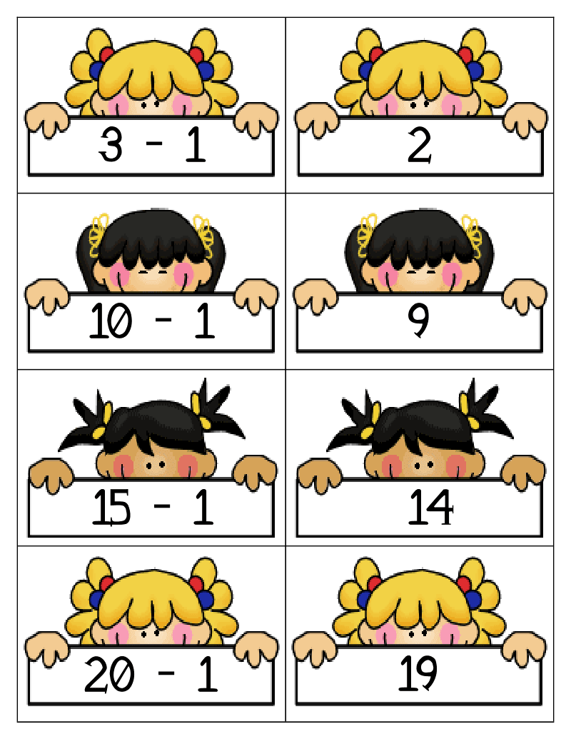
5 | Know all the number bonds to 20 and the related subtraction facts.  11 + 9 = 20  + 9 = 20  9 + 11 = 20  + 11 = 20  20 = 11 + 9  20 – 11 =  20 – 9 = | Play number bond ping pong: You could be working on number bonds for 10 or 12 not just the number bonds to 20. Pretend you are playing tennis or ping pong. Pretend to hit a number and they hit the other number back to you that makes 20 eg. You say “11” and they say “9” then you say “makes?” together say “20”.  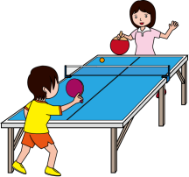  Write the addition and subtraction calculations: Find all the ways to make 20 using addition and subtraction calculations.
6 | Add and subtract 1-digit and 2-digit numbers up to 20.  16 + 2 = 18  18 – 2 = 16  9 + 9 = 18  18 – 9 = 9  12 + 4 = 16  16 – 4 = 12  8 + 8 = 16  16 – 8 = 8 | Design your own board game:  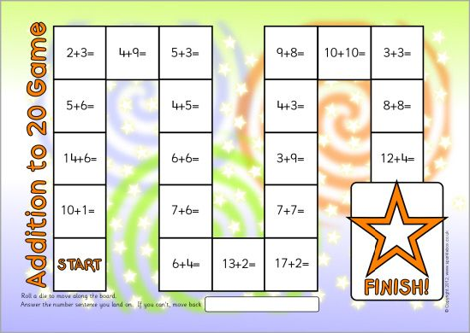  Play shops: Start by using pennies until children are confident using 5p, 10p and 20p. Set up a toy shop and get the children to write price labels but keep them within 10p. There are so many ways to play so that the children are learning to add and subtract (so they can give change – which is difficult). To start with they may choose 2 items and then add their prices together to get a total. Once they have mastered this then, as a challenge, you might want to teach them how to work out the correct amount of change. Just stick with prices under 20p.  Find the missing numbers: Write out some calculations with missing numbers which the children have to fill in.  For example: 12 + = 20
7 | Be able to double and halve numbers up to 20.  double 7 is 14 or 7 + 7 = 14  half of 14 is 7 or 14 – 7 = 7 | Play double snap: Get a pack of playing cards. Take out all the Jacks, Queens, Kings and Jokers. Split the pack into half and just like snap, each person takes a turn to place a card down until you both get the same number. The person who says snap first has to say double ___ is ___. For extra challenge, write the calculations at the end of the game.  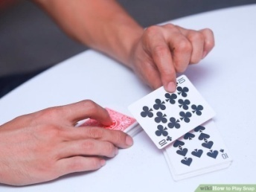  Play double/half ping pong: Same as number bond ping pong but this time children have to double the number eg. You say “double 3 is” they say “6”. Do the same for halving numbers.  Find the missing numbers: Write out some calculations with missing numbers which the children have to fill in.  For example: 8 + = 16
8 | Count in twos.  2, 4, 6, 8, 10, 12 ... 100 | Make equal groups of 2s, 5s and 10s: Use small objects around the house to make equal groups such as cutlery, hair clips, socks, etc. then count in 2s, 5s or 10s.  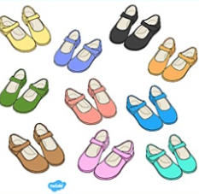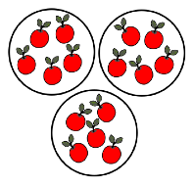  Make your own 2s, 5s and 10s numberlines: Here is an example below. Then count forwards and backwards.  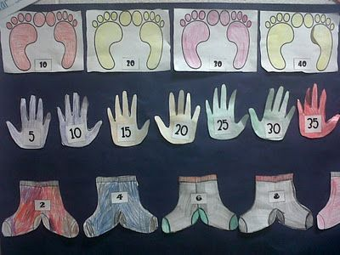  Finish the sequence: Start a sequence of numbers and get your children to finish it.  5,10,15,20,__, __,__
9 | Count in fives.  5, 10, 15, 20 ... 100
10 | Count in tens.  10, 20, 30, 40 ... 100
Online resources to support with learning at home:
Numberblocks
Website: https://www.bbc.co.uk/cbeebies/grownups/help-your-child-with-maths
Key stages: early years foundation stage and key stage 1
Description: videos for numeracy development designed for children aged 0 to 6. There are fun activities that can be applied to everyday life and play.
Registration: not required

TTRockstars/Numbots
Website: https://play.ttrockstars.com/auth/school/student/32939
https://play.numbots.com/#/account/school-login/32939
Key stages: early years foundation stage to key stage 2
Description: Drill-and-skill early number (numbots) and times table (TTR) apps.
Registration: Login’s handed out – please note login for TTR is the same for Numbots.
Also refer to extra online resources attached.

