The TOP TEN maths skills Year 4 children need to know!
1 | Place Value and Number  Can your child recognise the value of each digit in a 4-digit number? Can they recognise the number of thousands, hundreds, tens and ones in any 4-digit number? For example, 1358 = 1 thousand, 3 hundreds, 5 tens and 8 ones = 1000, 300, 50, 8. Can your child then use this information to put 4-digit numbers in order of size? | Play ’Largest Number’ Card Game:  Using a deck of playing cards (or make your own!) 4 cards are dealt out to each player.  Players arrange their 4 cards to make the largest possible number they can e.g. with cards 2, 5, 1 and 8 a player would make 8521.  The player with the largest number in each round keeps the cards they were dealt. Everyone else puts their cards back in the pack.  The game ends when there are not enough cards to deal out. The winner is the player who has collected the most cards.  Place Value Toss  Set out 4 baskets/buckets/boxes at least 2 metres away from where you are planning on throwing the objects. Line the tubs up vertically.  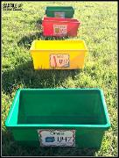  <- Thousands  <- Hundreds  <- Tens  <- Ones  Stand on a marked spot and throw 10 bean-bags/teddies/objects into the tubs.  The number of bean bags in each tub represents the value for that number.  Write the number down – the player with the largest/smallest/largest even number/largest odd number/multiple of 5 etc… (the possibilities are endless!) is the winner.
2 | Read Roman Numerals to 100  Can your child read and interpret Roman numerals up to 100, understanding how the order of the numerals can change the number, such as IV is 4 and VI is 6? | Roman Numeral Hopscotch!  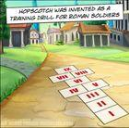  Back in the day, Roman soldiers were required to play the game as a training drill. They had to ‘play’ in ‘full kit’ i.e. wearing their full armour, spear, sword, shield & helmet. Luckily, you won’t need to do this!
3 | Count in Multiples of 6, 7, 9, 25 and 1000  Can your child count in multiples of 6, 7, 9, 25 and 1000? If given a number, can they add/subtract the different range of multiples? | Skip Counting with Calculators E.g. Type “6+6=” into a calculator and record the result. Then continue to type “+6=” and record the sequence that they generate.  Walk forwards or backwards: If you have space outdoors, or in a hallway indoors, start on an imaginary given number and pretend there is a number track. Jump forwards on the number track while counting on; jump backwards on the number track while counting back. Move forwards and backwards in different ways. E.g. each jump forward could be ‘count on 7’.  Finish the sequence: Start a sequence of numbers and get the children to write the rest of the numbers in the sequence.  6, 12, 18, __, __, __, __ or __, __, __, __, 90, 99, 108 or 25, 50, 75, 100, ___ , ___  Try missing out some numbers too!  1000, __, 3000, __, 5000
4 | Multiplication and Division  By the end of Year 4 your child should know all of the times tables facts up to 12 × 12. They should be able to recall times tables facts by heart, such as 4 × 8 = 32, and also identify the inverse division facts too. For example, if they know that 4 × 8 = 32, then they should know that 32 ÷ 8 = 4 and 32 ÷ 4 = 8. | Play ‘Multiplication Quick Draw’:  Using a deck of playing cards (or make your own!) all the cards are dealt out to the players.  One player calls, ‘Draw’ and both players turn over their top card and place it face up in the centre.  The players multiply the two numbers together and the first player to call out the product wins the two cards.  After all cards have been used, the players count the number of cards that they have won. The winner is the person who has the most cards.  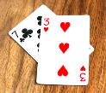 In this example, 7 x 3 = 21  Write the calculation: Get children to write the multiplication facts or design their own flashcards. See example.  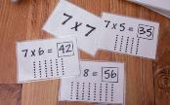
5 | Round Any Number to the nearest 10, 100 or 1000  Can your child round numbers using their knowledge of place value? For example, if you were to round the number 5762 to the nearest hundred, it would be 5800 (we round up because the digit in the tens column is 5 and over).  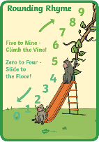 | Play rounding tennis: Pretend you are playing tennis. Player one serves a number, player two works out if it rounds up or down, then player one has to round it. This then swaps around: eg. In this game we are rounding to the nearest 10. You say “251” and they say “down” you say “250”; then they say a number “567” you say “up” then they say “570”. The rally ends when someone makes a mistake or hesitates. You could even score it like regular tennis and host your own rounding Wimbledon!    Play ‘Roll It’:  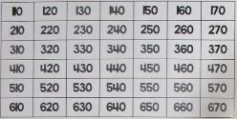  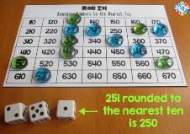  Copy out the grid above. Roll 3 dice. Make a 3 digit number. Round this 3 digit number to the nearest 10 following the rhyme. If the number is available on the grid colour it in! If it isn’t you lose that turn. The game ends when the grid is complete.
6 | Addition and Subtraction  Your child should develop their ability to use mental calculation to add and subtract numbers such as a 3-digit number and a 1-digit number. For example, 126 + 8 = 134  Can your child use the formal, written column method to add and subtract numbers with up to 4 digits? This includes using regrouping (sometimes called ‘carrying ‘in the past) and exchanging (which was sometimes called ‘borrowing’ in the past). | Mental Addition  Copy this grid:  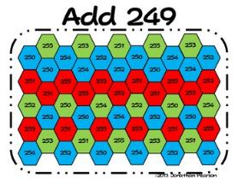  Each game uses a six-sided die (or number cards 1-6). The first player will roll the die to get a number then quickly add the number listed at the top of the game board to the number on the cube. On the game board, place a marker over one of the spaces containing that answer. The second player will repeat these steps. The purpose of the game is to get five spaces covered in a row (vertically ↕, horizontally ↔, or diagonally ↖↗). You may try to win as fast as possible or you may work to block your partner from winning. The game play gives opportunity for strategy along with addition skills.  Have fun experimenting with your own version, changing the number you start with! What else has to change if 249 changes? What about inventing a version for subtraction?  Card Addition  Use a deck of cards to generate two 3-digit numbers. Then add them together! The player with the highest total wins the round.
7 | Count in Tenths and Hundredths  Can your child count in both tenths and hundredths and understands that tenths arise when we divide an object into ten equal parts, or that hundredths arise when divided into a hundred equal parts? Also, that we divide a number by 10 and 100 to find tenths and hundredths. | Skip Counting with Calculators  E.g. Type “0.1+0.1=” into a calculator and record the result. Then continue to type “+0.1=” and record the sequence that they generate.  Walk forwards or backwards: If you have space outdoors, or in a hallway indoors, start on an imaginary given number and pretend there is a number track. Jump forwards on the number track while counting on in tenths and jump backwards on the number track while counting back in tenths. Move forwards and backwards in different ways.  Finish the sequence: Start a sequence of numbers and get the children to write the rest of the numbers in the sequence.  0.1, 0.2, 0.3, __, __, __, __ or __, __, __, __, 0.76, 0.77, 0.78  Try missing out some numbers too!  1.4, __, 1.6, __, 1.8
8 | Multiply and Divide Using Formal Written Methods  Can your child use their knowledge of multiplication and times tables to complete multiplication mentally? This includes using factor pairs and understanding commutativity (2x3 is the same as 3x2) in calculations. Can they also multiply 2-digit and 3-digit numbers by a 1-digit number using a formal, written layout? | 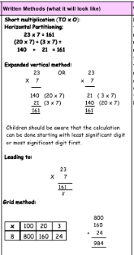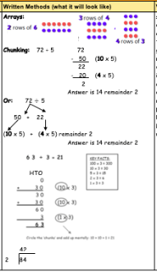
9 | Money  Does your child know how many pence make a pound? Can they use money in context to solve problems, such as adding and subtracting amounts and calculating change? | Play shops: Create some play money! Make enough 1p, 2p, 5p, 10p, 20p, 50p, £1,and £2 coins to open a shop! Set up a toy shop and get the children to write price labels. There are so many ways to play so that the children are learning to add and subtract (so they can give change). To start with they may choose 2 items and then add their prices together to get a total. Once they have mastered this then you might want to teach them how to work out the correct amount of change.  Exact Money  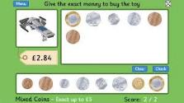  Set up scenarios where the children must give you the exact money to buy an item from the shop – using various coins. Add a challenge by removing certain coins e.g. no 50ps allowed.
10 | Time  Can your child read the time on an analogue clock with increasing accuracy, to the nearest minute? Do they know the number of seconds in a minute, minutes in an hour and hours in a day? Can your child convert the time between 12-hour and 24-hour clocks as well as between analogue clocks and digital clocks? For example, can they convert half past one p.m on an analogue clock, to 13:30 on a digital, 24-hour clock and vice versa? | What’s the time Mr. Wolf?  A classic! Decide who will be Mr. Wolf, and that person stands at one end with their back to everyone else.  The other children stand at the opposite end and shout "What's the time Mr. Wolf?"  Mr. Wolf answers with different times - "one o'clock" or "eight o'clock" for instance.  The players that number of steps toward Mr. Wolf - eight steps for eight o'clock, and so on. Then ask again, "What's the time Mr. Wolf?" and take the right number of steps again, always getting closer to Mr. Wolf.  When Mr. Wolf feels like it, he (or she) answers "dinnertime" and starts chasing the other children.  The first to be caught becomes the next Mr. Wolf.  Stop the clock:  Using a stopwatch, who can stop the clock closest to 30 seconds (or other given time). Can anyone get it exactly right?  Mr Newbert’s best attempt:    At various points of the day stop and say:  What time is it now?  What is the time in the 24-hour format?  What time will it be in 20 minutes?  Doing this will build up a sense of time passing and allow the children to calculate with time.
Online resources to support with learning at home:
Nrich
Website: https://nrich.maths.org/
Key stages: early years foundation stage to key stage 2
Description: a range of activities. Some are interactive and some are to be completed offline. Activities are categorised by age range.
Registration: not required

TTRockstars/Numbots
Website: https://play.ttrockstars.com/auth/school/student/32939
https://play.numbots.com/#/account/school-login/32939
Key stages: early years foundation stage to key stage 2
Description: Drill-and-skill early number (numbots) and times table (TTR) apps.
Registration: Login’s handed out – please note login for TTR is the same for Numbots.
BBC Bitesize Daily Lessons
Website: https://www.bbc.co.uk/bitesize/dailylessons
Key stages: key stage 1 and key stage 2
Description: You'll find daily lessons for homeschooling in Maths and English for every year group, as well as regular lessons in Science, History, Geography and more. – Aligned with Power Maths and White Rose
Registration: not required

Also refer to extra online resources attached.

