The TOP TEN maths skills Year 2 children need to know!
1 | Count in steps of 2, 3, and 5 from 0, and in tens from any number forward and backward  0,2,4,6,8,10,12,14,16,18,20  20,18,16,14,12,10,8,6,4,2,0  0,3,6,9,12,15,18,21,24,27,30  30,27,24,21,18,15,12,9,6,3,0  0,5,10,15,20,25,30,35,40,45,50,55,  60,65,70,75,80,85,90,95,100  100,95,90,85,80,75,70,65,60,55,50,  45,40,35,30,25,20,15,10,5,0 | 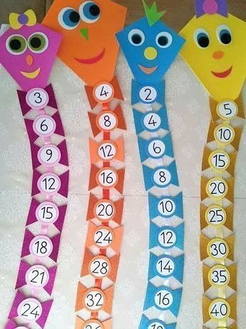Design your own kites:  Here is a simple example of some kites that you can make that can be adapted to counting in different multiples, forwards and backwards. Here I used different colours and wrote each number counting up in multiples of 2, 3 5 and 10 – you can try to make then counting backwards.  Hanger numbers: Below I have used a hanger and some pegs on which I have written the multiples of 5. I can see the number increasing in value and they can easily be removed and swapped to count backwards.  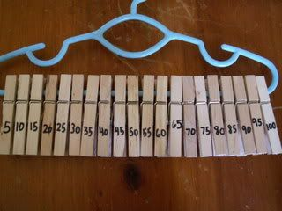  Stair counting: When walking up or down the stairs count in a multiple of 2, 3 or 5 either forwards or backwards. This will help children to become more fluent with counting in multiples and is something that can be easily at home or when out on a walk.
2 | Recognise the value of each digit in a two-digit number (tens, ones)  35 | Box/Brick partitioning: To the left I have shown an example for the number 35 and how it is made up from 3 tens and 5 ones. For this activity you can use either a box or some building blocks.  Below I have used building blocks to show the same number. You can use a piece of cardboard and draw and line down the middle – to the left label Tens and to the right Ones. You can use counters, pencils, marbles, sweets to show many tens and ones there are in a number. Get a family member to see if they can guess the number.  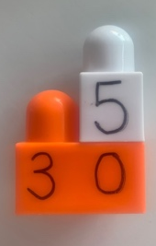  Alternatively, you can do this outside if you have chalk. Draw a partition box and partition a number get a family member to guess the number and say how many tens/ones there are.
  Tens | Ones
  3 | 5
3 | Compare and order numbers from 0 up to 100; use <, > and = signs  < less than  > greater than  = equal  3<6 (3 is less than 6)  6>3 (6 is more than 3)  5+2 = 2+5 (equal)  6+3> 3+2 (6 +3 is more than 3+2) | Card compare: You can play this alone or with a partner. You will need a deck of cards – for this I used ‘UNO’ cards, but any number cards are fine, if you haven’t any you could make some. REMEMBER: take out the Kings, Queens, and Jacks if you are using a deck of cards. You will need 3 cups – 1 labelled with ‘we are equal’, another with ‘I am greater’ and the final with one with ‘I am less’. Turn the cards over so you can see them. One person chooses the first card, player 2 will choose the next card and decide where it needs to go. Is it equal, greater than or less than the previous number player 1 pulled out?  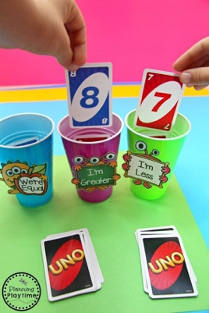  Who has more?  For this game you will need 2 players, 2 bowls and some objects. Hand out some of the objects to player 1 and player 2. Decide who has more or less or are they equal.
4 | Read and write numbers to at least 100 in numerals and in words  Children need to know how to write numbers to 100 in words and using numerals. They need to know that digits have to be in the correct order e.g. thirty-four is 34 not 43 which children often write.  ‘Teen’ numbers are unusual because in ‘fourteen’ the 4 is said first but is in the 1s column. | 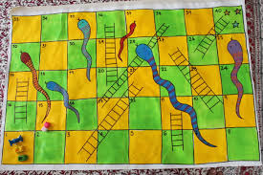  Design your own snakes and ladders game: If you have space outside and some chalk then help children make a giant snakes and ladders game or alternatively you could draw one on paper indoors. All you need are dice and counters (which you could also make). The focus is on writing the numbers correctly in the right spaces. You could make one up to 30, 40 or 50 if you prefer a smaller one.  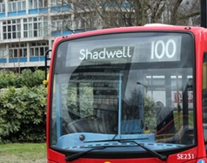  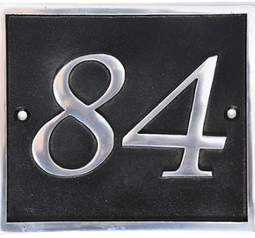  Walking number hunt: Go for a walk and see how many 2-digit numbers your children can find and read to you. Make sure they say 20-ty NOT 20-teen, 30-ty NOT 30-teen. These can be spotted on buses, door numbers, signs and also shops.
5 | Solve problems with addition and subtraction  Your child should be able solve calculations involving 2 numbers for both addition and subtraction. They should know that for addition calculations the numbers being added can be in any order but, at thus stage, for subtraction calculations they start with the greatest value and take the smaller value away. (When they are older they have to subtract a larger number from a smaller one e.g. 3 – 7 = -4 and then work with negative numbers). | Design your own board game: Below is a simple example which could be adapted for numbers to 100. You can make your own rules up but make sure it involves solving addition/subtraction calculations.  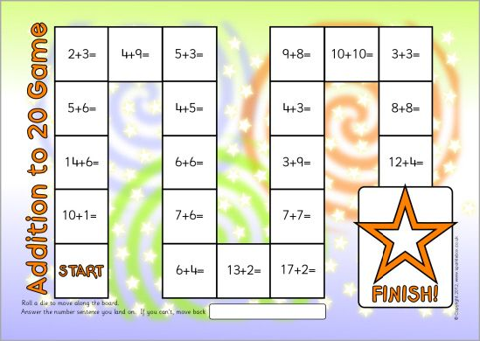  Jenga: Set up Jenga blocks with addition and subtraction calculations (using one-digit and two-digit numbers to 100) written on them. Each player has to say the answer to the calculation before they remove the piece.  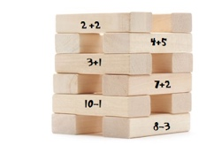  How much…?: Ask: How much change should I get if I start with 10p and spend 3p? How much do I need to pay if a bar of chocolate costs 45p and a packet of crisps costs 15p?
6 | Recall and use addition and subtraction facts to 20 fluently, and derive and use related facts to 100  If 2 + 3 = 5 then we know that 5 – 3 = 2 and that  20 + 30 = 50 and  50 – 30 = 20 without the need to work it out. | Play bingo: Start with a grid that has 16 boxes on it (4 columns, 4 rows). In each box write a multiple of 10 below 100 (10, 20, 30, 40, 50, 60, 70, 80, 90). For each person that plays provide them with a different set of numbers. Call out an addition or subtraction fact to 20 which each player has to use to find the addition or subtraction fact to 100 e.g. 5 + 3 = 8, the children need to work out 50 + 30 = 80. They then highlight the number (if they have it) on their grid. The person who gets a line of 4 (across, down or diagonally on the grid wins) or the player with the most numbers highlighted wins.  Matching pairs: Make two sets of 10 cards. On one set, write addition and subtraction facts to 20. On the other, write the corresponding facts to 100. Put both sets together, shuffle them and place them face down in rows of 5. Each player has to choose 2 cards. If the facts relate, then they get to keep the cards, if not the cards are replaced face down. The player with the most cards wins.  “If you know…”: Say: If you know that 10 – 3 = 7 what else do you know? Children will then write all of the facts that relate to 10 – 3 = 7, e.g. 10 – 7 = 3; 3 + 7 = 10; 7 + 3 = 10; 100 – 30 = 70; 100 – 70 = 30; 30 + 70 = 100; and 70 + 30 = 100.
7 | Add and subtract numbers using concrete objects, pictorial representations and mentally  Your child should be able to choose an efficient strategy to solve calculations and know when it is appropriate to use each strategy. | Solving addition and subtraction using concrete objects: Using any resources that are accessible (stones, pasta, Lego pieces, beads etc.) solve addition and subtraction calculations for numbers below 25.  Card addition or subtraction: Use a deck of cards (or make your own) to generate two 2-digit numbers. Then add them together. The player with the highest total wins the round. This could be used for subtraction also. This time the player with the lowest value wins the round.  Popcorn maths: Write a range of numbers (to 100) on small, individual pieces of paper and the + and – signs on a different coloured paper (have a few each of the signs). Scrunch these up to look like popcorn and place inside a ‘popcorn holder’. Get your child to choose 2 number slips and one sign slip from the holder. They then create an addition or subtraction calculation which they solve mentally by counting on or back. For example, for 29 – 14 =, first count back 10 from 29 to give 19. Then count back 4 from 19 to give 15.
8 | Recall and use multiplication and division facts for 2, 5 and 10 times tables, including recognising odd and even numbers  By the end of year 2 your child should know the 2, 5, and 10 times tables. They should be able to recall times tables facts by heart such as 6 x 5 = 30, and also identify the inverse division facts. For example, if they know that 6 x 5 = 30, then they should know that 30 ÷ 6 = 5 and 30 ÷ 5 = 6. | Play ‘Multiplication Quick Draw’: Make a set of flashcards with calculations for either the 2, 5 or 10 times tables written on them. Face the deck of cards down. Players take turns to reveal the calcuation on the top. The player that solves the calcuation and says whether the answer is odd or even first wins the round.  Triangular multiplication and division: Get your child to make triangular cards (see below) with multiplication and division facts. Then get them to write 2 multiplication and 2 division facts using the same numbers. The value at the top is the greatest and those at the bottom are the lesser values. Starting at the top, your child should be able to generate 2 division calcuations. By starting at the bottom they should be able to generate 2 times calculations.  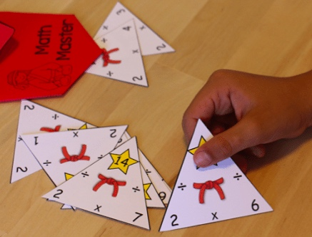  For this triangle, it shows 6 x 2 = 12, 2 x 6 = 12, 12 ÷ 6 = 2, 12 ÷ 2 = =6;  6 x 2  12  ÷ ÷  Beat the timer: Provide a range of multiplication and division calcuations. Set a timer and get your child to complete them within the allocated time. To challenge them further get them to solve the same calcuations but at a quicker speed.
9 | Solve problems involving multiplication and division using materials, arrays, repeated addition, mental methods and multiplication and division facts, including problems in contexts  Your child should be able to solve multiplication and division calculations using a range of strategies. | Play matching pairs: Write a range of multiplication calcualtions and draw the corresponding arrays (see below). Get your child to match each calculation to the correct array.  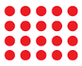  4 x 5 = 20  Repeated addition: Using groups of objects (3 groups of 5 stones) get your child to write the repeated addition calculation and the corresponding multiplication calculation. For example, 5 + 5 + 5 = 15 and 3 x 5 = 15.  What’s the question? Give your child a range of answers. Get them to write either a multiplication or division calculation to match the answer.
10 | Recognise, find, name and write fractions 1/3, 1/4, 2/4 and 3/4 of a length, shape, set of objects or quantity | 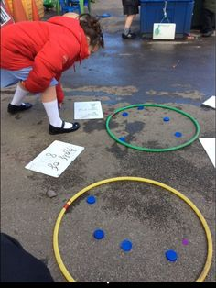  What is half? For this game you will need 2-4 hoops – if you don’t have hoops you can draw large circle on paper or in the garden using chalk. Choose a number, I chose number 8 here on the left. I counted out 8 bears and then split them into 2 equal groups. This allowed me to see that when 8 was split in half there were 4 in each group, therefore, half of 8 is 4. Then I used a whiteboard or paper to write this. To share objects equally into thirds and quarters you need more circles (three for thirds and four for quarters).  You can also use everyday objects to find different fractions of a shape. Here is an example of an apple that has been cut up first into halves, thirds then quarters. This is also fun to do with pizzas.  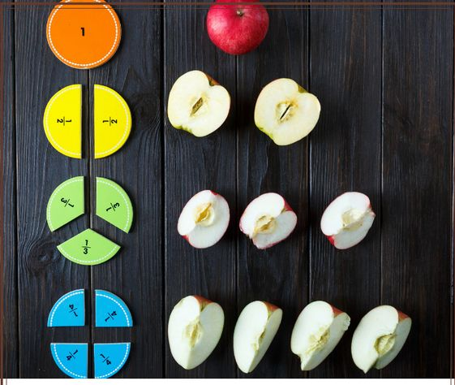  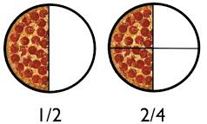
Online resources to support with learning at home:
Numberblocks
Website: https://www.bbc.co.uk/cbeebies/grownups/help-your-child-with-maths
Key stages: early years foundation stage and key stage 1
Description: videos for numeracy development designed for children aged 0 to 6. There are fun activities that can be applied to everyday life and play.
Registration: not required

TTRockstars/Numbots
Website: https://play.ttrockstars.com/auth/school/student/32939
https://play.numbots.com/#/account/school-login/32939
Key stages: early years foundation stage to key stage 2
Description: Drill-and-skill early number (Numbots) and times table (TTR) apps.
Registration: Login’s handed out – please note login for TTR is the same for Numbots.

