The TOP TEN maths skills Year 3 children need to know!
1 | Place Value and Number  Can your child recognise the place value of each digit in a three-digit number (hundreds, tens, ones)?  Children should count in ones, tens and hundreds, so that they become fluent in the order and place value of numbers to 1000 using a variety of representations.  By the end of Year 3, children should be able to use larger numbers to at least 1000, applying place value using varied problems, building on work from Year 2 (for example, 146 = 100 + 40 and 6, 146 = 130 + 16) | Make Sentence Strips:  Write a range of three-digit numbers on paper. Have your child identify the hundreds, tens and ones and then the value of each digit by writing it in expanded form. This will help them understand the place value of each digit.  See example:  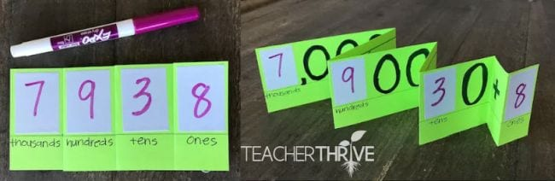  Make it Practical!  Gather lolly sticks, straws or anything you can bundle in 10s to create a practical activity for your child. Bundle many groups of ten and have 10 single objects. Next, call out random 2 and 3-digit numbers for your child to make (see example).  Make it more challenging by trying to re-create the number in a different way.  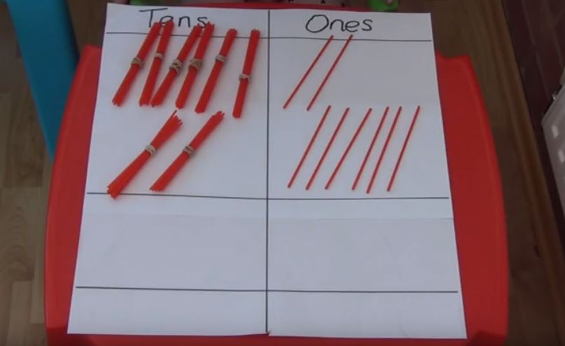
2 | Read and write numbers up to 1000 in numerals and words  Can children read numbers to 1000 in numerals?  Can children read numbers to 1000 in words? | Things to remember:  - When writing numbers between 21 and 99 we use a hyphen, like fifty-seven.  - We don’t write the ‘zero’ unless 0 is by itself.  - A number in the hundreds only has three digits!  The ‘slow motion’ game!  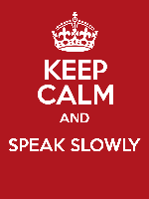  Choose a 3-digit number and say it very s-l-o-w-l-y. Then write it down! If playing with a family member, the other person could shout ‘freeze’ after each part of the number. For example, “four hundred (freeze) and fifty (freeze) nine (freeze)”. This game allows you to clearly hear each part of the number!
3 | Count in Multiples of 4, 8, 50 and 100  Can your child count in multiples of 4, 8, 50 and 100? If given a number, can they add/subtract the range of multiples? |   Skip Counting with Calculators  E.g. Type “4+4=” into a calculator and record the result. Then they continue to type “+4=” and record the sequence that they generate.  Walk forwards or backwards: If you have space outdoors or in a hallway indoors, start on an imaginary given number and pretend there is a number track. Jump forwards on the number track while counting on and jump backwards on the number track while counting back. Move forwards and backwards in different ways.  Finish the sequence: Start a sequence of numbers and get the children to write the rest of the numbers in the sequence.  24, 32, 40, __, __, __, __ or __, __, __, __, 150, 200, 250  Try missing out some numbers too!  100, __, 300, __, 500
4 | Multiplication and Division  Can your child recall and use multiplication and division facts for the 3, 4 and 8 times tables? They should be able to recall times tables facts, such as 4 x 8 = 32  If children know that 4 × 8 = 32, then they should also know that 8 x 4 = 32, 32 ÷ 8 = 4 and 32 ÷ 4 = 8. This is called the commutative law. | Get Outside  Have your child go outside and write the four facts for each multiplication table in chalk on a footpath.  For example: 4 x 8 = 32, 8 x 4 = 32, 32 ÷ 4 = 8 and 32 ÷ 8 = 4.  See example:  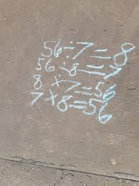  Write the calculation: Get children to write the multiplication facts and/ or design their own flashcards. See example:  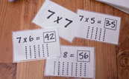
5 | Money  Children need to be able to add and subtract amounts of money using both pounds (£) and pence (p). | Play ‘shops’!  Use real money or create your own. Either print coins or draw different sized circles – get the children involved in making the money too, discussing the colour, size and shape of the different coins.  Once you’ve got enough money, set up a shop!  Work together with your child to decide what to sell, gather the products and get the children to write the price labels.  Take it in turns to play the ‘customer’ – buying items - and the ‘shopkeeper’ – giving relevant change.  Differentiate!  Make the game more/ less challenging though the complexity of the prices and the number of objects the children must buy.  Once the children are able to use the correct money to buy 1 item, they can move on to buying two or three at a time. They must then add the prices together to get a total before paying.  Set challenges!  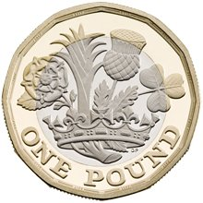  Give children a set amount of money, for example £1, and set a problem:  - What could you buy with that amount?  - Could you afford to buy anything else?  - What’s the maximum number of items you could buy?  - Can you spend entire amount? How?  - What could you buy in order to get 10p change?  - If your change is 45p, what item did you buy?
6 | Addition and Subtraction  Can your child add and subtract numbers mentally, including: a three-digit number and ones, a three-digit number and tens and a three-digit number and hundreds?  By the end of Year 3, pupils will need to add and subtract numbers with up to three digits, using formal written methods of column addition and subtraction. | Adding and Subtracting:  Choose two 3-digit numbers and practise the formal written method of column addition and subtraction. Ensure the numbers are lined up properly and begin with the right side in the ones column. 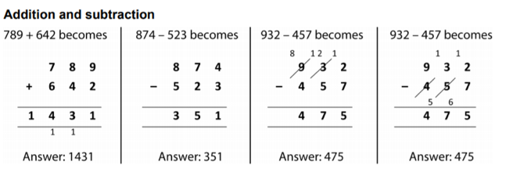  Try it with playing cards!  Complete the formal written method but make it more fun! Use a deck of playing cards to choose six cards, line them up and use the numbers on the cards as your two 3-digit numbers.  See example:  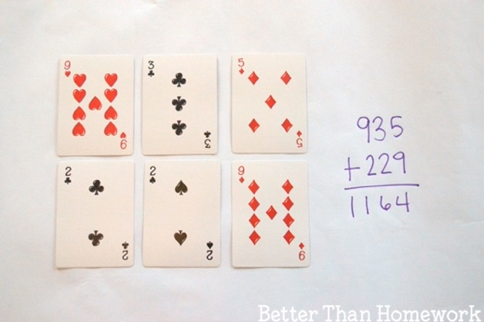
7 | Angles and turns  Children must be able to identify right angles, recognise that one right angle is equivalent to a quarter turn, two right angles are equivalent to a half turn, three are equivalent to a three quarter turn and four a complete turn.  They must also be able to identify whether angles are greater than or less than a right angle. | Make an Angle Eater!  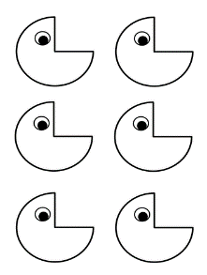  Discuss with your child what a right angle/ 90-degree angle is – what shapes have right angles? Can you draw/ find any?  Create a Pac-Man angle eater. Children use their angle eater to find right angles around the house. Can children find any acute or obtuse angles?  Acute: An angle less than 90 degrees  Obtuse: An angle greater than 90 degrees  Make a treasure hunt!  Hide an item in the house or garden.  Use the language ‘quarter turn’, ‘half turn’, and ‘full turn’ to write clues.  Children write/ follow instructions e.g. Make a full turn and take 4 steps forwards, make a quarter turn right and walk forward 5 steps, make a quarter turn left and take two steps forward etc.  Make a map!  Children can use squared paper or draw a grid on plain paper and create their own maps. They can then write a set of instructions to accompany their map for somebody to follow. Use a counter or other small object to follow the instructions. Do you end up at the treasure? e.g. Move 4 squares forwards, make a quarter turn left, move 2 squares forwards, make a quarter turn right etc.
8 | Telling the Time  By the end of Year 3, children must be able to tell the time, to the nearest minute, on a digital and analogue clock with increasing accuracy. They must also be able to solve problems involving time e.g. ‘James finishes school at 3:30. He has his dinner 40 minutes later. What time does he have dinner?’ | Get children to practise telling the time on different clocks around the house.  Ask questions throughout the day based on everyday activities:  - What is the time now?  - Dinner will be ready in 30 minutes, what time will it be then?  - Bedtime is at 7:30 PM, how long do you have left to play?  - You can play on your tablet for an hour, what time do you need to stop?  - The recipe says, ‘bake for 45 minutes’, what time do we need to take the cake out of the oven?  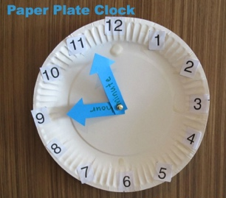  Make a clock!  You will need:  - a paper plate for the clock face,  - numbers 1 – 12 written on/stuck onto the clock face  - a minute and hour hand made from paper  - a split pin or blue tack to hold the hands in place  Get your child to practise making and reading times.  Use an online, interactive teaching clock to test your child’s understanding. One example can be found at:  https://www.topmarks.co.uk/time/teaching-clock
9 | Multiplication and Division  Write and calculate mathematical statements for multiplication and division using the multiplication tables that they know, including for two-digit numbers multiplied by one-digit numbers, using mental methods and progressing to formal written methods. | Grid Method: Formal Method:
10 | Fractions  Children must be able to add and subtract fractions with the same denominator within one whole. For example, $\frac{1}{7}$ + $\frac{3}{7}$ = $\frac{4}{7}$ | Drawing fractions  Using pictorial representations for adding fractions can be useful (see example). Eating fractions!  If you can, make it practical!  Make a cake or a pizza and have a go at adding fractions to your plate. Educational and delicious!
Online resources to support with learning at home:
Nrich
Website: https://nrich.maths.org/
Key stages: early years foundation stage to key stage 2
Description: a range of activities. Some are interactive and some are to be completed offline. Activities are categorised by age range.
Registration: not required
TTRockstars/Numbots
Website: https://play.ttrockstars.com/auth/school/student/32939
https://play.numbots.com/#/account/school-login/32939
Key stages: early years foundation stage to key stage 2
Description: Drill-and-skill early number (numbots) and times table (TTR) apps.
Registration: Login’s handed out – please note login for TTR is the same for Numbots.
BBC Bitesize Daily Lessons
Website: https://www.bbc.co.uk/bitesize/dailylessons
Key stages: key stage 1 and key stage 2
Description: You'll find daily lessons for homeschooling in Maths and English for every year group, as well as regular lessons in Science, History, Geography and more. – Aligned with Power Maths and White Rose
Registration: not required
Also refer to extra online resources attached.

