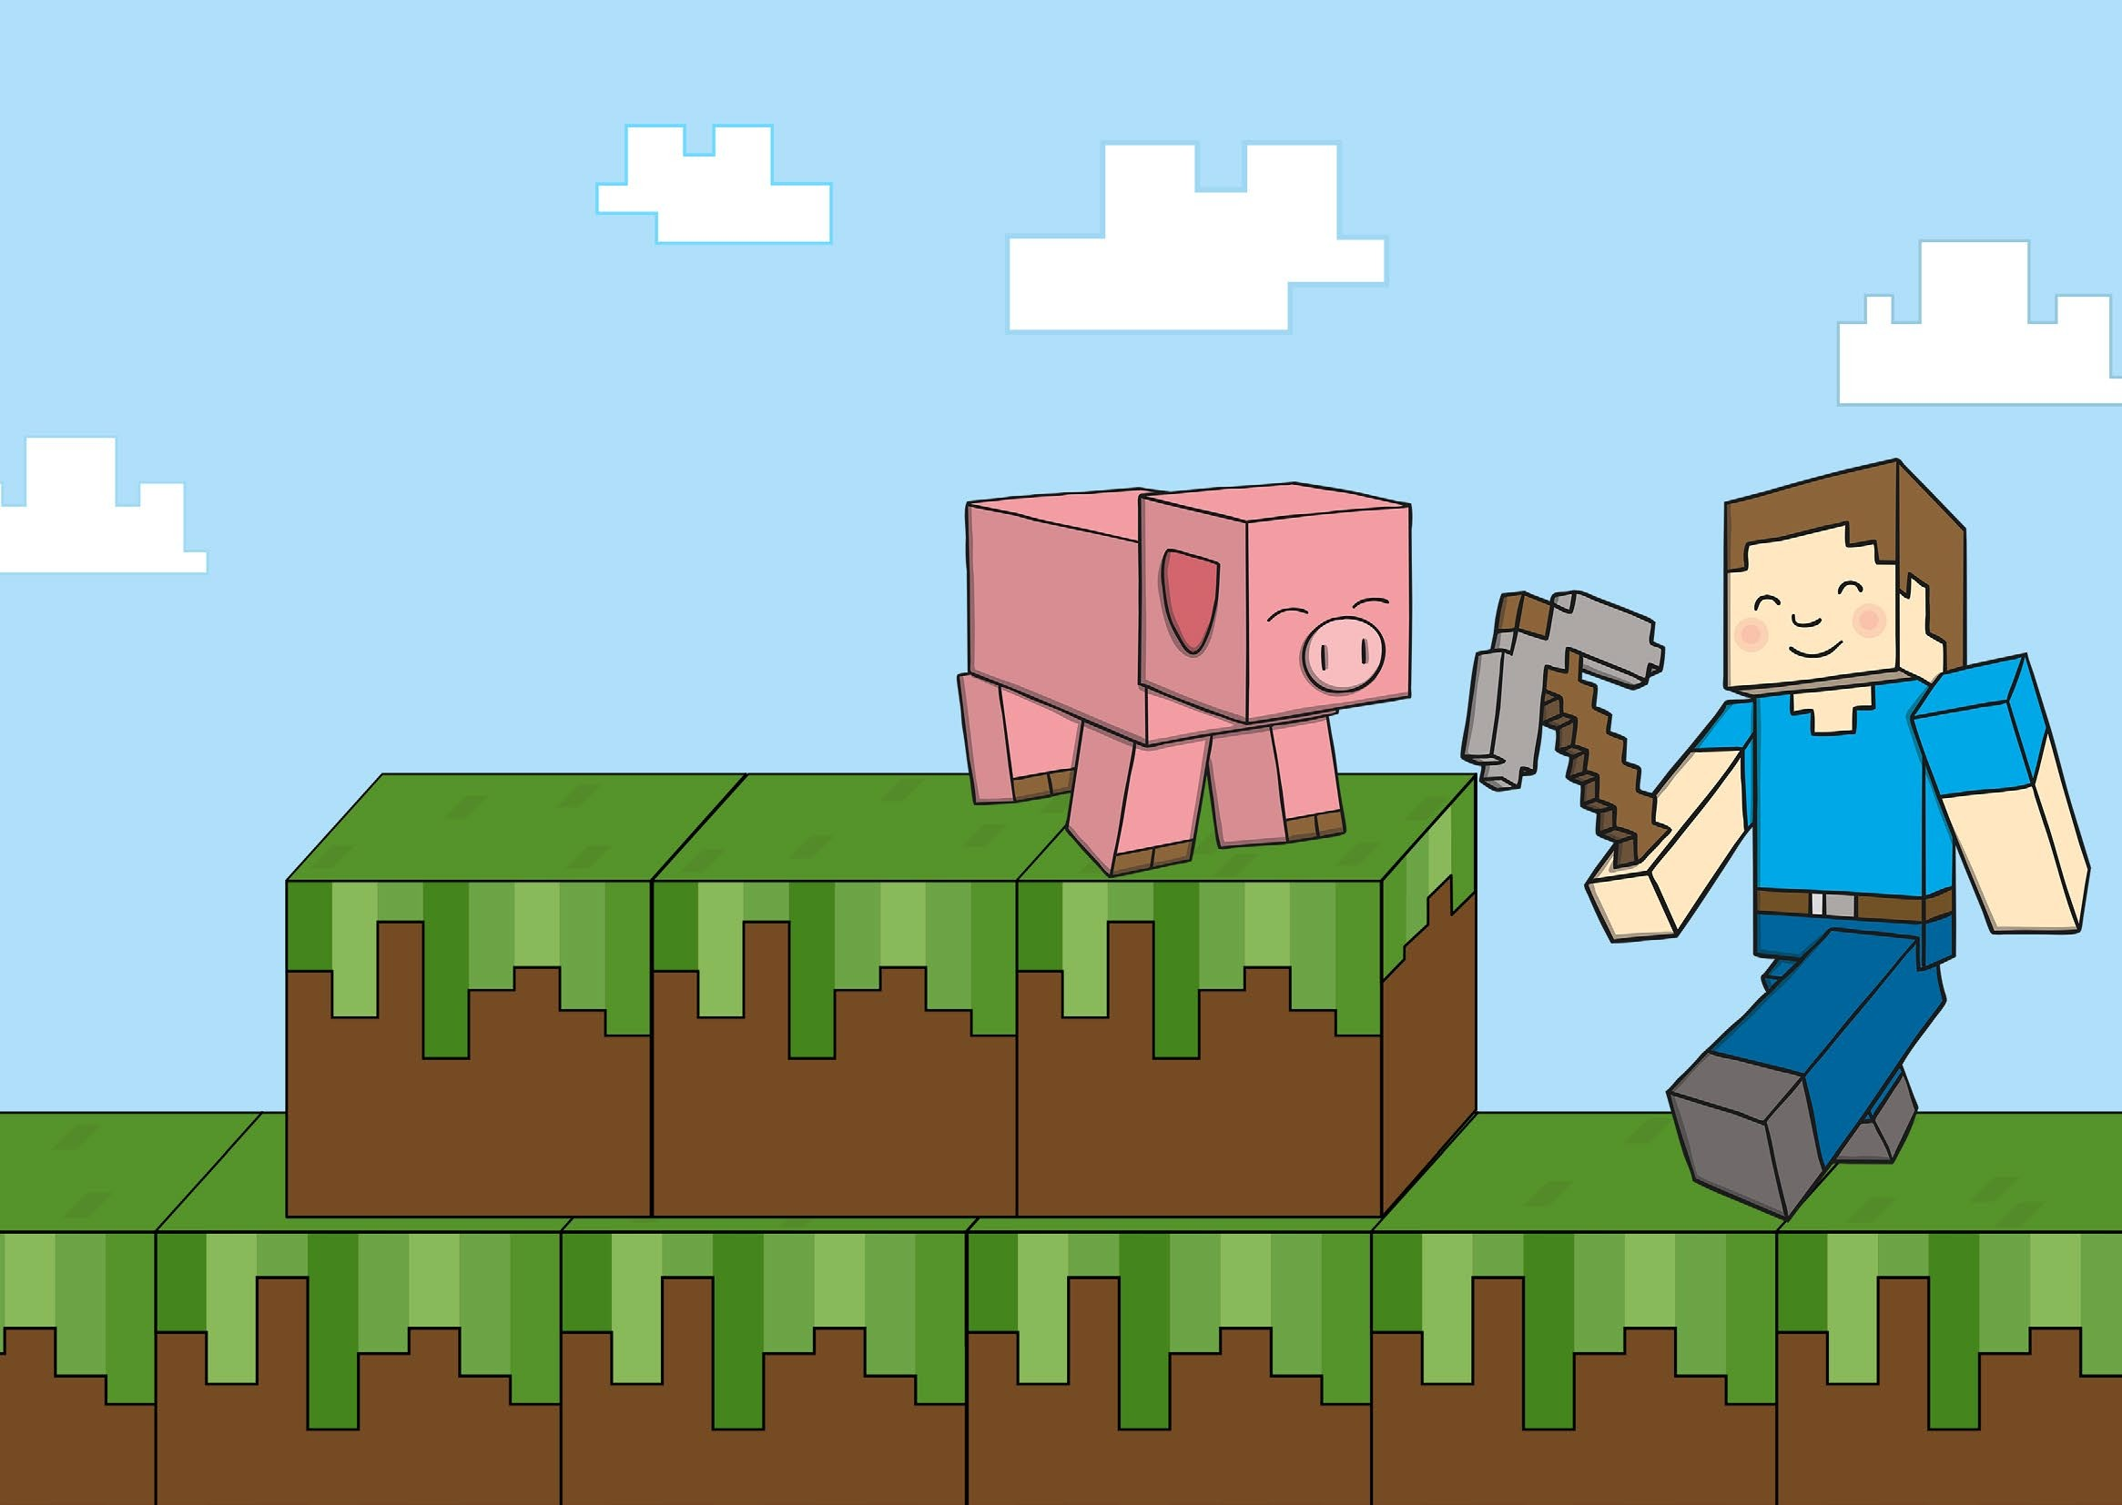

Phonics/ Spelling

Godwin Primary School

Year 1 and 2 Common Exception Word Challenges

Choose a list of spellings overleaf and some challenges to complete. Happy spelling!

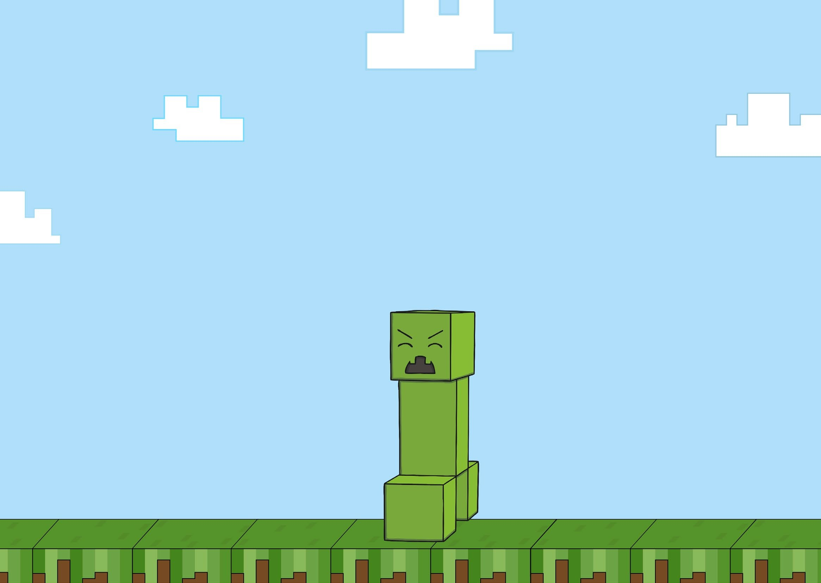



Rainbow Write | Matching Pairs
Write your spelling words using  multi-coloured pencils.  s p e l l | Make a matching pairs game by writing each of your spellings out twice on pieces of paper or card.
Word Search | Air Write
Hide your spelling words inside a word search. | Write each of your spelling words in the air using a magic finger!
Collage Letters | Dough Letters
Cut letters out of magazines and newspapers to make your spelling words. | Roll out sausage shapes using playdough. Make each of the letters from your spelling word.
Spelling Train | Pyramid Words
Write all of your words in one long spelling train using different coloured pencils.  spellwordschoolpencil | Create a  spelling pyramid.  s  s p s p e s p e l  s p e l l

Challenge 1 | Challenge 2 | Challenge 3
today  of  said  says  are  were  was  you  your  they | here  there  where  love  come  some  one  once  friend  school | house  door  floor  poor  because  find  kind  mind  behind
Challenge 4  child  children  wild  climb  most  only  both  old  cold  gold | Challenge 5  hold  told  every  great  break  steak  pretty  beautiful  after  fast | Challenge 6  past  father  class  grass  pass  plant  path  bath  hour

