The TOP TEN maths skills Year 5 children need to know!
1 | Place Value and Number  Can your child recognise the value of each digit in a 5-digit number? Can they recognise the number of ten thousands, thousands, hundreds, tens and ones in any 5-digit number? For example, 41358 = 4 ten thousands, 1 thousand, 3 hundreds, 5 tens and 8 ones = 40, 000, 1000, 300, 50, 8. Can your child then use this information to put 5-digit numbers in order of size | Play ’Largest Number Card Game’:  Using a deck of playing cards (or make your own!) 5 cards are dealt out to the players.  Players arrange their 5cards to make the largest possible number they can, e.g. with cards 2, 5, 1, 6 and 8 a player would make 86,521.  The player with the largest number in each round keeps the cards they were dealt.  The game ends when there are not enough cards to deal out. The winner is the player who has collected the most cards.  Place Value Toss  Set out 5 baskets/buckets/boxes at least 2 metres away from where you are planning on throwing the objects. Line the tubs up vertically.  <- Ten Thousands  <-Thousands  <- Hundreds  <- Tens  <- Ones  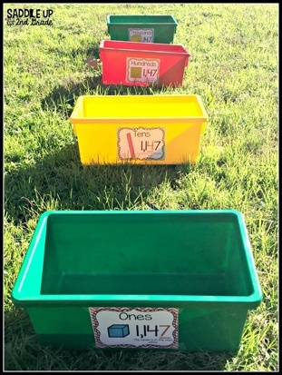  Stand on a marked spot and throw 10 bean-bags/teddies/objects into the tubs.  The number of bean bags in each tub represents the value for that number.  Write the number down – the player with the largest/smallest/largest even number/largest odd number/multiple of 5 etc… (the possibilities are endless!) is the winner.
2 | Read Roman Numerals to 1000  Can your child read and interpret Roman numerals up to 1000, understanding how the order of the numerals can change the number, such as IV is 4 and VI is 6? | Roman Numeral Hopscotch! Roman numeral clock face  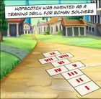  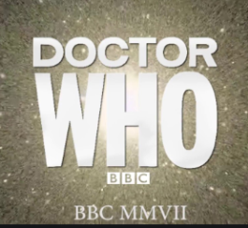  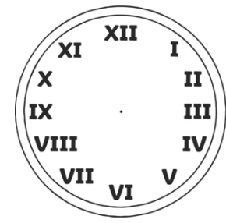  Back in the day, Roman soldiers were required to play the game as a training drill. They had to ‘play’ in ‘full kit’ i.e. wearing their full armour, spear, sword, shield & helmet. Luckily, you won’t need to do this!  At the end of films and TV programmes, credits often have the date in Roman Numerals. Can you use these to work out the year it was filmed?
3 | Multiplication and division  Can your child divide numbers with up to 4 digits by a 1-digit number using the formal written method of short division and interpret remainders appropriately for the context? | To achieve well in Year 6 children MUST be confident with the times tables, up to 12x12. They must be able to record these at speed without calculating them. The should also know the division facts.  So they should know 7 x 8 = 56 and 8 x 7 = 56 but also 56 ÷7 = 8 and 56 ÷8 = 7;  If this is not the case, then this should be a priority. Log on to TTRockStars to practise.  Play using cards or dice  Each player picks some cards from the deck to generate a 4- or 5-digit number to be the dividend. Then you pull a card from the deck to generate a divisor. Who can generate a calculation that does not require a remainder?  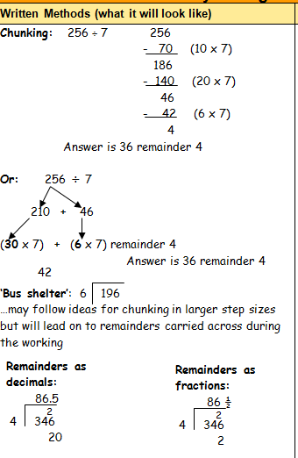  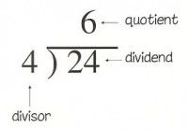
4 | Negative numbers  Can your child interpret negative numbers in context, count forwards and backwards with positive and negative whole numbers, including through zero? For example counting backwards through 0, -1, -2, -3, -4 etc. | Play ‘clap and count’:  Decide on a start number (this could be positive or negative) and decide whether to go forwards or backwards. One person claps a chosen amount of times whilst the other counts the numbers out loud, either forwards or backwards from the chosen number, each time they hear a clap. What number did they land on?  Finish the sequence: Start a sequence of numbers and get the children to write the rest of the numbers in the sequence.  -2, -4, -6, __, __, __, __ or __, __, __, __, -22, -24, -26  Try missing out some numbers too!  3, __, -1, __, -5  Real life: Get children to write a calculation where they have a sum of money and they spend too much at the shop so their bank balance goes into the negative/red. How much have they gone overdrawn by? Use this as an opportunity to talk to the children about budgets, bank accounts, overdrafts and debt. Can they help you set a shopping budget? Can they plan what to buy with you so as not to go into the ‘negative’?  Children could also think about comparing the temperature in different countries. For example, in England in winter the temperature might be 2 degrees but in Canada it is – 6 degrees. What is the difference? Look up the average temperatures of different countries at different points of the year. Try looking up the temperatures in the Arctic and Antarctic.
5 | Round Any Number to the nearest 10, 100 or 1000  Can your child round numbers using their knowledge of place value? For example, if you were to round the number 5762 to the nearest hundred, it would be 5800 (we round up because the digit in the tens column is 5 and over).  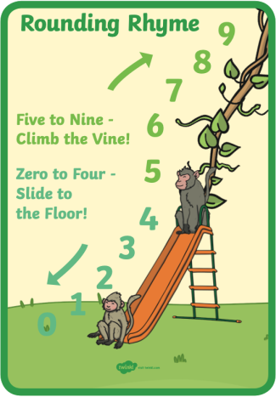 | Play rounding tennis: Pretend you are playing tennis. Player one serves a number, player two works out if it rounds up or down, then player one has to round it. This then swaps around: eg. In this game we are rounding to the nearest 10. You say “251” and they say “down” you say “250”; then they say a number “567” you say “up” then they say “570”. The rally ends when someone makes a mistake or hesitates. You could even score it like regular tennis and host your own rounding Wimbledon!    Play ‘Roll It’:  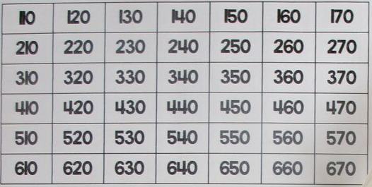  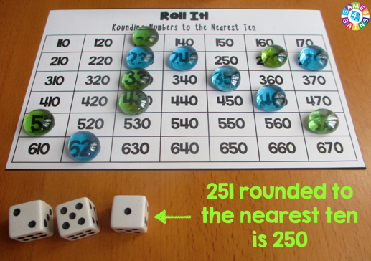  Copy out the grid above. Roll 3 dice. Make a 3 digit number. Round this 3 digit number to the nearest 10 following the rhyme. If the number is available on the grid colour it in! If it isn’t you lose that turn. The game ends when the grid is complete.
6 | Addition and Subtraction  Your child should develop their ability to use mental calculation to add and subtract numbers such as a 5-digit number and a 1-digit number. For example, 126 + 8 = 134  Can your child use the formal, written column method to add and subtract numbers with up to 4 digits? This includes using regrouping (sometimes called ‘carrying ‘in the past) and exchanging (which was sometimes called ‘borrowing’ in the past). | Mental Addition  Copy this grid (or make up your own using 4-digit and 5-digit numbers):  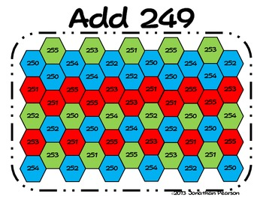  Each game uses a six-sided die (or number cards 1-6). The first player will roll the die to get a number then quickly add the number listed at the top of the game board to the number on the cube. On the game board, place a marker over one of the spaces containing that answer. The second player will repeat these steps. The purpose of the game is to get five spaces covered in a row (vertically ↕, horizontally ↔, or diagonally ↖↗). You may try to win as fast as possible or you may work to block your partner from winning. The game play gives opportunity for strategy along with addition skills.  Have fun experimenting with your own version, changing the number you start with! What else has to change if 249 changes? What about inventing a version for subtraction?  Card Addition  Use a deck of cards to generate two 5-digit numbers. Then add them together or subtract! The player with the highest total (addition) or lowest total (subtraction) wins the round.
7 | Count in Tenths and Hundredths  Can your child count in both tenths, hundredths and thousandths and understand that tenths arise when we divide an object into ten equal parts, or that hundredths arise when divided into a hundred equal parts? Also, that we divide a number by 10 and 100 to find tenths and hundredths. Can your child read, write, order and compare numbers with up to three decimal places? | Skip Counting with Calculators  E.g. Type “0.1+0.1=” into a calculator and record the result. Then they continue to type “+0.1=” and record the sequence that they generate.  Walk forwards or backwards: If you have space outdoors or in a hallway indoors, start on an imaginary given number and pretend there is a number track. Jump forwards on the number track while counting on in tenths and jump backwards on the number track while counting back in tenths. Move forwards and backwards in different ways.  Finish the sequence: Start a sequence of numbers and get the children to write the rest of the numbers in the sequence.  0.1, 0.2, 0.3, __, __, __, __ or __, __, __, __, 0.76, 0.77, 0.78  Try missing out some numbers too!  1.4, __, 1.6, __, 1.8
8 | Multiply and Divide Using Formal Written Methods  Can your child use their knowledge of multiplications and times tables to complete multiplications mentally? This includes using factor pairs and understanding commutativity (2x3 is the same as 3x2) in calculations. Can they also multiply 2-digit, 3-digit and 4-digit numbers by a 1-digit number using a formal, written layout? | 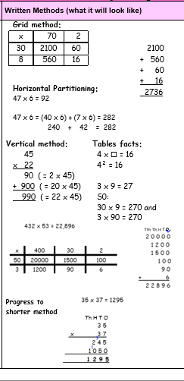  Multiplication card game  Multi-player game using number cards.  Place the cards face down and each player is to take it in turns to turn 2 cards over and multiply them, whoever answers with the correct answer first, wins the cards. Carry on until you have no cards left!  Rock, paper, scissors  Players put up fingers instead of rock, paper, or scissors. The first partner to multiply the two sets of fingers together and call out the product gets a point.  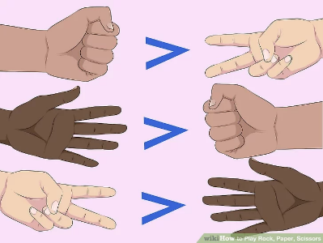
9 | Number – fractions (including decimals and percentages)  Does your child recognise the per cent symbol (%) and understand that per cent relates to ‘number of parts per hundred’, and write percentages as a fraction with denominator 100, and as a decimal? For example, 28 % = 28/100 = 0.28. Can your child solve problems which require knowing percentage and decimal equivalents of ¼ (25% and 0.25), ½ (50% and 0.5) and ¾ (75% and 0.75)? | 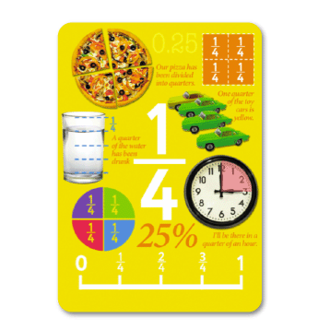  Cooking  Whilst cooking or baking at home, think about the measurements of the ingredients that you are using. For example, ½ a tablespoon of vanilla extract or 2 and ¾ of a cup of milk.  When making or eating a pizza, look at the equal parts of the whole pizza it has been sliced into.  How many slices of that whole has each person eaten? If the pizza is sliced into 10 equal parts, and someone has 6/10 of the pizza, what fraction is left? (4/10)  Time  Whilst at home, discuss the time of when you are going to be doing certain things. For example, at quarter past 9 you might make breakfast. Is there another way your child can tell you what time you would be having breakfast? (9:15am)  In ¾ of an hour you will be making lunch. How many minutes are in 1 whole hour? (60minutes) As we know that the clock is split into 4 parts or quarters, how many minutes are there in 3 quarters? (45minutes)  Money  Using real life examples of handling money, divide an amount of money by using fractions. Ask someone what ½ of £2.00 would be if you were to share it between 2 people. If the total amount of £2.00 is 100% of the money you are about to share. What is the percentage if you split the whole amount into 2 or half it? (50%)  When shopping, in person or online, talk about sales giving 50% off or 25% off and work out the new prices.
10 | Time  Can your child read the time on an analogue clock with increasing accuracy, to the nearest minute? Do they know the number of seconds in a minute, minutes in an hour and hours in a day? Can your child convert the time between 12-hour and 24-hour clocks as well as between analogue clocks and digital clocks. For example, they can convert half past one p.m on an analogue clock, to 13:30 on a digital, 24-hour clock and vice versa. | What’s the time Mr. Wolf?  A classic! Decide who will be Mr. Wolf, and that person stands at one end with their back to everyone else.  The other children stand at the opposite end and shout "What's the time Mr. Wolf?"  Mr. Wolf answers with different times - "one o'clock" or "eight o'clock" for instance. Can they say this time in the 24 hour clock? 13 hundred hours, 22 hundred hours.  The players that number of steps toward Mr. Wolf - eight steps for eight o'clock, and so on. Then ask again, "What's the time Mr. Wolf?" and take the right number of steps again, always getting closer to Mr. Wolf.  When Mr. Wolf feels like it, he (or she) answers "dinnertime" and starts chasing the other children.  The first to be caught becomes the next Mr. Wolf. The children could adapt this game to include other times.  Stop the clock:  Using a stopwatch, who can stop the clock closest to 30 seconds (or other given time). Can anyone get it exactly right?  At various points of the day stop and say:  What time is it now?  What is the time in the 24-hour format?  What time will it be in 20 minutes?  Doing this will build up a sense of time passing and allow the children to calculate with time.  Create a timetable for the day – putting the times in 12 hour clock and 24 hour clocks. Calculate how much time they will spend working, reading, eating, playing, sleeping etc.
Online resources to support with learning at home:
Nrich
Website: https://nrich.maths.org/
Key stages: early years foundation stage to key stage 2
Description: a range of activities. Some are interactive and some are to be completed offline. Activities are categorised by age range.
Registration: not required

TTRockstars/Numbots
Website: https://play.ttrockstars.com/auth/school/student/32939
https://play.numbots.com/#/account/school-login/32939
Key stages: early years foundation stage to key stage 2
Description: Drill-and-skill early number (numbots) and times table (TTR) apps.
Registration: Login’s handed out – please note login for TTR is the same for Numbots.
BBC Bitesize Daily Lessons
Website: https://www.bbc.co.uk/bitesize/dailylessons
Key stages: key stage 1 and key stage 2
Description: You'll find daily lessons for homeschooling in Maths and English for every year group, as well as regular lessons in Science, History, Geography and more. – Aligned with Power Maths and White Rose
Registration: not required

Also refer to extra online resources attached.

