The TOP TEN maths skills Year 6 children need to know!
1 | Place Value and Number  Can your child read, write, order and compare numbers up to 10 000 000 and determine the value of each digit? | Use virtual dice (https://dice.virtuworld.net ) or a 0-9 dice if you have one to generate random numbers with seven digits. If this is a problem, use flashcards as described in skill number 2. Ask your child to read the number out loud. Then, ask them to write it in words and in digits. For example, 6 345, 702 = six million, three hundred and forty-five thousand, seven hundred and two. They must spell the words correctly. Finally, ask them to write the number in words/digits first and then say it out loud. If struggling, use fewer digits.  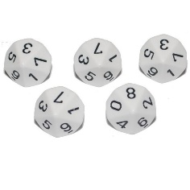  Once confident, ask what amount is represented by each digit? For example, in the number 4, 560, 432, what amount is represented by the 5? (500 000) By the 3? (30) etc. Extension tasks include: How many thousands altogether? (4560) How many hundred thousands? (45) How many times greater is the higher value 4 from the lower value 4? (10 000) etc.  Can your child partition a seven-digit number? e.g. 4 073 483 = 4000000 + 70000 + 3000 + 400 + 80 + 3? Can they recognise amounts shown on an abacus like the one below?  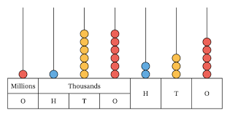  Use the dice again to create seven-digit number to compare. E.g. I have 6 9 2 1 4 7 3. Using these digits make the largest and smallest number possible. How did you do it? What did you have to think about? Generate five different seven-digit numbers. Put them in order from smallest to largest then largest to smallest? Compare the numbers using greater than (>), less than (<) and equal to (=).
2 | Place Value and Number  Can your child round any whole number to a required degree of accuracy? | Create flash cards on paper, with digits 0 -9. In total you should have 10 pieces of paper, with one digit on (0, 1, 2, 3, 4, 5, 6, 7, 8 and 9). Or use a 0-9 dice.  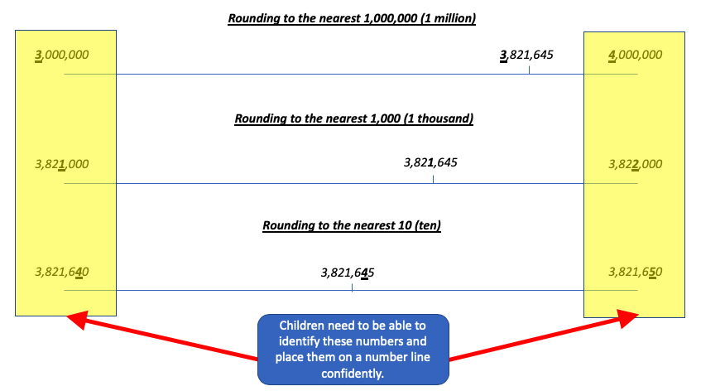  Make a 7-digit number e.g. 3, 821, 645.  Round to the nearest 10 by identifying the multiples of 10 it sits between on a number line 3, 821, 640 and 3, 821, 650). If the ‘ones’ digit is 5 or above, round up. If it is below 5, round down. In this case, the ones digit is a 5, so we round up to 3 821 650.  Repeat by rounding the same number to the nearest 100. The tens digit is a 4, so we round down to 3 821 600. Then round to the nearest 1000 by using the hundreds digit to determine whether we round up or down. It is a 6 so we round up to 3 822 000. Repeat for the other columns then try a different 7-digit number.  An alternative method is shown below:  To round 2681 to the nearest thousand, underline or circle the thousands digit, then draw an arrow the next digit on the right. In this case, it is the 6. If that digit is 5 or more, round up. If the digit is 4 or less, round down. So, the answer will be 3000.  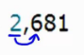  Once confident, use the flash cards to practice with other 4, 5, 6 and 7-digit numbers. Round the number to the nearest 10, 100, 1000, 10,000 etc.  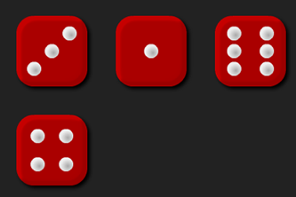  Dice game to use at home.  Roll a dice four times to create several 4-digit numbers.  Round each of them to the nearest multiple of 1000, 100 and 10. For example: 1,324 rounds to 1000, 1,300 and 1320; 2,314 rounds to 2000, 2,300 and 2,310; 4,312 rounds to 4000, 4,300 and 4,310.  Move onto 5, 6 and 7-digit numbers, rounding to the appropriate power of 10 (10, 100, 1000, 10000). If you do not have access to dice, try using your flash cards from earlier.
3 | Place Value and Number  Can your child use negative numbers in context, and calculate intervals across zero? | Using a ruler and a sharpened pencil, draw a number line ranging from -10 to 10. See below for an example.  - Work out the difference between numbers: e.g. -5 and 7, 10 and 4, -9 and -1  - Add and subtract using negative numbers: e.g. -5 +8 =, 6–10=, -9+4=  - Repeat with different numbers  Use single digit flash cards to generate a 2-digit number e.g. 12. Now count back 10 times, in steps of 5: 12, 7, 2, -3, -8, -13, -18, -23, -28, -32. Is there a pattern forming? Repeat by beginning with a negative number and count forwards in steps of 5. Draw a number line that shows the steps. See above for an example of a number line. Repeat with larger steps and/or different starting numbers.  Create a human size number line. -10 through to 10. Throw an object onto the number line. Note down the first number. Throw the object again. Note the second number. What is the difference between the two? Get the children moving by jumping the difference between the two numbers.  Extend by providing number sequences with missing numbers: e.g. 10, 8, _, 4, 2, 0, _, -4, _ -8 etc. Or: Amy starts a number sequence which goes down by 150 each time. She starts with 350. What will the next five numbers in her sequence be? (200, 50, -100, -250, -400).  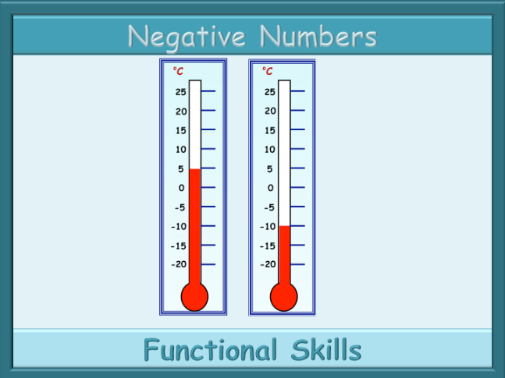  Find the difference between temperatures: e.g. two thermometers as shown on the left or between a range of cities: Stockholm -12°C, London 5°C, New York -5°C, Cape Town 25°C etc.  Also, put into practical contexts. The temperature of the freezer is -10°C. If it warns up by 15 degrees, what will the temperature be? If it gets 8 degrees colder, what will the temperature be then?  Discuss bank accounts and how someone can have a negative bank balance if they spend more than they have. This is a good opportunity to discuss the dangers of borrowing and overdrafts. The example below introduces overdrafts and links to spending habits.  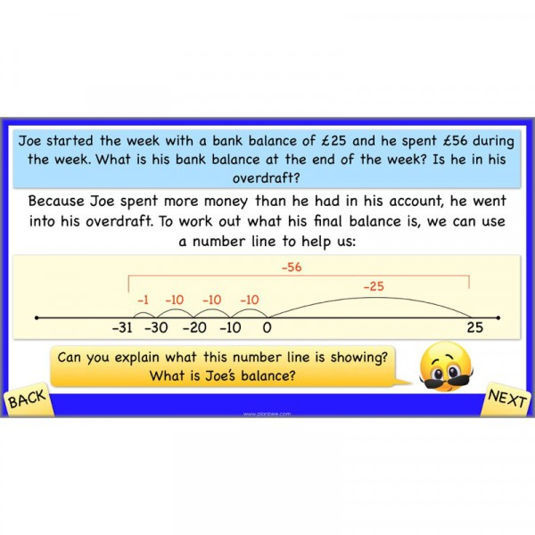
4 | Multiplication and Division  Can your child multiply multi-digit numbers up to 4 digits by a two-digit whole number using the formal written method of long multiplication? | Children MUST be confident with the times tables, up to 12x12. They must be able to record these at speed without calculating them. The should also know the division facts.  So they should know 7 x 8 = 56 and 8 x 7 = 56 but also 56 ÷7 = 8 and 56 ÷8 = 7;  If this is not the case, then play Times Tables Clocks (instructions below) for a fun and engaging way to develop and strengthen the knowledge of the times tables or log onto TTRockStars to practise. If they go to secondary school not knowing their times tables they are going to struggle with secondary level maths.  First of all, complete 391 X 9 on the top row. Then complete 391 X 30 on the next line. When multiplying by a multiple of 10, there must ALWAYS BE A 0 in the tens column.  Using your number cards, generate further calculations that look like the example here. Then use the formal written method as shown.  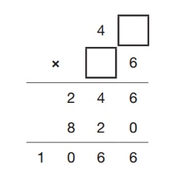  If confident, try calculations with missing digits to extend understanding like this the one on the left.  Times tables Clocks  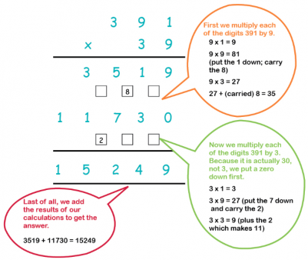  On a piece of paper, draw a circle for each player. Around the circle write the numbers 1 – 12, just like a clock. Pick a times table and write the number in the middle. If the 7 times table has been picked, then write 7 in the middle. Once everyone is ready with their circle, numbered 1 – 12, the game can begin. Ready, Steady, Go! As quickly as possible, write the answers next to each number.  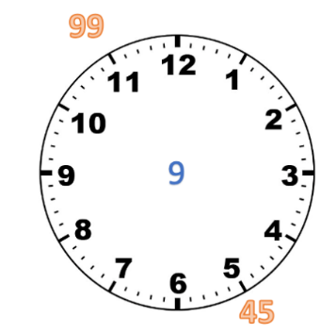  For the example on the right, the 9 times table has been picked. Next to the 11, 99 has been written because 9 x 11 = 99. Next to the 5, 45 has been written because 9 x 5 = 45 and so on. The first person to complete their times table clock is the winner.
5 | Multiplication and Division  Can your child divide numbers up to 4 digits by a two-digit number using the formal written method of short division where appropriate, interpreting remainders according to the context? | 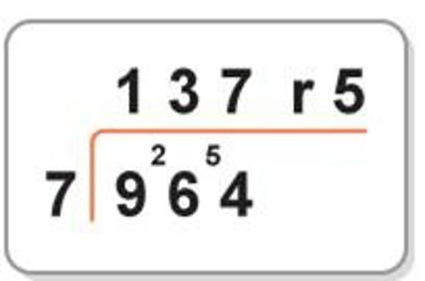  First of all, your child needs to be able to complete bus shelter calculations like the one shown here, expressing their answers with remainders where appropriate. Use flash cards or 0-9 dice to create examples. This is the same method that most parents would have learnt at school.  In this example, we are splitting 964 into groups of 7. We have 5 left of a group of 7. So another way of dealing with the remainder is to express the answer as 137 5/7.  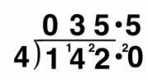  A final way to convert the remainder is with a decimal. To the right, instead of writing remainder 2 after the Ones column, a decimal point has been inserted, and the process of division and carrying continues. So our answer here is 35.5. It could also have been expressed as 35 r2 or 35 2/4 or simplified to 35 1/2  It is important that children know how to interpret remainders in practical situations. E.g.:  - There are 350 children and staff going to a concert by coach. Each coach can hold 60 people. How many coaches will be needed?  - 1100 pencils were put into groups of 12. How many pencils were left?
6 | Multiplication and Division  Can your child identify common factors, common multiples and prime numbers? | 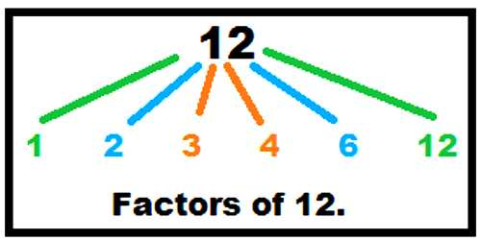  Your child needs to know what a factor is: a number which, when multiplied, gives another number.  1, 2, 4, 5, 10 and 20 are factors of 20 because they can be multiplied to reach 20. Also, 1, 3, 5 and 15 are factors of 15 etc.  We can find factors by dividing a number too. Start by selecting numbers with lots of factors. Can your child find them all? Numbers with lots of factors include those in the 8 times table (24, 32, 40, 48 etc). The 50 times tables (50, 100, 150 etc) is useful too.  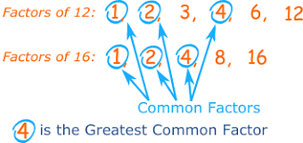  Next, look at common factors: factors which are shared by more than one number. All whole numbers have 1 as a common factor. All even numbers have 2 as a common factor. All whole numbers ending in 0 have 10 as a common factor etc. Ask your child to find the common factors of pairs of numbers. Can they find the highest common factor? In the example above 1, 2 and 4 are common factors; the highest common factor is 4.  If you are having difficulty finding factors, put household objects such as Rice Krispies or buttons on a table. If you have 24 Rice Krispies, how many factor pairings can you create? The factors would be 1x24, 2x12, 3x8, 4x6 so those numbers are all factors of 24. Try with different totals.  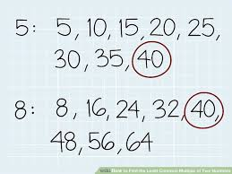  Multiples are found when a factor is multiplied. For instance: 4, 8, 12, 16, 20, 24 etc are multiples of 4. Also, 9, 18, 27, 36 etc are multiples of 9.  A common multiple is a number that appears in the times tables of more than one factor. In the example on the left, 40 is a common multiple of the factors 5 and 8. Also, 5 X 4 = 20, so 20 is a multiple of both 5 and 4.  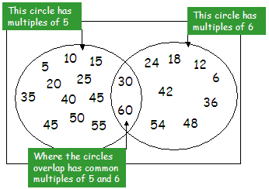  Try using Venn Diagrams to organise the multiples of different factors like in the example here. Explore the idea of a lowest common multiple. On the right, the lowest common multiple of 5 and 6 is 30.  Most numbers have lots of factors. By now your child should be able to list them easily. Some numbers though have only two factors: themselves and 1. We call these prime numbers. They include 2, 3, 5, 7, 11, 13, 17, 19 etc. Can your child list all the prime numbers to 100? Try creating a hundred square and highlighting prime numbers. Can you rule some of the numbers out straight away? For example, numbers ending in 0 cannot be primes as they are all multiples of 5. There is only one even prime – why?  You can also use a 100 square to find all the multiples of 6, multiples of 10 etc.
7 | Fractions (incl. decimals and percentages)  Can your child add and subtract fractions with different denominators and mixed numbers, using the concept of equivalent fractions? | Adding & Subtracting Fractions When adding or subtracting fractions, they must have a common denominator (the numbers at the bottom of the fractions you are adding or subtracting must be the same). If they have different denominators, they need to be converted to an equivalent fraction that works for both of them (see above). When you have common denominators, add the numerators (top numbers) and keep the denominator the same.  A further example: 2/3 + 1/5 needs converting to a common denominator of 15. Then 10/15 + 3/15 = 13/15. Subtracting works the same way but in reverse. This could be practised quite easily at home by using a dice to create random fractions. Your child can then practise using their knowledge of multiples to find a common denominators and then add or subtract them.  Calculating with Mixed Numbers  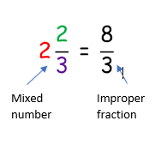  Mixed numbers are made up of a whole number and a fraction (e.g. 1 ½ - where 1 is the whole number and ½ the fraction). Sometimes, the easiest way of adding or subtracting fractions with mixed numbers is to convert them into improper fractions first. On this example, each of the whole ones consists of three thirds, so there are eight thirds altogether. Now we could subtract or add to it just like before – although we must ensure the fractions have common denominators. If we end up with an improper fraction after completing the calculation, we need to convert back to a mixed number to finish.  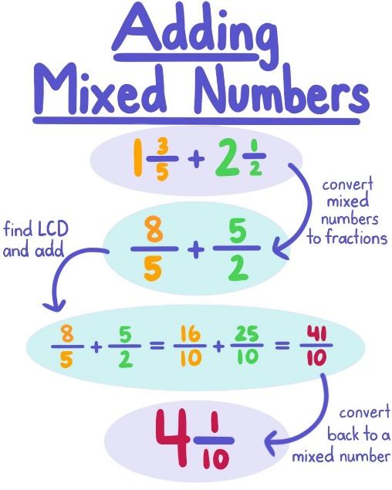  Here’s an example: Step One is to convert the mixed numbers into improper fractions. Step Two is to change them into equivalent fractions with a common denominator. The adding part is then easy. Because we end up with and improper fraction, it needs changing back to a mixed number.  Try this with any mixed numbers once your child has got the hang of it. Again, subtracting fractions and mixed numbers can be done the same way, but in reverse.  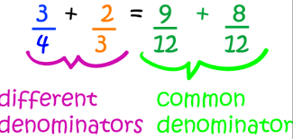  Another way of practising is through pictures. Draw several circles and split them evenly like this example. Shade in at least one whole circle and a fraction of the other and ask your child to record it as an improper fraction and mixed number.  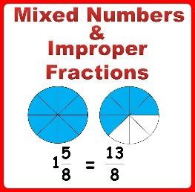  Think about using practical items in the house to help. If I have two and a half apples and one and a quarter apples, how much do I have in total? Try quartering all the apples and see home many quarters you have. You would have 15 quarter or 15/4. How many whole apples is this? 15 ÷ 4 = 3 whole apples and 3 quarter left over or 3 ¾. Don’t forget to eat the apples!
8 | Fractions (incl. decimals and percentages)  Can your child identify the value of each digit in numbers given to three decimal places and multiply and divide numbers by 10, 100 and 1000 giving answers up to three decimal places? | 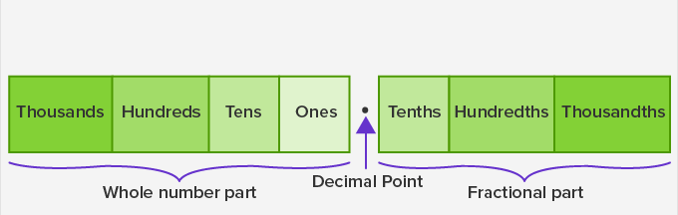  Your child needs to understand that whole numbers and fractions (in the form of decimals) are separated by a decimal point and know the value of each column in relation to the others. For example: ten hundredths make a tenth; ten tenths make a whole; 10 ones make a ten; ten tens make a hundred etc. Practise this.  They must be able to read numbers such as 137.95 and say the value of each digit (e.g. the 1 represents 100, the 5 represents 0.05 etc). Practise and repeat.  Partitioning numbers helps to embed place value. For example 132.637 = 100 + 30 + 2 + 0.6 + 0.03 + 0.007. This can also be repeated until secure.  To mulitply a number by ten, the digits move ONE column LEFT. For example, 1.6 X 10 = 16. The ones digit (1) and tenths digit (6) have both moved one column left. To multiply by 100, the digits move TWO places LEFT. To mulitply by 1000, the digits move THREE places LEFT. The digits head the other way when dividing. The diagram below provides a summary.  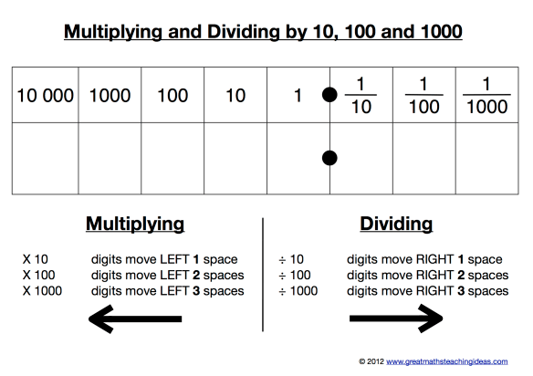  This can be practised by quick fire questions: 5670 x 10 = 56700 or 76.8 ÷ 100 = 0.768.  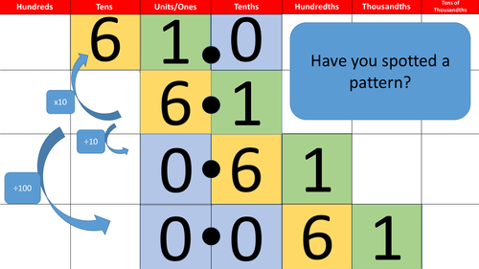  Please DO NOT accept an answer of multipying by 10 means adding a zero to the end – this is not the case and will only cause further misunderstanding.  You could also use a dice to generate a number, then create cards that multiply or divide by 10, 100 and 1000. Once a number is generated, turn over a card to determine which operation to use.
9 | Fractions (incl. decimals and percentages)  Can your child recall and use equivalences between simple fractions, decimals and percentages, including in different contexts? | 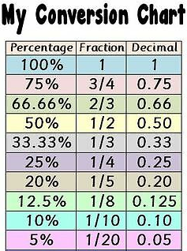  Your child will need to confident in their ability to recall simple equivalence between fractions, decimals and percentages. The best way to do this would be to create a table showing equivalence and practise until they know it off by heart.  What is 75% as a fraction and decimal? What is 0.33 as fraction and percentage? etc.  You can also ask your child to demonstrate equivalence pictorially.  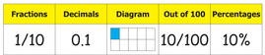  Ask questions that enable this knowledge to be used for practical purposes. For example:  A computer game costs £50. It is reduced by 50%. What is its new price? What would the cost of the grocery bill be if it was 10% more expensive? What would the price of a car costing £20 000 be if it had 10% off? What would it be if it had 2/5% off?
10 | Ratio and Proportion  Can your child solve problems involving the calculation of percentages (for example, of measures, and such as 15% of 360) and the use of percentages for comparison? | Your child must be able to find percentages of amounts as well. Begin with easier ones like 50% which is half. So in order to find 50%, you divide the number by 2.  To find 25% you divide 4; to find 10% you divide by 10; to find 1% you divide by 100.  The key is to be able to find 1% of an amount (by dividing by 100) and 10% (by dividing by ten). This can then be used to find any percentage.  For example, to find 30%, divide your number by 10 (to find 10%) then multiply by 3 to get 30%.  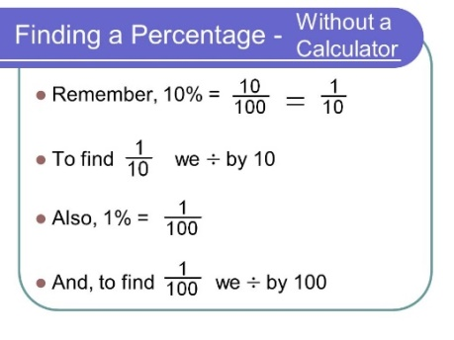  To find 42% of 500, divide 500 by 10 to get 10% (50). Then multiply that answer by 4 to get 40% (200). Then go back to the original 500 and divide it by 100 to find 1% (5). Multiply that number 2 to find 2% (10) and add them together (210). So 42% of 500 is 210.  Some examples of word problems: There are 240 pages in my book and I’ve read 65%. How many pages is that? How many do I have remaining? If a lettuce is 80p Asda reduce it by 10%, is that a better deal than the lettuce at Tesco which is 90p but has 15% off today? Try some cooking and finding percentages of the measures. That looks like too much flour. We only need 300g. What percentage do we have to remove?
Online resources to support with learning at home:
Purple Mash
Website: http://www.purplemash.com/
Key stages: EYFS, key stage 1 and key stage 2
Description: Set tasks as 2do’s and mark them online – also the Blog is a great place to post documents/links for the children to follow to access the plethora of online resources outlined above!
Registration: Logins sent out

TTRockstars/Numbots
Website: https://play.ttrockstars.com/auth/school/student/32939
https://play.numbots.com/#/account/school-login/32939
Key stages: early years foundation stage to key stage 2
Description: Drill-and-skill early number (numbots) and times table (TTR) apps.
Registration: Login’s handed out – please note login for TTR is the same for Numbots.

BBC Bitesize Daily Lessons
Website: https://www.bbc.co.uk/bitesize/dailylessons
Key stages: key stage 1 and key stage 2
Description: You'll find daily lessons for homeschooling in Maths and English for every year group, as well as regular lessons in Science, History, Geography and more. – Aligned with Power Maths and White Rose
Registration: not required

Also refer to extra online resources attached.

