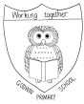
Godwin Primary School Nursery

How to help your child to develop pre-writing skills
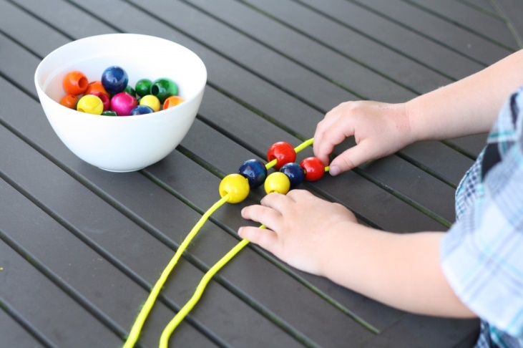

In order for children to develop the pencil control they need for writing, it is important that they have had the opportunity to develop their muscles in preparation. It is not only the muscles in the hands that need to be strengthened but first the muscles in the neck, then the shoulders, elbow and the wrist. A child will not be able to gain good pencil control without having the opportunity to strengthen these muscles through indirect activities.

Here we provide you with some activities that you can do at home to support your child to develop good muscle control, in preparation for writing.
Gross motor skill activities
Learning to write involves muscles in the neck, shoulders, trunk of the body, elbow and wrist, as well as the hand, so it is important that your child has strength and control of all of these. Access to physical activities that support the development of these muscles will also help your child to gain good posture which will be needed when they are expected to write for a longer period of time. Here are some activities to try at home to develop your child’s gross motor skills:
- Hanging from monkey bars - take your child to the park and support them to hang from monkey bars and trees to develop the muscles in their arms and wrists.
- Using climbing frames and climbing ladders.
- Pushing and pulling activities such as pushing a friend on the swing or pulling a rope in a game of tug of war.
- Dancing with ribbons or scarves - making large circles and waving ribbons can help to develop muscles in the shoulders, arms, elbows and wrists.
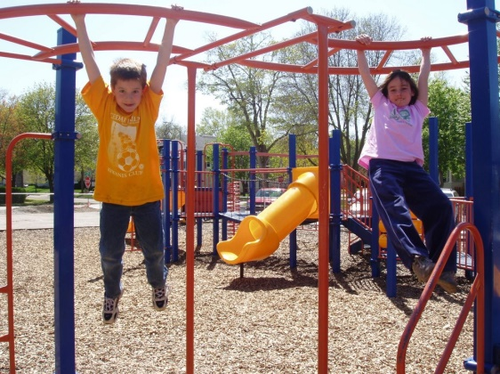
- Making marks on large paper - encourage your child to make large marks and circles on paper with paint brushes, felt tips and pencils etc.

Fine motor skill activities
Some children will not naturally want to draw or take part in creative activities. However, it is still possible to develop the muscles they need for writing using activities they do enjoy. The following activities will help children to strengthen the muscles in the wrists, hands and fingers:
- Construction toys - playing with Lego and building materials.
- Playdough - manipulating playdough by rolling it, squashing it, pinching it and stretching it.
- Using tweezers and tongs to pick up objects helps to develop the pincer grip needed to hold a pencil, as does squeezing clothes pegs.
- Give your child some child-sized scissors and with supervision let them cut up old cards and magazines. As they develop scissor-control, encourage them to cut around pictures.
- Threading beads on a string.
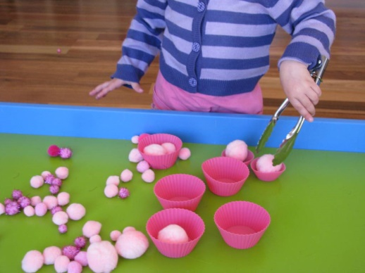
- Encourage children to use their fingers to make marks in sand.
- Cookery - stirring the mixture and squeezing out icing will help children develop the muscles in their arms and hands.
Mark-making activities
At this stage children are not required to be able to write letters but mark-making in different ways will support them to gain the necessary pencil control. Here are some activities to support them to gain this control:
- Lying on the floor to draw - some children find it difficult to sit at a table so instead, put paper on the floor and let them lay on their tummies to draw.
- Painting with water - give your child a large paint brush and a bucket of water to paint the fence or patio with.
- Chalking on the patio.
- Bark rubbing.
- Mark-making with different media such as felt tips, crayons, pencils and paint on small and large pieces of paper.
- Making marks with sticks in sand or mud.
- Tracing pictures and patterns.
- Colouring simple pictures.
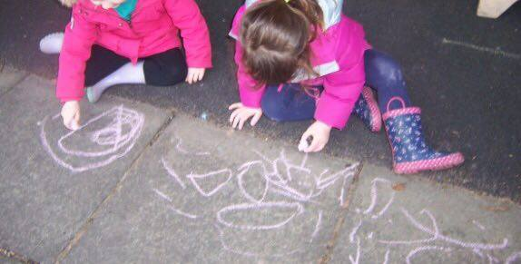

Pencil grip
The most effective grip for writing is the tripod or pincer grip. However, when children first begin to make marks they will often hold the pencil in a fist-like grip. The fine motor and mark-making activities previously listed will support children to hold the pencil in a tripod grip. If your child is able to effectively control their pencil using a different kind of grip that is more comfortable for them, that’s fine. Seek advice from your child’s teacher if you are concerned. Below is an image showing the typical stages of developing an effective tripod grip.
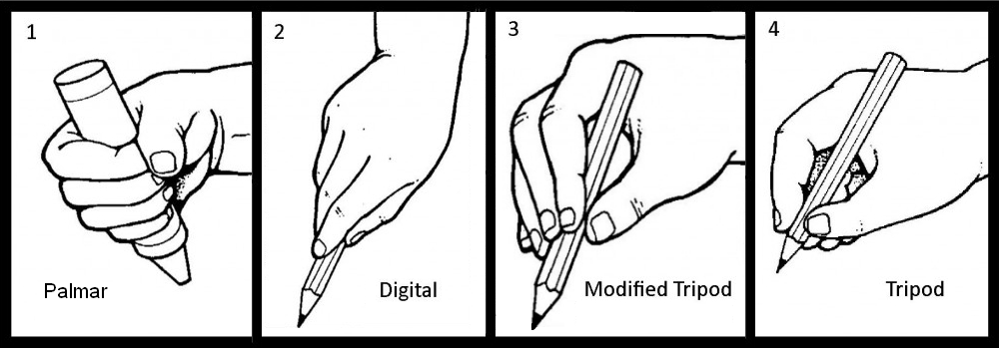

Additional advice
If your child naturally uses their left hand to mark- make etc, do not discourage it. This could be detrimental to the development of their pencil control and physical development in general.

Pre-writing shapes and patterns

To support children to start writing letters they should first focus on making shapes with their pencil. The image below shows you the shapes they should start forming; practising these will support their future letter formation.
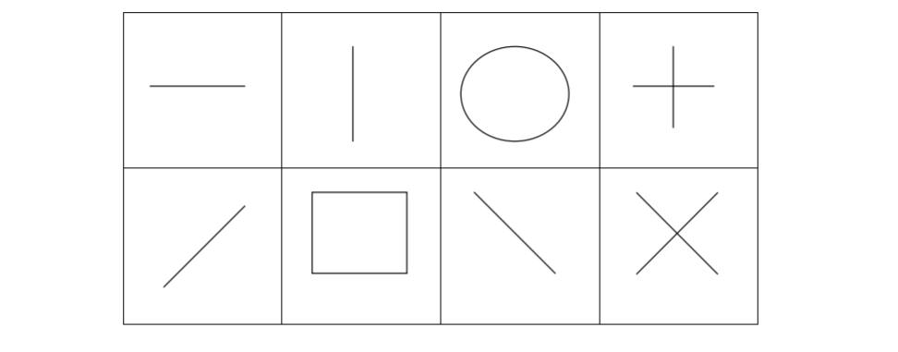
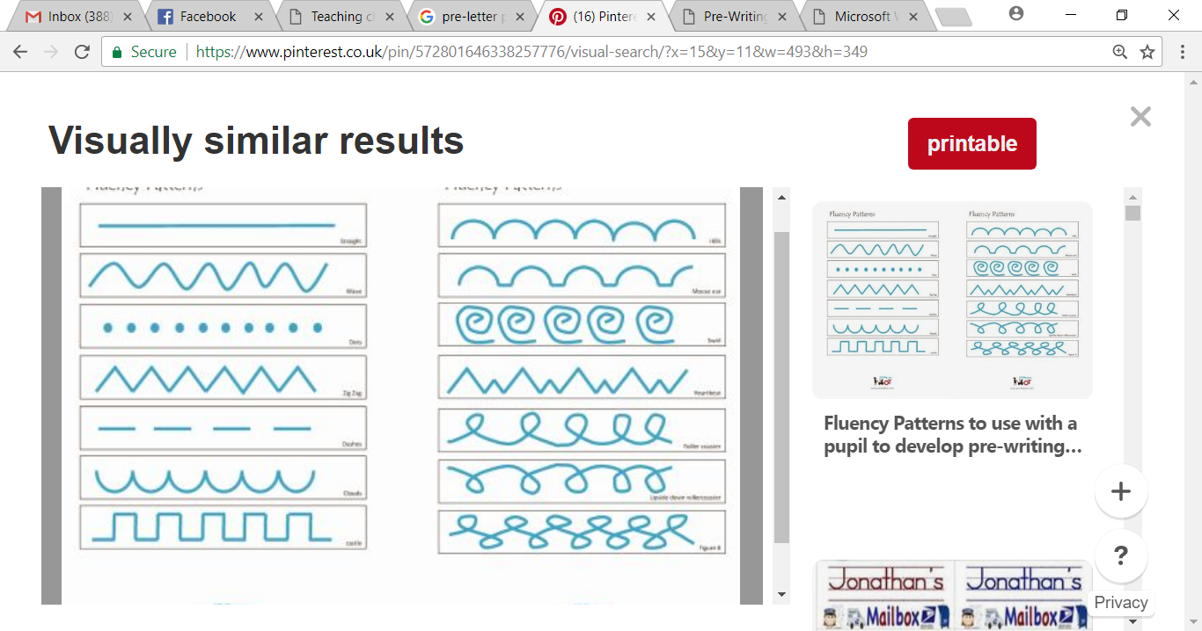
When your child has mastered these shapes they can begin to move on to pre-writing patterns. There is no particular order to these patterns. Below are a few patterns you could try:
Encourage your child to copy or trace over these patterns, more can be found online.

Beginning to write letters
Your child will be ready to write letters when they are able to:
- Hold a pencil in a tripod grip.
- Make controlled marks.
- Press their pencil on the paper effectively.
- Begin to draw simple, recognisable pictures.
- Copy simple shapes and patterns.

You may wish to start teaching your child how to write their name. Our school has a specific way in which we teach children to form letters. Please speak to your child’s teacher if you would like a copy of your child’s name card showing you how each letter in their name should be formed. Make sure that any writing sessions are no more than 5-10 minutes long.

Please speak to your child’s teacher if you have any other concerns regarding your child’s pre-pencil- control and remember to make any activities fun for you and your child.



