Dear Parent / Carer / Nursery / School,
We are sending you this Being Adventurous with Food pack because your child or a child you work with has been identified as having:
- “Behavioural feeding difficulties” or “Sensory based food aversion”.
This means that they have some foods that they will accept and can manage to eat but introducing new foods can be difficult and foods might be rejected because of the way they look, feel, smell or taste. Your child probably isn’t very interested in food and will try to refuel as quickly as possible so they can get back to something they enjoy more. From the information we have, we are not concerned that your child has a problem swallowing their accepted foods safely or managing fluids safely.
When your child doesn’t eat well it is one of the most difficult and stressful experiences as a parent as our most basic instinct is to feed our children. We hope that this pack will help you understand more about your child’s difficulties with eating and give you some ideas to help make positive changes.
We encourage you to start by watching a video online. This is part of the SOS approach to feeding resources and is available free to watch via the link or QR code below.
https://sosapproachtofeeding.com/parent-workshop-when-children-wont-eat/

After you have watched the video, have a read through our information pack and start to use some of the ideas with your child. Persevere and be consistent because making changes takes time and most importantly try to have FUN with food with your child.
If you would like to access further support with feeding, you can attend our online drop-in sessions - please email BDSLT.dysphagia@nelft.nhs.uk for more details.

Barking and Dagenham SALT Dysphagia Team

Video: SOS approach to feeding
Contents:
Page 3 | Start by sitting down for eating
Page 4, 5 and 6 | Learn how to develop a mealtime routine
Page 7 | Your child’s ‘safe’ and ‘unsafe’ foods
Page 8 and 9 | Learn to have fun with food through Food Play
Page 10 | Learn about the different Steps to Eating
Page 11 | Try using a graded exposure ladder
Page 12 | Further advice on eating and drinking
Page 13 | Details for Feeding Drop-in sessions

Sitting down for eating
Why should my child sit to eat?
Eating, drinking and swallowing are complex processes which need full concentration to keep us safe. How and where your child is sitting to eat can have a huge impact on the success of a meal. Sitting without proper support is so tiring and painful for your child that they are likely to rush a mealtime or avoid it altogether. Try sitting on a chair and raise your feet from the floor, notice how hard you must work your tummy muscles just to keep upright. If your child is concentrating on trying to keep themselves upright without proper support, they will not be able to concentrate on the task of eating safely.
“My child struggles to sit and prefers to eat walking around – what should I do?”
Support your child to sit for as long as they are able. Allow them to then have a movement break to regulate, however try to ensure they do not take food and/or drink with them on this movement break. Don’t follow your child around with food. Once they have settled, redirect them back to their seat to continue with the meal. Your child may require frequent movement breaks and redirection attempts per mealtime – this is okay.
What is the correct position for eating?
- The ideal sitting position for eating requires the hips and knees to be bent and feet to be flat on the ground or on a footrest with the weight evenly distributed. Use a highchair with a footrest or position a footrest under the table (this can be made from a box / book) to support the positioning of hips, knees and ankles.
- Your child’s back should be supported, and they should maintain an upright position.
- Feet should be sitting comfortably apart, resting on the floor or footrest.
- Use towels, cushions and wedges to help support good posture and eating position.
- Straps and seat belts can help to keep the pelvis stabilised and encourage symmetry and stability.
- Provide a solid table surface, ideally positioned between the child’s belly button and chest level.

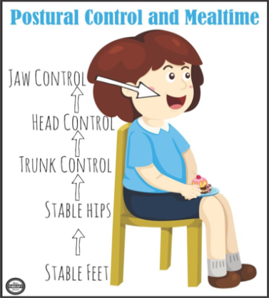
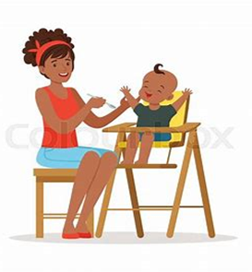
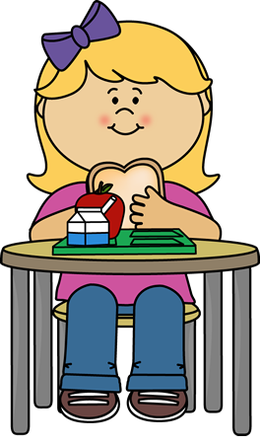

Develop a mealtime routine
  Do |   Avoid
Eat together as a family as much as possible. Sit with your child at mealtimes and eat your meal with them so they can learn what a mealtime looks like. Your child trusts you more than anyone so if they see you eating a food, they can see it is safe. You are also showing them what to do and how to develop their skills. | Distractions. Your child can only concentrate on one thing at a time. If there is a TV on or other screens or toys your child will concentrate on those. Eating, drinking and swallowing are very complicated and need full concentration.  No toys, iPads, TV or phones.
Offer food at routine times. Give them time and space to eat.  - 3 mealtimes (breakfast, lunch and dinner)  - 2 snack times (for example, mid morning and mid afternoon).  Keep mealtimes to no longer than 20-30 minutes – your child will get tired and bored!  There should be at least two hours between mealtimes and snack times. This gives the tummy enough time to digest the last meal and develop an appetite for the next meal. | Forcing them to eat. Being forced to eat something you don’t want is a horrible experience and will put your child off eating even more. The aim is to create positive experiences of food.  Do not make your child sit at the table for over 20-30 minutes or until they have finished their plate.
Reduce the likelihood of your child feeling overwhelmed at mealtimes.  - Fill most of the plate with foods that your child likes.  - Fill the plate with only the amount of food your child will eat (not the amount you would like them to eat). | Setting a goal that is too big around mealtimes (e.g. eating three slices of bread, finishing their whole plate of food, eating a whole new food)  Setting a goal and changing it during the mealtime (e.g. saying “just one more” and then “just one more again”).
Let your child be messy with food. This will allow them to have a positive experience with food. Allow them to touch, smell and play with their food. This will lead to them being more likely to eat the food in the future.  Use phrases like:  - “How loud can we crunch this?”  - “Lets crush it with our fingers!”  - “Shall we smell, touch or nibble?”  - “I’m going to smell, ooo it’s fruity!” | Saying phrases like:  - “Stop playing with your food”  - “Please just try it”  - “Eat it, you’ll like it!”  - “3 more bites for Mummy”
Be consistent between adults – you should use the same strategies as you are a team and to make sure your child is getting the same message. | Pleading deals (e.g. if you eat this fruit, I’ll let you play on the iPad). Making threats (e.g. if you don’t finish this, I will take away your toy car)

Develop a mealtime routine
Routines help us understand what is going to happen and make a task easier to manage. Setting up a daily mealtime routine will help your child to learn what to expect at mealtimes and will help them to be less anxious about it. Try using this mealtime routine and give your child visual clues (objects, pictures, you modelling the task) to help them understand.
Step 1:
- Give your child a verbal warning “we will eat in 5 minutes”
- Show them a 5-minute countdown e.g. 5 fingers, sand timer, 5 minute countdown on your phone.
Step 2:
- Say “washing hands”
- Bring them to the sink to wash their hands.
- Model washing your hands.
Step 3:
- Say “sitting at the table”
- Give them their plate to take to the table.
- Bring your child to the table to sit down. Sit down with them.
Step 4:
- Say “let’s eat”
- Eat your food with them so they can see what a mealtime looks like.
- Do not force them to eat/drink.
- Allow movement breaks from the table and redirect back after a short break.
Step 5:
- Say “let’s tidy up”
- Support your child to put food in the bin and put plate in the sink.
- Bring them to the sink to wash their hands. Model washing your hands.
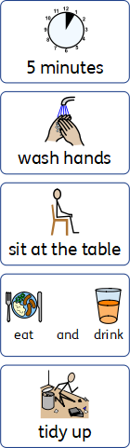

Develop a mealtime routine
Meals are made to be social and enjoyable experiences. For both adults and children, it is a time of reflection, comfort and connection with family and friends. During mealtimes, children should be encouraged to explore new foods but have the option to decline and eat the foods that they are familiar with.
- Eat together as a family
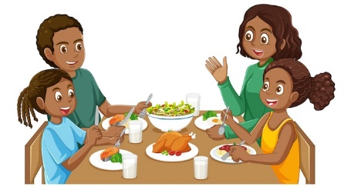
Eating meals together at the dining table or on a picnic rug helps your child to understand that they are in a defined area for eating and drinking. You may have to start small and expect your child to sit for 30 seconds and slowly increasing this over time. Allow your child to wander away but ensure that the finger food or meal stays at the table or rug. Eating together as a family as much as possible shows your child good eating models. If your child eats alone for all meals, they won’t learn about what a positive experience eating can be.

- Offer a choice at mealtimes
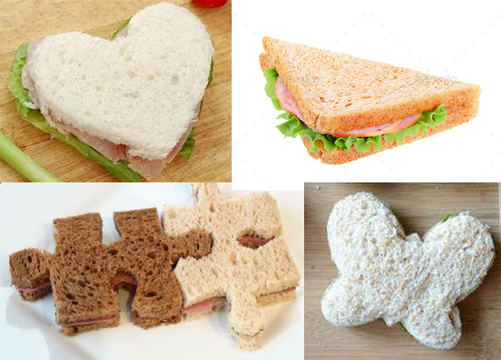
This will help give your child some control to their mealtimes. You may offer a choice of the food they have. However, the choice may also be things like:
- Choosing their own cutlery, plate, bowl or cup
- Where to place certain foods on the plate (e.g. on top of the rice vs. mixed together vs. put to the side of the plate)
- How much they want on their plate
- How something is cut (e.g. sandwich cut in triangles vs. squares)
- Choice between two side dishes (e.g. carrots vs. peas)

- Try introducing an exploring plate or scrap bowl
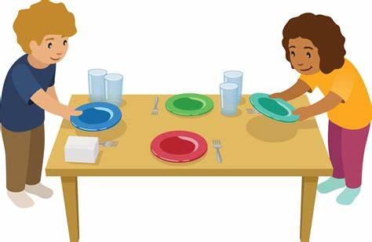
This is a plate or bowl on the table where a food item can be put by the child if they cannot tolerate having it on their plate. This is a very important step in building and maintaining the trust/promise that you have said “you do not have to eat this”. This needs to be respected since we have encouraged mealtimes to be stress-free.

By introducing a scrap bowl, your child has a choice ‘to eat it’ and ‘not to eat’. It encourages them to interact with the new food since they will physically need to put it in the scrap bowl.

Your child’s ‘safe’ and ‘unsafe’ foods
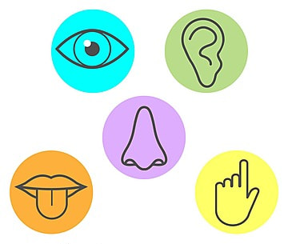
Selective feeding difficulties can stem from our senses which include touch, taste, smell, sight and sound. Children may have a difficulty with any one of these senses or be oversensitive in a particular area.
Eating is the most complicated sensory task that children participate in due to the simultaneous integration of all of their sensory systems. The sensory properties of food change constantly from one presentation to the next, and during chewing and swallowing.
Some children really struggle with fruit and vegetables and prefer more prepackaged foods. This is because prepackaged foods are consistent and predictable in how they feel, taste, smell, look etc. They are the same every single time. Whereas food that is not prepackaged can vary in how they feel, taste, smell, look etc and these make them less predictable.
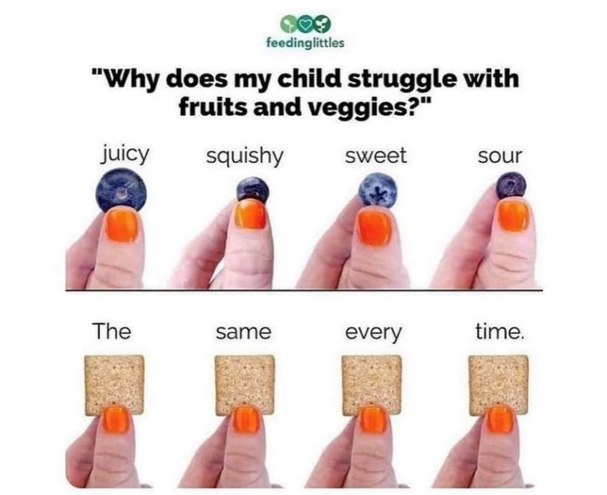

Safe foods are those foods you know your child will eat. Safe foods will often follow ‘rules’. For example, being a certain texture, colour, temperature, brand.
- Have a think about your child’s safe foods – do they have anything in common?
Unsafe foods are the ones you know your child will reject.

We want to work on expanding your child’s safe foods, so they start to readily accept more foods into their diet. We can do this through food play and exploration.

Food play/Food exploration
Food play is the time to have lots of fun with your child and help them to learn about food. For your child to try a new food, they need many opportunities to explore the food with all their senses (e.g. eyes, smell, touch) in a fun and relaxed manner.
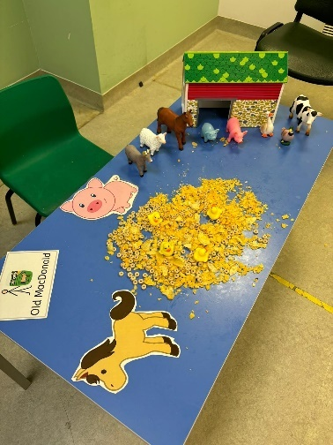
You may start with pretend play with food toys. Then introduce real foods for your child to explore. Use a plastic container and gradually introduce foods to it. Dry foods like cereal are good foods to start with as dry foods are not too difficult to wipe from your hands – e.g. cereals such as Weetabix can be crushed, sprinkled, drive cars in, roll balls in, and let plastic people or animals jump in or use spoons to feed dolly or teddy.

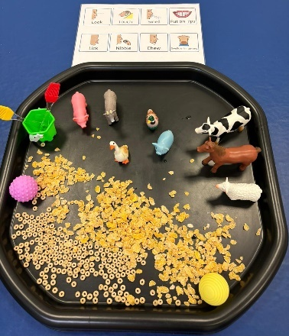
Encourage your child to use as many senses around food exploration as possible. Talk about what food looks like, how it smells or sounds, and what it may feel like. Model different ways to play and explore the food. This helps them to safely explore foods without the pressure to have to eat the food.

Let your child get messy with the food. This is a normal part of development. Once the child is happy to touch and explore the food, progress to smelling, licking, biting and tasting one small piece. Praise them when they touch, smell, lick or taste the food. Let them explore the foods by themselves. There should be no expectation to eat the food, the goal is to explore the food in a fun and relaxed manner. Do not try and take this to their mouth to feed them as they may be put off by this and reject any other food you offer to explore.

When you think your child is comfortable with exploring the food during play, then it may be introduced at mealtimes. Place the targeted food on a separate plate a little distance away from your child. There should be no expectation to eat it when it is first introduced. Gradually move it closer and when you think your child is ready, place it on their plate. When you child can tolerate the food on their plate, encourage your child to interact, smell, then lick or taste it when they are ready. This may have to be done gradually over many mealtimes. You can encourage this by doing it yourself. (Please see Steps to Eating (page 9) for more details.)
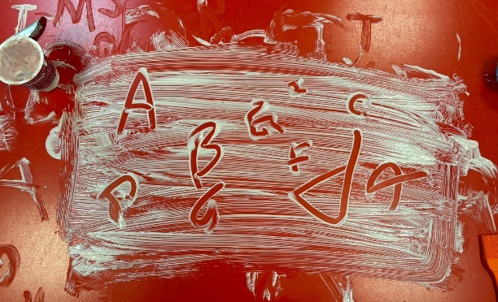
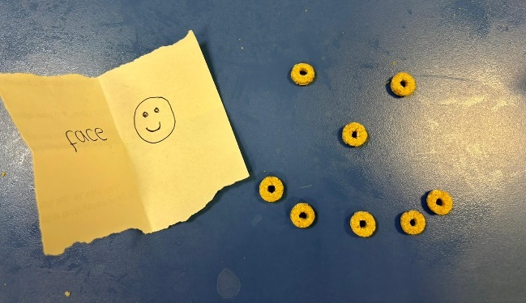
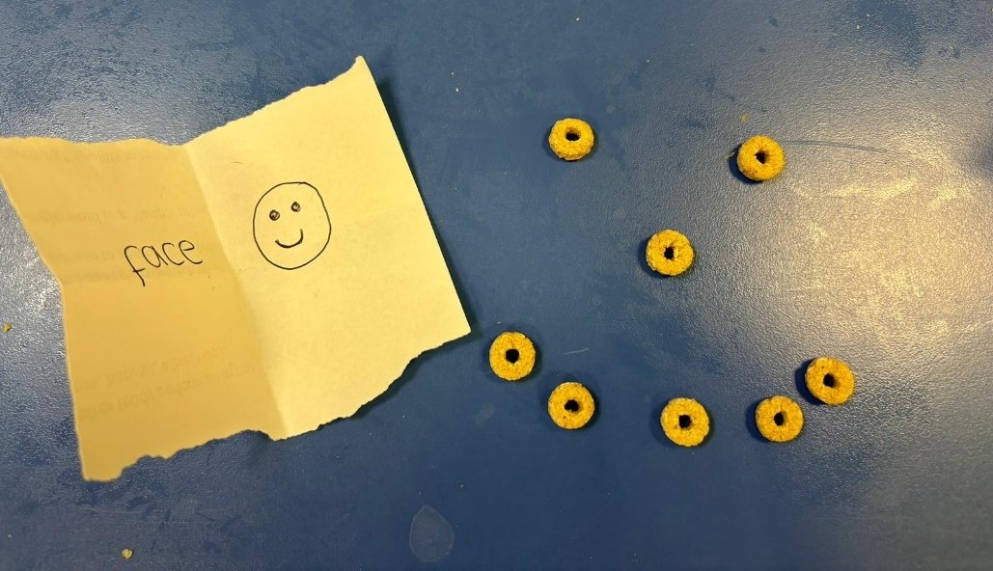
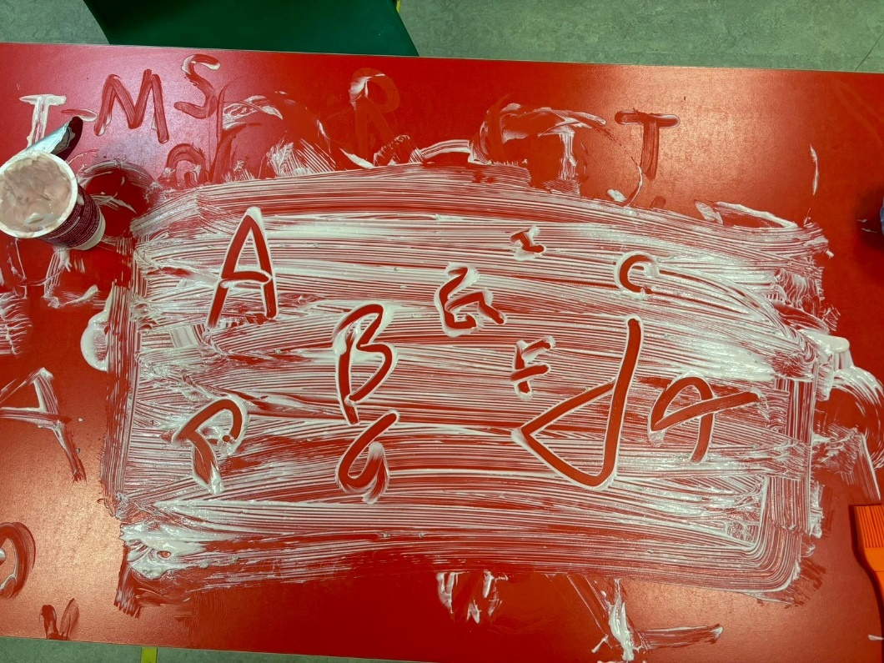
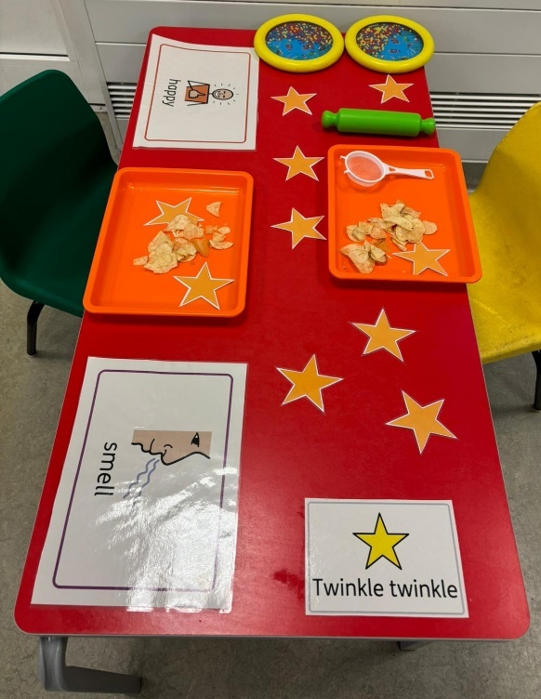

Food play activity ideas
The aim is to encourage the child to eventually expand their food intake once they feel more comfortable with the food in food play.

Pretend play | Activities  - Play a pretend game of shopping (*go shopping together at the supermarket)  - Hold a pretend tea party with a doll or teddy  - Have items in a feely bag to explore  - A treasure hunt to find the missing food | Materials  - Plastic food toys  *You may introduce whole real food items (e.g. hard fruits and vegetables) in play when your child is tolerating pretend food toys.
Hard and dry textures | Activities  - Sticking uncooked lentils to paper  - Pouring uncooked pasta from one cup to another  - Sorting two items into containers  - Threading pasta on string or straw  - Washing whole fruits/vegetables  - Objects hidden in uncooked rice/pasta/lentils | Food  - Hard fruit (apple, pear)  - Hard vegetables (carrot, celery)  - Dried fruit and vegetables  - Rice cakes  - Cereals (no milk)  - Crackers/biscuits  - Hard cheese  - Uncooked pasta/rice  - Uncooked lentils/beans
Soft textures | Activities  - Funny faces – arranging pieces of vegetable in mashed potatoes to make funny faces with coloured spaghetti hair  - Vegetable printing – printing with cut up beetroot  - Objects hidden in cooked rice/pasta/lentils  - Cooking activities:  - Stirring/mixing with spoon or whisk  - Adding ingredients to make a salad  - Sprinkling cheese on top of pizza  - Assembling a fruit kebab | Food  - Soft fruit (banana, orange, pineapple, melon, grapes)  - Soft cooked vegetables (peas, sweetcorn, broccoli, mashed potato)  - Cooked pasta and rice (no sauce)  - Soft and crumbly cheese
Wet, sticky and mixed textures | Activities  - Dip pieces of fruit into yoghurt  - Finger painting with ketchup  - Objects hidden in jelly  - Funny faces – arranging pieces of vegetable and use yoghurt or dip as glue  - Building a house with toast and spread  - Cooking activities:  - Making/kneading dough with yoghurt + flour/water + flour  - Decorating biscuits with icing | Food  - Yogurt  - Icing  - Dips  - Spreads, honey/syrup  - Sauces  - Cereals with milk (porridge, cornflakes, Weetabix)  - Cooked pasta and rice (with sauce)  - Textured soups and casseroles  - Ice-cream

Steps to Eating
These are all the steps children have to work through before they will be confident to try a new food. Your child will have to tolerate these steps before they are ready to chew and swallow a new food.

First, we must tolerate the physical presence or the look of the food. This might even include just being in the same room as the food. Then, perhaps, we can interact with the food without directly touching the food to your skin, maybe by using a kitchen utensil. Next, our body needs to process and manage the smell of a food. The play then expands to include touching the food with your fingers, hands, body, and mouth. Tasting comes next, which might look like quickly poking the food with the tip of your tongue, or maybe putting the food in your mouth, and spitting it out. Finally, we are ready to practice chewing and swallowing.

Start from the bottom of the table and work out where your child is for a particular food then aim to show them (by doing it yourself!) how to move to the next step during food play activities. Your child will be more confident with some foods than others so find out where they are for each food. If your child gets up and leaves the room when a certain food is presented, they are showing they cannot tolerate being close to that food yet, start by getting them used to the food being in the room.

It can take up to 20 repeated presentations of a new food with positive reinforcement before a child will begin to accept that food regularly. Many people make the mistake of taking that first rejection of a new food as the final word, but it is not.
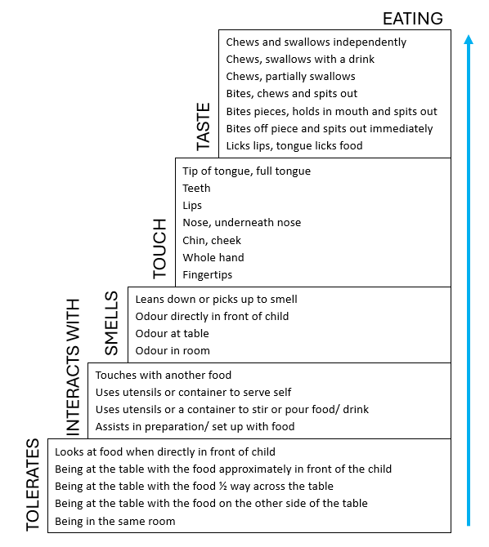

Copyright 2009 Dr Kay A Toomey
Try using a graded exposure ladder with your child if they like to see and be praised for how well they are doing with exploring food. Show your child how to climb up the ladder by exploring a food. Start by writing the name of the food at the top.
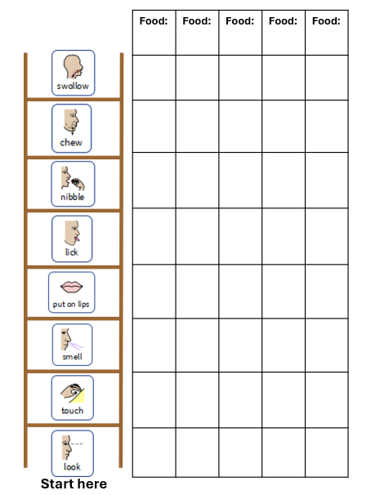
- Start by looking at the food and talk about how it looks. What shape is it? What colour? When they can do this give them a sticker/tick/colour in the ‘look’ box. If they can do that, move onto the next step.
- ‘Touching’ the food. Talk about how it feels (e.g. warm, cold, smooth, bumpy, hard, soft). If touching the food is too hard try with gloves or by using a toy/spoon/fork or putting the food in a plastic bag so there is a barrier between it and your child’s skin. Again, once they can do that, move onto the next step…

Remember
- Praise your child for any attempts and every tiny step they have taken.
- Go slowly and have fun!
- Get involved - you do the steps too! It will take the pressure off your child and show them that it is safe and okay to explore the foods.
Further Advice:
Bottle drinking
Baby feeding bottles (with a teat) are designed for babies up to one year old. Most children can be given a cup to practise drinking when they are able to sit upright and when they begin to wean to solid foods. If your child is stuck on drinking from a bottle, then try to introduce an open cup, beaker (free-flow without a valve) or a straw cup for their drinks with snacks and mealtimes first. An open cup, beaker or strawed cup will help your child learn to sip and not suck, which is developing their oral motor skills and is also better for their teeth. It might be messy, but this is part of learning a new skill. Learning a new skill will take time to practice and develop, so be persistent in your efforts.

Milk
If your child is given too much milk throughout the day, this can fill them up and make them not hungry enough to want to try foods. Your child should gradually move towards eating 3 meals a day in addition to milk between 7 and 9 months. As they eat more solids they will want less milk. From 12 months this should be approximately 350mls of milk or two servings of dairy products alongside three meals, two snacks and water throughout the day. Remember: Milk is a food not a drink.

Biting and chewing
Children may have difficulties with chewing for 2 reasons.
- Developmental: They are just not ready. Children need to be offered food which is appropriate for their level of general development. This might not be the same as their actual age.
- Sensory: They do not like how lumps feel in their mouth. This may be because they have had some difficult experiences around their mouths when they were younger such as reflux or frequent medical interventions. For some children, they feel lots of things more intensely than other children, and eating is just part of that sensory sensitivity.

For children to learn to bite and chew they need to have opportunities to explore foods that require biting and chewing. Page 7 and 8 gave you ideas on how to engage in food play. It may take your child a long time to tolerate exploring these textured foods and that is okay. Once more comfortable with exploring these foods in play, they need regular opportunities to feed themselves appropriate finger foods. You could try firstly with some foods that dissolve, these are foods that you bite, and they then melt in the mouth with saliva so are easier to swallow (e.g. wafers, rusks, wotsits, quavers). You could then also cut soft foods into bite sized pieces (e.g. soft, cooked vegetables, soft cheese, ripe/tinned fruit). Ensure your child has opportunity to see yourself or other children eating these foods as they will learn skills, such as how to bite and chew, by watching others.

Vitamin Supplements – If you have questions about vitamins, please speak to your health visitor or GP for more information.

Virtual Feeding Drop In Session

For parents/carers with questions about eating and drinking

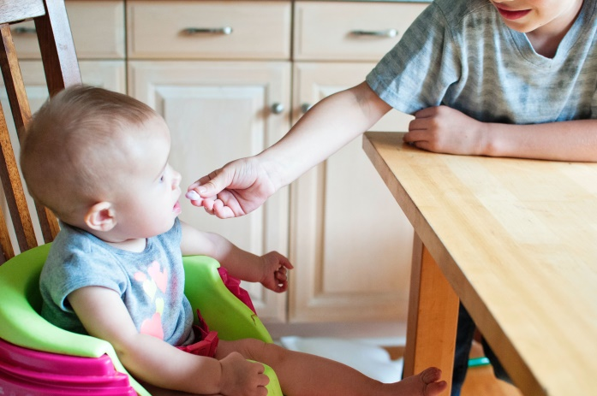
At our drop in sessions, our feeding team will be able to offer you virtual support about your feeding concerns, such as:
- Picky eating
- Introducing new foods
- Bottle weaning
- Independent eating

www.nelft.nhs.uk

For more information and to receive the link to join the drop in session, please email BDSLT.dysphagia@nelft.nhs.uk
(Please put ‘feeding drop in’ in the subject line.)

www.nelft.nhs.uk

On: Fourth Thursday of every other month at 1pm
(via Microsoft Teams)
January, March, May, July, September, November
Hosted by: Barking and Dagenham - Speech and Language Therapy (Feeding Team)

www.nelft.nhs.uk

